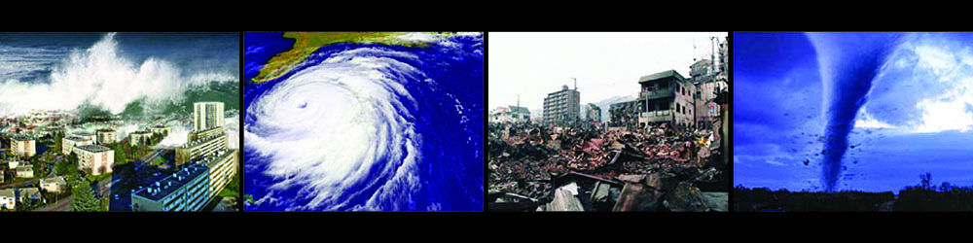

NATIONAL SCIENCE FOUNDATION AWARDS $11M TO CREATE A COMPUTATIONAL MODELING AND SIMULATION CENTER FOR NATURAL HAZARDS ENGINEERING

March 27, 2017

UC Berkeley Professor of Structural Engineering Stephen Mahin will lead a new center for computational modeling and simulation of the effects of natural hazards on the built environment (SimCenter). Supported by a five-year, $10.9-million grant from the National Science Foundation (NSF), the SimCenter is part of the Natural Hazards Engineering Research Infrastructure (NHERI), a distributed, multi-user national facility that will provide natural hazards engineers with access to research infrastructure. In addition to the SimCenter, NHERI includes a Network Coordination Office (NCO), Cyberinfrastructure facility (CI), and Experimental Facilities for earthquake and wind hazards engineering research, including a post-disaster, rapid response research (RAPID) facility. NHERI has the broad goal of supporting research that will improve the resilience and sustainability of civil infrastructure, such as buildings and other structures, underground structures, levees, and critical lifelines, against the natural hazards of earthquakes, tsunami, and windstorms in order to minimize loss of life, damage, and economic loss.

Principal Investigator (PI) Mahin is joined by co-PIs at Stanford University (Greg Deierlein), University of Washington (Laura Lowes), University of Notre Dame (Ahsan Kareem), and UC Berkeley/CITRIS and the Banatao Institute (Camille Crittenden). More than 35 other affiliated faculty, staff, postdocs, and students from more than 12 major research universities from around the U.S. will actively contribute to the SimCenter’s activities.

The goal of the SimCenter is to provide the natural hazards engineering research and education community with access to next-generation computational modeling and simulation software tools, user support, and educational materials needed to advance the nation’s capability to simulate the impact of natural hazards on structures, lifelines, and communities. In addition, the new center will enable leaders to make more informed decisions about the need for and effectiveness of potential mitigation strategies.

The SimCenter will provide modeling and simulation tools using a new open-source framework that: (1) addresses various natural hazards, such as windstorms, storm surge, tsunami, and earthquakes; (2) tackles complex, scientific questions of concern to disciplines involved in natural hazards research, including earth sciences, geotechnical and structural engineering, architecture, urban planning, risk management, social sciences, public policy, and finance; (3) utilizes machine learning to facilitate and improve modeling and simulation using data obtained from experimental tests, field investigations, and previous simulations; (4) quantifies uncertainties associated with the simulation results obtained; (5) utilizes high-performance parallel computing, data assimilation, and related capabilities to easily combine software applications into workflows of unprecedented sophistication and complexity; (6) extends and refines software tools for carrying out performance-based engineering evaluations and supporting decisions that enhance the resilience of communities susceptible to multiple natural hazards; and (7) utilizes existing applications that already provide many of the components required for the complex computational workflows.

According to Professor Mahin, “The new NHERI SimCenter will provide a cloud-based ecosystem for diverse multidisciplinary groups to work collaboratively on solutions to complex problems in natural hazard engineering without regards to their local resources and geographic proximity.” In tandem with the framework and applications being developed, in-person and online educational programs will be created within a new Virtual Community of Practice to provide an online meeting place for researchers and practitioners to exchange ideas, provide feedback, and share best practices, insights, and innovations for modeling and simulation of natural hazards engineering. The SimCenter will also offer workshops and a graduate student research traineeship program, and will host two students as part of the NCO’s Research Experiences for Undergraduates program. Professor Mahin also noted that “the SimCenter welcomes the contributions and participation of all those interested in the application of computational simulation to improving the resilience of structures and communities to natural hazards.”

NHERI continues NSF’s emphasis on earthquake engineering research infrastructure previously supported under the George E. Brown, Jr. Network for Earthquake Engineering Simulation (NEES), and now broadens that support to include research infrastructure for wind and coastal hazards. Information about NHERI resources is available on the NHERI CI web portal (http://www.DesignSafe-ci.org). The SimCenter is an independent center but builds on the support from the Center for Information Technology Research in the Interest of Society (CITRIS) and the Banatao Institute, the Pacific Earthquake Engineering Research (PEER) Center, the Lawrence Hall of Science, and others at UC Berkeley.

Principal Investigator:
- Stephen Mahin, UC Berkeley

Leadership team:
- Camille Crittenden, CITRIS and the Banatao Institute, UC Berkeley
- Greg Deierlein, Stanford University
- Sanjay Govindjee, UC Berkeley
- Ahsan Kareem, University of Notre Dame
- Laura Lowes, University of Washington

Management Team
- Frank McKenna, Chief Technology Officer
- Matthew Schoettler, Associate Director for Operations

The NHERI SimCenter can be contacted at nheri-simcenter@berkeley.edu.

Media Contacts:
- Professor Stephen Mahin, SimCenter and UC Berkeley, mahin@berkeley.edu, 510-693-6972
- Julie Sammons, CITRIS and the Banatao Institute, juliesammons@berkeley.edu, 510-643-9043
- Grace Kang, PEER, g.kang@berkeley.edu, (510) 642-3462

Image attribution:
This work, “NaturalDisastersRow.jpg”, is a derivative of "Amazing-natural-disasters.jpg" by no (disasters) [CC BY-SA 4.0 (http://creativecommons.org/licenses/by-sa/4.0)], via Wikimedia Commons

Image HTML code for web use:
<a title="By no (disasters) [CC BY-SA 4.0 (http://creativecommons.org/licenses/by-sa/4.0)], via Wikimedia Commons" href="https://commons.wikimedia.org/wiki/File%3AAmazing-natural-disasters.jpg"><img width="256" alt="Amazing-natural-disasters" src="https://upload.wikimedia.org/wikipedia/commons/b/b9/Amazing-natural-disasters.jpg"/></a>

