ANNUAL COUNCIL Community REPORT
Year-1

NHERI Council
Dr. Ross Boulanger, NHERI-UCDavis Director (Award CMMI- )
Dr. Joel Conte, NHERI-UCSD Director (Award CMMI- )
Dr. Dan Cox, NHERI-OSU Director (Award CMMI- )
Dr. Arindam Chowdhury, NHERI-FIU Director (Award CMMI- )
Dr. Steve Mahin, NHERI-SimCenter Director (Award CMMI- )
Dr. Forrest Masters, NHERI-U. of Florida Director (Award CMMI- )
Dr. Julio Ramirez, NHERI-NCO Director (Award CMMI-1612144)
Dr. Ellen Rathje, NHERI-DesignSafe-CI Director (Award CMMI- )
Dr. Jim Ricles, NHERI-Lehigh Director (Award CMMI-)
Dr. Ken Stokoe, NHERI-UT Austin Director (Award CMMI- )
Dr. Joseph Wartman, NHERI-UW Director (Award CMMI- )

Submitted to
NHERI Community
Issued: March 1, 2018

| Executive Summary

The Cooperative Agreement between each of the eleven awardees and NSF to provide collective and coordinated leadership to the Natural Hazards Engineering Research Infrastructure (NHERI) directs that the NHERI Council publish an annual Community Report on the NHERI website at DesignSafe-CI. In this report of the Council to the NHERI community, the following aspects are highlighted:

- NHERI and its Governance
- Activities in Year 1
- Priorities for Year 2

In response to this requirement, the NHERI Council is submitting to the NHERI Community its Year 1 Community Report. The content of this report includes an introduction of NHERI and its governance of the community followed by sections structured along the major three areas described above after the first year of NHERI with all eleven of its facilities awarded as of October 2017.

The NHERI leadership and professional staff encompassing all awards are pleased to report that, as planned, ten of the eleven facilities are fully operational and focused on serving the needs of the users in response to their respective cooperative agreements’ terms and conditions. The eleventh, RAPID, facility is proceeding as scheduled to begin operations later in 2018. The NHERI governance groups: (i) Council, (ii) Network Independent Advisory Committee (NIAC), and (iii) User Forum have been populated and are fulfilling their responsibilities to collectively provide effective, fair, and transparent governance in all NHERI activities that builds community, meets the research and educational user needs, and disseminates the impact of the user efforts.

1. NHERI and its Governance

1.1 NHERI
In 2016 the National Science Foundation (NSF) announced that all the components of the Natural Hazards Engineering Research Infrastructure (NHERI) were established. More information about the five-year award can be found at the following link from the NSF website:

https://www.nsf.gov/news/news_summ.jsp?cntn_id=189975

The process of awarding the various components started in July 2015 with the establishment of the cyberinfrastructure at the University of Texas at Austin. The various experimental facilities, with the exception of the RAPID facility, were awarded throughout the period from September 2015 to January of 2016. The Network Coordination Office was awarded to Purdue University in July 2016, followed by the Computational Modeling and Simulation Facility at the University of California, Berkeley and the RAPID facility to the University of Washington.

As of October 1, 2016, the Natural Hazards Engineering Research Infrastructure (NHERI) — supported by the National Science Foundation (NSF) as a distributed, multi-user national facility that provides the natural hazards research community with access to research infrastructure — was fully in place. NHERI is comprised of separate research infrastructure awards for a Network Coordination Office (NCO), Cyberinfrastructure, Computational Modeling and Simulation Center, and eight Experimental Facilities, including a post-disaster, rapid response research facility (RAPID). Information about the unique capabilities of these facilities can be found at the NHERI website:

https://www.designsafe-ci.org/facilities/experimental/

Awards made for NHERI contribute to NSF's role in the National Earthquake Hazards Reduction Program (NEHRP) and the National Windstorm Impact Reduction Program (NWIRP). The mission of NHERI is to provide the earthquake, wind, coastal engineering and social sciences communities with access to research infrastructure and education and community outreach activities focused on improving the resilience and sustainability of the civil infrastructure against earthquakes, windstorms and associated natural events such as tsunami and storm surge in coastal areas.

1.2 Governance

Under the terms of the NSF cooperative agreements, NHERI is governed by three bodies supported by the Network Coordination Office (NCO): the NHERI Council, the Network Independent Advisory Committee (NIAC), and the User Forum. Table 1.1 contains the membership of the three groups in Year 1. The role, charge and approved meeting minutes of the three groups can be found on the DesignSafe-CI website at: https://www.designsafe-ci.org/facilities/nco/governance/.

Table 1.1 NHERI Governance

Council of Principal Investigators
Full Name  (last, first) | Professional Title |  | Organizational  Affiliation (and Department) | Organizational  Internet domain | Project Position Title |  | Description of Responsibilities
Boulanger, Ross | Professor |  | University of California, Davis | www.ucdavis.edu | UCDavis-NHERI Director |  | Leadership- UCDavis-NHERI facility overall direction strategic and operational
Conte, Joel | Professor |  | University of California, San Diego |  | UCSD-NHERI Director |  | Leadership- UCSD-NHERI facility overall direction strategic and operational
Cox, Daniel | Professor |  | Oregon State University |  | OSU-NHERI Director |  | Leadership- OSU-NHERI facility overall direction strategic and operational
Chowdhury, Arindam | Associate Professor |  | Florida International University |  | FIU-WOW-NHERI Director |  | Leadership- FIU-WOW facility overall direction strategic and operational.
Mahin, Steven | Professor |  | University of California, Berkeley |  | SimCenter Director |  | Leadership- SimCenter facility overall direction strategic and operational
Masters, Forrest | Professor |  | University of Florida |  | UofF-NHERI Director |  | Leadership- UofF-NHERI facility overall direction strategic and operational
Ramirez, Julio | Professor |  | Purdue University | www.purdue.edu | NCO-NHERI Director |  | Leadership- Network Coordination Office (NCO) overall direction strategic and operational.
Rathje, Ellen | Professor |  | University of Texas at Austin |  | DesignSafe-CI Director |  | Leadership- DesignSafe-CI facility overall direction strategic and operational
Ricles, Jim | Professor |  | Lehigh University |  | Lehigh-NHERI Director |  | Leadership- Lehigh-NHERI facility overall direction strategic and operational
Stokoe, Ken | Professor |  | University of Texas at Austin |  | UTAustin-NHERI Director |  | Leadership- UTAustin-NHERI facility overall direction strategic and operational
Wartman, Joseph | Associate Professor |  | University of Washington, Seattle |  | RAPID-NHERI Director |  | Leadership- UW-RAPID facility overall direction strategic and operational
Network Independent Advisory Committee
Full Name  (last, first) | Professional Title |  | Organizational  Affiliation (and Department) | Organizational  Internet domain |  | Project Position Title | Description of Responsibilities
Ewing, Lesley | PhD, PE, DCE, lead coastal engineer |  | California Coastal Commission |  |  | Member | To provide independent guidance and advice to the Council on: (a) progress, plans, and performance of the Awardees and annual Council work plan, (b) an assessment of the level of community engagement and user satisfaction across NHERI, with input from the User Forum survey results, (c) an assessment of NHERI’s continuing value added for and impact on research and educational advancements, and (d) assessment of the transparency an efficiency of the NCO's Facility Scheduling Protocol.
Hansmire, William | PhD, Senior Vice President |  | Parsons Brinckerhoff, Inc. |  |  | Member
Naeim, Farzad | PhD, SE, Esq., Adjunct Professor of Civil and Environmental Engineering |  | University of California, Irvine |  |  | Member
Petroff, Catherine | PhD, Coastal Engineering Consultant, US Army Corps of Engineers, UW Adjunct Professor |  | US Army Corps |  |  | Member
Van de Lindt, John | PhD, George T. Abell Professor in Infrastructure |  | Colorado State University |  |  | Member
Vickery, Peter | PhD |  | Applied Research Associates |  |  | Member
Woods, Richard | PhD, Emeritus Professor |  | University of Michigan |  |  | Member
User Forum
Full Name  (last, first) |  | Professional Title | Organizational  Affiliation (and Department) | Organizational  Internet domain |  | Project Position Title | Description of Responsibilities
Green, Russell |  | Professor | Virginia Tech | www.cee.vt.edu |  | Chair | To provide the Council with independent advice on community user satisfaction priorities and needs related to the use and capabilities of NHERI.
Stark, Nina |  | Assistant Professor | Virginia Tech | www.cee.vt.edu |  | Vice-Chair | Work with the Chair in meeting the responsibilities of the User Forum. Also, a member of the User Satisfaction Committee
Sutley, Elaina |  | Assistant Professor | University of Kansas | www.ceae.ku.edu |  | Secretary | Carry out duties of the office for the User Forum. Also a member of the ECO Committee
Johnson, Erik |  | Professor | University of Southern California | www.cee.usc.edu |  | Member | Member of the User Satisfaction Committee
Kargarmoakhar, Ramtin |  | PhD | T.Y. Lin International | www.tylin.com |  | Member | Member of the Central Scheduling Committee
Elsharawy, Mohamed |  | PhD | SOH Wind Engineering | www.sohwind.com |  | Member | Member of the Central Scheduling Committee
Athanasopoulos-Zekkos, Adda |  | Associate Professor | University of Michigan | www.umich.edu |  | Member | Member of the ECO Committee
Malley, James O. |  | Structural Engineer | Degenkolb Engineers | www.degenkolb.com |  | Member | Member of the Technology Transfer Committee
Ritchie, Liesel A. |  | PhD | University of Colorado Boulder | www.colorado.edu |  | Member | Member of the User Satisfaction Committee and lead on the development of the User Satisfaction Survey in Year-2

As described in Table 1.1, the Council is composed of all Principal Investigators (PIs) of each NHERI Awardee or a designated substitute member as chosen by each PI not present at Council meetings. The roles of the Council are as follows: to provide a collective and coordinated leadership for steering the NHERI program through the development of policies, to develop the Council’s annual work plan of network-side activities, and to create the Annual Community Report — this document. This group had its first meeting on November of 2016 and met four times during Year 1.

NHERI Council. In its first year, the Council accomplished key tasks. It established through its membership a centralized scheduling protocol and a facility scheduling dashboard (https://www.designsafe-ci.org/facilities/scheduling/). It established guidelines for data sharing and archiving (https://www.designsafe-ci.org/facilities/experimental/) and focused on attracting new users and providing research support at the NHERI facilities in a safe an effective environment. In addition, the Council established two key international partnerships, and worked on the dissemination of the impact of the work of NHERI researchers. In Section 2 of this report more details are provided on the key activities in NHERI.

Network Independent Advisory Committee. The NIAC is composed of representatives from the broad scientific and engineering communities served by NHERI. The role of the NIAC includes providing independent guidance and advice to the NHERI Council and keeping the community and NSF informed of NHERI activities via the publication of an annual report. The NIAC had its first meeting in April of 2017. NIAC members endeavor to follow the activities in NHERI by participating in the Summer Institute and interacting with the early career professionals and researchers attending the Institute, meeting with the facility PIs and working closely with members of the User Forum to get a full picture of the needs and activities of NHERI’s users.

User Forum. The User Forum is composed of elected members from the community. Its role is to provide input to the Council on community satisfaction within the NHERI program and to raise awareness of the community’s priorities and needs. The group was elected by the NHERI community and had its first meeting in February of 2017. Fully engaged in key activities of NHERI, its members have joined network committees such as the Central Scheduling Committee and the Education and Community Outreach Committee (https://www.designsafe-ci.org/facilities/nco/eco/) to bring input from NHERI’s users into all activities of the network. The Forum meets monthly, and the officers join the biweekly meetings of the Network Coordination Office (NCO) Strategic Committee.

There is ample opportunity and avenues to provide input to any and all of these groups via DesignSafe-CI. For instance, on the User Forum page there is a live link to send input as shown in the Figure 2.1.

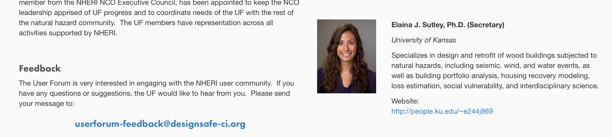

Figure 1.1 Feedback to the User Forum

2. Activities in Year 1

2.1 NHERI Science Plan
The NHERI NCO and the Council were charged in Year 1 with the coordinated leadership of the nation’s multi-hazards community to develop the five-year research agenda that will elucidate grand challenges, key questions, and research objectives for earthquake, wind, coastal engineering and social sciences communities. The process and publication of the first plan in Year 1 are described next. The publication of the plan in DesignSafe-CI on July 17, 2017 is one of the main achievements of NHERI in Year-1.

Process: As soon as all NHERI components were awarded, the NCO convened the NHERI Council and collected all awardee Science Plan components to serve as the starting point in the development of the plan. Next, with concurrence from the Council, the NCO established a task group to develop the first draft in the first three months of the award starting July 1, 2016. The entire process was community-driven by collecting broad input and ideas from a number of stakeholders and engaging recognized leaders in the earthquake, wind, coastal engineering and social sciences fields in the task group to synthesize that input into a comprehensive plan. During FY 1, the task group (TG) held 6 virtual meetings. The first meeting took place November 29, 2016. A subcommittee was established during that meeting to develop a proposed outline for the TG's consideration. The next meeting of the TG was on January 24, 2017. An updated timeline was developed after the meeting. Meetings of the TG on April 12 and May 16 were for the purpose of developing the draft and resolving review comments.

Publication: In May of 2017, the first draft of the plan was made available to the three governance groups of NHERI — the Network Independent Advisory Committee (NIAC), the User Forum, and the NHERI Council of principal investigators — for review and comment. A meeting of the TG was held on June 19 to resolve comments from the Council and NCO. The Science Plan draft was posted on the DesignSafe website on June 22 for a public comment period. On July 10, a meeting was held to resolve comments received from the Community during the public comment period. The first edition of the Science Plan was posted on DesignSafe on July 14 to serve as a resource for the community as it develops research and education proposals for submission to NSF and other funding agencies. The plan can be found at:

https://www.designsafe-ci.org/facilities/nco/science-plan/

The NHERI Science Plan provides the earthquake, wind, and coastal hazards community, including NSF and other funding agencies, a roadmap for high-impact, high-reward, hazards engineering research at the NHERI facilities. Examples of possible projects at the facilities can be found in the Science Plan at the respective facility appendix. The research results are intended to enable damage mitigation and prevent loss of life from natural hazards. The plan is a living document that will be reviewed annually and improved/modified to reflect the advances made in improving the resilience of civil infrastructure as a result of the work conducted in NHERI and throughout the world.

Figure 2.1 NHERI Science Plan

2.2 Research Support- Facility Scheduling Dashboard
As one of its core roles, the Network Coordination Office (NCO) maintains a Facility Scheduling Dashboard that allows researchers and managers at Experimental Facilities (EF) to centrally manage the efficient use of assets at their facility during time dedicated to use by NHERI projects. A full-time Facility Scheduling and Operations Coordinator (FSOC) works with a designated manager at each EF site to handle the scheduling of projects. To aid these tasks, a scheduling protocol is used, along with an online scheduling system through the Microsoft Project Online platform to maximize the throughput of projects during the time each EF site has pledged to NHERI. The scheduling protocol also allows researchers to follow progress and plan on possible access to one or more facilities in their proposals.

https://www.designsafe-ci.org/facilities/scheduling/

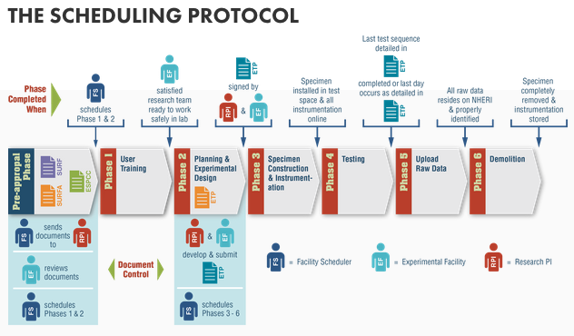
Figure 2.2.1 NHERI Scheduling Protocol

2.3 Education and Community Outreach
Multiple avenues for community participation are available through the various NHERI-wide education and community outreach activities. Two network-wide activities led by the NCO working with the other NHERI awardees are the Research Experience for Undergraduates (REU) program and the Summer Institute, a program for early career faculty and practicing engineers and architects, graduate students.

REU Program (https://www.designsafe-ci.org/learning-center/reu/)
In the first year, the REU program was organized and implemented at the end of Year 1 and the beginning of Year 2. It consisted of two, 10-week REU programs beginning in the summer of 2017. Each NHERI site hosted 2 REU students, with the possibility of adding 1-2 adjunct REU students through a smaller stipend provided to undergraduate research students that are already enrolled at a given site. The 2017 REU program featured seventeen students assigned to sixteen projects throughout the network of NHERI facilities. At the conclusion of each ten-week summer program, students produced a research poster and paper for their project and gave a presentation on their experience. A sample of the posters and papers can be seen in Figure 2.3.1. Copies of the presentation slides, as well as a video recording of the presentations, can be found at the "REU 2017" project within the DesignSafe-CI Data Depot and accessed from the REU page link above.

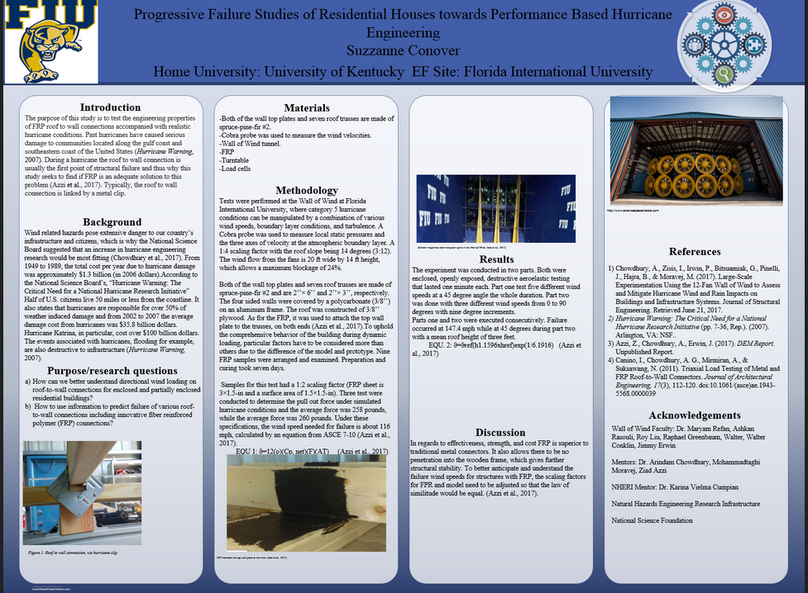
Figure 2.3.1 Sample research poster. REU Student Suzzanne Conover: Progressive failure studies of residential houses towards performance based hurricane engineering

Summer Institute (https://www.designsafe-ci.org/learning-center/summer-institute/)
In its inaugural year, the 2017 NHERI Summer Institute brought together a total of 72 practicing engineers, principal investigators, researchers, K-12 teachers, early career faculty members and graduate students for a week-long series of workshops to discuss the advancement of research in natural hazards engineering. The event was held at the University of Texas at San Antonio’s (UTSA’s) main campus from July 24 to 28. The NHERI NCO funded 18 early career faculty and graduate students as well as 12 local-area K-12 educators and educational leaders to attend the event.

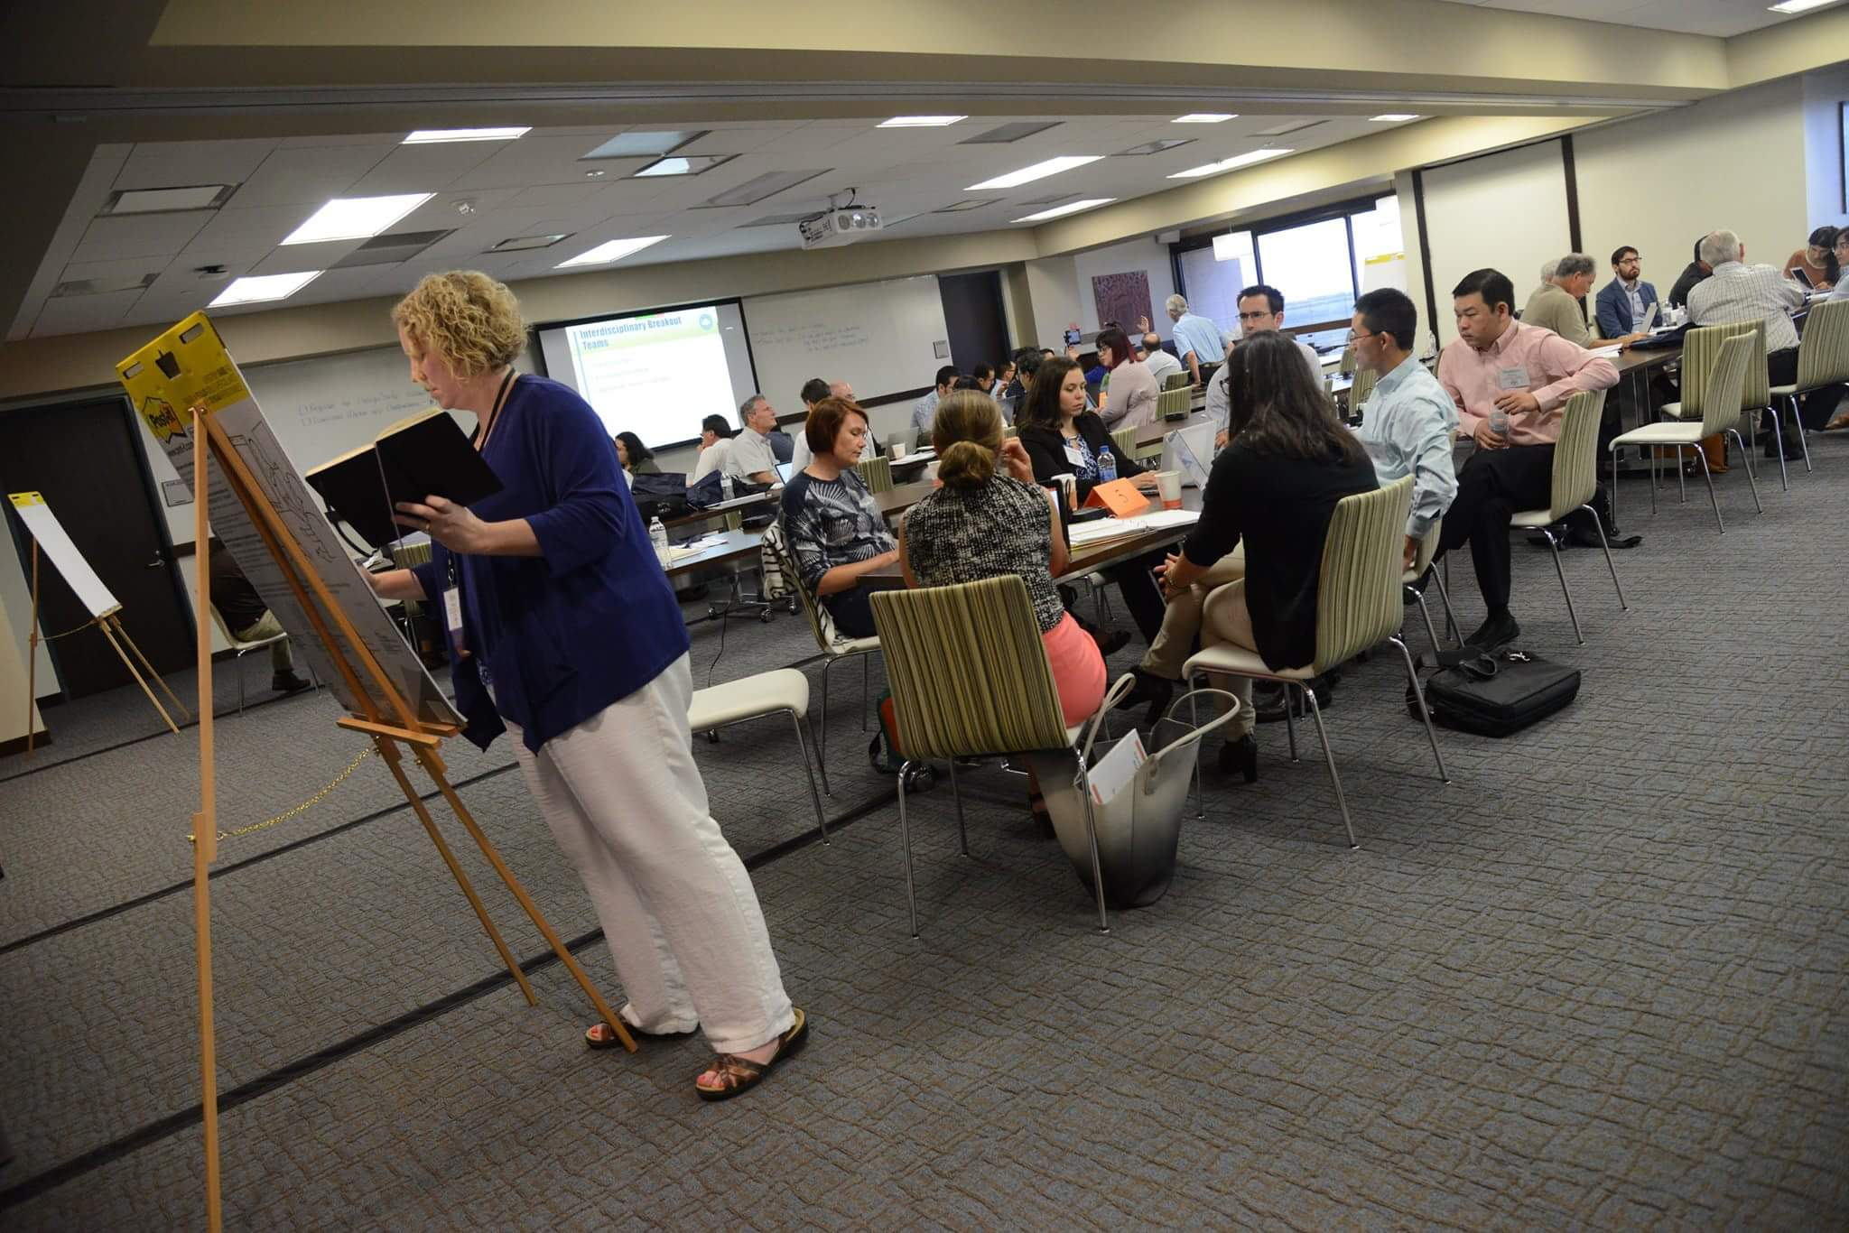
Figure 2.3.2 Participants engaged in hazard risk mitigation at the Summer Institute

Pre- and post-assessments of the program were distributed to the participants and the following was learned from the collected responses: The majority of the participants (61.5%) went from having less than moderate experience to having a great deal of experience working with the natural hazards engineering community, and all surveyed participants (100%) learned about the NHERI community and its research work. During the Summer Institute, the majority of participants (85%) also worked with other natural hazards engineering professionals and researchers outside their specializations, and all responded that they planned to work with the NHERI community. There was also a positive shift in the confidence level in writing research grant proposals that participants experienced as a result of attending the workshop. Along with this shift also came a positive shift in the confidence level of working on research projects with other professionals and researchers outside the participants’ universities. All participants (100%) were interested in collaborating with the natural hazards engineering professionals that they met at the Summer Institute.

The second annual NHERI Summer Institute will be held on June 4-6, 2018, at the University of Texas at San Antonio (UTSA) Downtown Campus. K-12 educators, engineers, and researchers interested in learning more about the Natural Hazards Engineering Research (NHERI) community are invited to apply at https://www.designsafe-ci.org/learning-center/summer-institute/.

Topics of the three-day event include:

- The mission of the NHERI program
- Writing a grant proposal
- NHERI network facility capabilities
- Requesting research resources within the NHERI network
- The NHERI Science Plan
- Hands-on computational research and data management

Again, the NHERI-NCO is planning to fund a limited number of early career faculty members (i.e., non-tenured professors) and early career professionals for travel assistance to the Summer Institute program as well as senior-level graduate students. K-12 educators will also be able to apply for a stipend for participating. International travel assistance will be evaluated on a case-by-case basis as the grant funds allow. The deadline for travel stipend applications is February 15, 2018, at 11:59pm Central Time with funding decisions by March 2018.

2.4 International Partnerships
In fulfillment of the charge from NSF to the NCO of establishing partnerships that are beneficial to NHERI and its users, two letters of agreement have been signed between Purdue University on behalf of NHERI — one with the National Research Center on Earthquake Engineering (NCREE) of Taiwan and a second with the National Research Institute for Earth Science and Disaster Resilience (NIED) of Japan. The agreements, which cover the important elements of access to facilities, research collaborations, data exchanges and educational activities, are posted on the DesignSafe-CI website.

Under the NHERI and NIED agreement, two meetings have been held. The meeting of July 13-14, 2017, established the framework for the research collaboration and included formal signatures to the agreement. The second meeting, held on October 31 and November 1, 2017, kick-started the research planning under the collaboration. Reports from both meetings, including presentations, are posted at: https://www.designsafe-ci.org/facilities/nco/partnerships/nied/

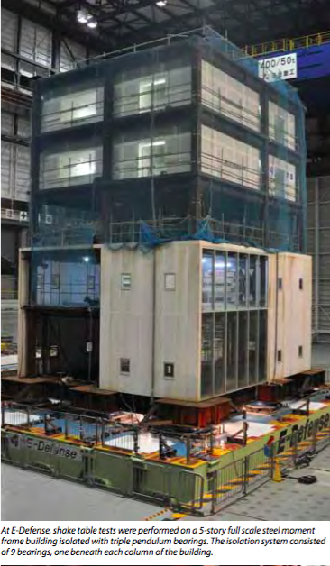
International Partnerships NHERI and NIED/EDefense

The meeting held on October 31 and November 1, 207 was the 1st NHERI/E-Defense Collaborative Research on Earthquake Engineering Meeting. Leading researchers from both countries as well as representatives from NSF, MEXT and other government agencies attended this meeting to discuss in plenary and breakout sessions the future plans for research collaboration. The report on the meeting was made available via DesignSafe-CI and e-mail distribution at the end of November 2017 to allow the community to consider the possible collaboration with E-Defense in their proposals to the NSF ECI deadline and other directorates of January 2018. Funding for the participants from the US at both meetings was provided by NSF as a supplement to the Award CMM!-1612144. Going forward, it is planned that annual meetings will be convened and funding to support the US participants will be sought thorough a workshop proposal to NSF.

2.5 Impact of NHERI Research
The first year of reporting on the research ongoing in NHERI provides a window into the vibrant collaborative milieu in which dedicated researchers, educators and professional staff endeavored to produce and preserve high-impact research. The community’s work is focused on improving the resilience of civil infrastructure against natural hazards such as earthquakes, windstorms, and related events like tsunamis and storm surge in coastal areas. The research aims to ensure secure economies, protect human lives, and contribute to the safety and well-being of our communities.

References preserving the impact of researchers working in NHERI have been assembled in the publication “NHERI Network Impacts, Year 1, 2016-2017” appended to this report. Frequent updates on the research activities in NHERI are provided in the NHERI Quarterly Publication. Since February 1, 2017, when the NCO began its activity as the NHERI facilities project scheduler, 59 projects have been reported using the facilities. Table 2.5.1 illustrates the current distribution of projects.

With each issue of the NHERI Quarterly Publication, readers get an inside look at the goings on at several NHERI facilities and find details on upcoming events, research and training projects, NHERI education and outreach programs, and general news from NHERI sites. These issues are available online at the Quarterly Publication archive page (https://www.designsafe-ci.org/community/news/quarterly/). Other ways of disseminating information about NHERI research include a monthly newsletter, the DesignSafe-CI website and multiple email distribution lists.

Table 2.5.1 NHERI Facility Utilization as of February 2018

Facility | NSF | Other Federal/State Agencies or Industry in NHERI Time | Non-NHERI Time
Oregon State U. | 6 | 2 | 1
UC Davis | 6 |  | 1
UC San Diego | 2 |  | 1
Lehigh University | 11
FIU | 10 |  | 4
U. of Florida | 12 | 1
UT Austin | 3 |  | 1
Total | 50 | 3 | 8

3. Priorities in Year 2

In Year 1, significant effort was spent establishing the governance of NHERI and related protocols in a timely manner — given that the various awards were issued at different times of the year. Additional important activities at the NCO were the deployment of the protocol for centralized experimental facility scheduling of projects under NHERI time and the implementation of the Facility Scheduling Dashboard in DesignSafe-CI. The organization and implementation of the NHERI REU program in collaboration with the NHERI awardees and the publication of the first edition of the 5-Year NHERI Science Plan also were significant tasks in Year 1. These efforts were critical steps for establishing the foundational mechanisms for NHERI and for ensuring the sound growth and operation of its community.

During Year 2, we envision that the groundwork laid in Year 1 will result in a broader involvement of stakeholders with NHERI, as well as a greater public awareness of natural hazards engineering research. This will be accomplished by leveraging the resources that NHERI has built, together with the invaluable work from its users. With this, our highest priorities for Year 2 are to:

1. Accelerate the pace of the growth of the NHERI community and act as catalysts in the development of a more multi-hazard approach to improving resilience of the civil infrastructure by bringing the earthquake, wind and coastal engineering groups together.

2. Disseminate broadly the NHERI impact through: (i) Science Plan related activities that include a workshop with international participation to refine the plan and identify research campaigns to help realize the vision; (ii) NHERI-wide sessions at professional meetings; (iii) increased outreach beyond the community of registered users in DesignSafe-CI by leveraging distribution lists of our partner organizations such as EERI, ASCE, ACI, PEER and similar groups; and (iv) providing information to the media about NHERI research and its impact on the resilience of civil infrastructure against earthquakes, tsunamis, windstorms and storm surge;

4. Accelerate the transfer of hazards engineering research to practice through the activation of the Technology Transfer Committee. This important group will be critical to help NHERI identify key projects, past and present, whose outcomes may be swiftly implemented. In Year 2, the TTC will be examining research projects that look promising for the implementation of new code provisions, new design guidelines, and new or improved experimental testing methods — all aiming to mitigate risks due to natural hazards.

