NHERI Display at Conferences and Professional Meetings

- Overview
The NHERI Council in its Year-1 Community Report stated as two of its priorities: (i) to accelerate the growth of the community; and (ii) to disseminate broadly the NHERI impact through several avenues, such as presence at professional meetings. Funding for this supplement will contribute directly to the outreach program for the duration of the NHERI award helping to grow the community and disseminate the impact of the work conducted by the users of the research infrastructure.

- Implementation of the Supplement
The members of the NHERI Council with support of at least one member of the NHERI professional staff will be responsible for staffing the booth at selected meetings where they are already planning to participate. The following members of the Council have indicated willingness to support this effort with their presence at the meetings shown in Table 1:

Table 1. Planned participation
NHERI Awardee Institution | Participants | Meeting | Impact
Florida International University | Arindam Chowdhury | ASCE-SEI Congress, April 25–27, Orlando, FL 2019
Florida International University | Arindam Chowdhury | Engineering Mechanics Institute, 2019
Oregon State University | Dan Cox | ASCE International Conference in Coastal Engineering (ICCE), 7/30 – 8/3, Baltimore, MD, 2018
Purdue University | Julio Ramirez | EERI Annual Meeting, 2019
??? |  | ASCE GEO Congress 3/24-27, Philadelphia, PA, 2019
??

An example of a display booth envisioned for this activity is shown in Figure1. This is a modern design with cost estimate starting at $2500.

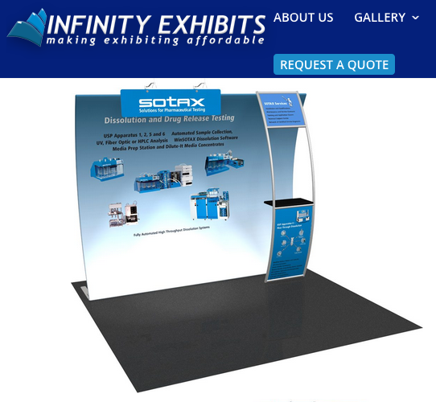
Fig.1 10’ FabLite Vertical Curve Booth (https://www.infinityexhibits.com/10-fablite-vertical-curve-tension-fabric-display/)

- Outreach activities
It is envisioned that the booth activities will include the presence of at least one professional staff representative of the experimental facilities and the awardee principal investigator(s)/or designee, both scheduled to cover the booth as needed. For this activity, two electronic displays are proposed. One of the displays is intended to run a continuous series of videos featuring testing at the laboratories, activities of the SimCenter and DesignSafe-CI, and community educational and outreach activities of the NCO. The second display will be connected to a computer to allow the visitor to experience hands-on activities using the NHERI cyberinfrastructure. In addition, posters will be displayed and one-page flyers available for distribution to the visitors.

- Summary of the scope of the supplement
This supplement request includes the support for the participation of professional staff, including meeting registration, travel and lodging costs, purchase of the booth, and two electronic displays and a portable computer. NHERI Council members will not be charging any costs to this supplement are their participation is programmed at this event with or without the booth presence.

NHERI booth to display at Conferences and Professional meetings

Budget
 | Cost
Personnel
NHERI professional staff participant support (1 at each meeting) | $8750
Materials and supplies
Display Booth and transportation case(s) | $2500
Printing of Posters for Display (11) | $3300
Electronic Displays (2) | $1500
Laptop | $1500
Total Direct Costs | $17550
TOTAL DIRECT COSTS | $17550
INDIRECT COSTS (%)
TOTAL

Budget Justification
PERSONNEL-Professional Staff: the total cost requested is $8,750.00
• Includes meeting registration, and travel and lodging costs for two staff attending each meeting estimated at $1250/meeting. We envision a maximum of seven conferences.
MISCELLANEOUS AND SUPPLIES: The total requested is $8800.00
• It includes: A display booth at $2500, $300 to print 11 posters (one for each NHERI component) to display at the booth as needed, two electronic large displays at $750 each, and one personal laptop to conduct hands-on demonstrations at the booth at $1500.
INDIRECT COST – Rate %. Indirect costs are applied to miscellaneous and supplies.

