
National Science Foundation
Natural Hazards Engineering Research Infrastructure (NHERI)

NHERI is a distributed, multi-user, national facility that provides the natural hazards engineering community with state-of-the-art research infrastructure. This handout includes information on the NHERI network.

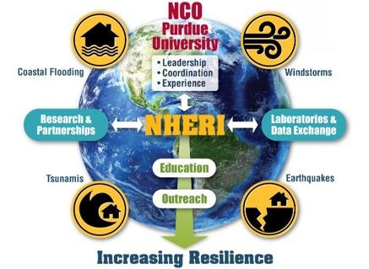
Network Coordination Office (NCO)
Purdue University
NSF award #1612144
www.designsafe-ci.org/facilities/nco/

The NCO serves as the leader and focal point for NHERI, building a global, multi-hazard, collaborative research community and research infrastructure focused on mitigating the impacts of earthquakes, windstorms, and related hazards of tsunamis and storm surge on civil infrastructure.


Wall of Wind
International Hurricane Research Center
Florida International University
NSF award #1520853
wow.fiu.edu

The Wall of Wind (WOW) is a large open jet wind tunnel facility with distinct advantages over conventional wind tunnels. WOW enables testing of entire structures at full-scale, leading to performance-based design for hurricanes through direct correlation of wind speed with performance and damage levels.


Advanced Technology for Large Structural Systems (ATLSS) Engineering Research Center
Lehigh University
NSF award #1520765
lehigh.designsafe-ci.org

Advanced Technology for Large Structural Systems Engineering Research Center at Lehigh University has a unique portfolio of equipment, instrumentation, infrastructure, testbeds, experimental simulation control protocols, large-scale simulation and testing experience along with know-how that does not exist elsewhere in the United States. The unique strength of the NHERI Lehigh EF is accurate, large-scale, multi-degree-of-freedom and multi-directional simulations of the effects of natural hazard events on civil infrastructure systems (i.e., buildings, bridges, industrial facilities, etc.) with potential soil-foundation effects.


O.H. Hinsdale Wave Research Laboratory Experimental Facility
Oregon State University
NSF award #1519679
wave.oregonstate.edu

The O.H. Hinsdale Wave Research Laboratory (HWRL) has two specialized large-scale resources for physical model testing of coastal systems subject to the action of tsunamis created by earthquakes and storm surge and waves created by wind storms. It consists of two main resources to support a wide base of users: the Large Wave Flume (LWF) and the Directional Wave Basin (DWB). Both the flume and basin are capable of generating wind waves and tsunamis. The flume is a two-dimensional representation of the coast (looking directly out to sea), eliminating the complexity of longshore currents and wave direction and allowing a cross-section of test specimens to be studied at a large scale.

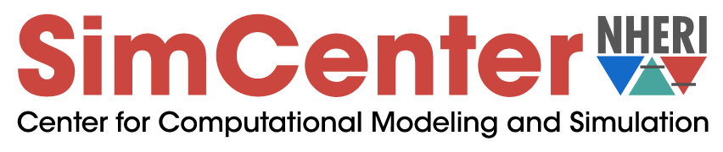
Computational Modeling and Simulation Center (SIMCenter)
University of California at Berkeley
NSF award #1622843
simcenter.designsafe-ci.org

The SimCenter provides next-generation computational modeling and simulation software tools, user support, and educational materials to the natural hazards engineering research community with the goal of advancing the nation’s capability to simulate the impact of natural hazards on structures, lifelines, and communities.

Centrifuge Facility

Center for Geotechnical Modeling
University of California at Davis
NSF award #1520581
cgm.engr.ucdavis.edu

Geotechnical centrifuges enable the use of scale models to investigate nonlinear, stress-dependent responses of soil masses that are many times larger than is possible on the world’s largest 1-g shaking tables. The centerpiece of our facility is one of the largest centrifuges equipped with a shaking table in the world, which enables researchers to perform experiments with a holistic-level of complexity that is not possible with smaller scale centrifuges.


Large High-Performance Outdoor Shake Table
University of California at San Diego
NSF award #1520904
nheri.ucsd.edu/about/contact.shtml

Large High-Performance Outdoor Shake Table at University of California at San Diego provide a large, high performance, outdoor shake table (LHPOST) to support research in structural and geotechnical earthquake engineering. This facility enables research, with extensively instrumented large- or full-scale structural, geotechnical, and soil-foundation-structural systems tested under extreme earthquake loads, to produce the experimental data essential to advancing predictive seismic performance tools.


Wind Experimental Facility
University of Florida
NSF award #1520843
ufl.designsafe-ci.org

The wind experimental facility provides users access to one of the largest wind engineering experimental research infrastructure facilities in the world. It enables investigators the opportunity to characterize loading on and dynamic response of a wide range of infrastructure types in a large, reconfigurable boundary layer wind tunnel (BLWT). Researchers can also conduct full-scale tests on large building systems with equipment capable of ultimate/collapse loads associated with a Simpson Hurricane Wind Scale Category 5 hurricane or an Enhanced Fujita Scale 5 tornado.

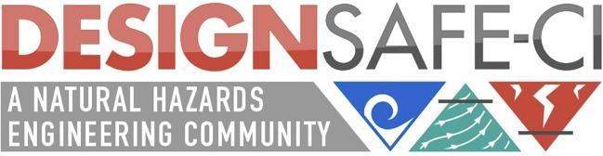
Cyberinfrastructure-DesignSafe
Texas Advanced Computing Center
University of Texas at Austin
NSF award #1520817
DesignSafe-ci.org

DesignSafe is the cyberinfrastructure (CI) platform for NHERI. DesignSafe allows researchers to more effectively share, publish, and find data using the Data Depot data repository; perform numerical simulations using high performance computing via the Discovery Workspace; and integrate diverse datasets across the platform. DesignSafe embraces a cloud strategy, with all data, simulation, and analysis taking place on the server-side resources of the CI, accessible and viewable from the desktop.


Large Mobile Shakers
University of Texas at Austin
NSF award #1520808
utexas.designsafe-ci.org

The large mobile shakers in the NHERI@UTexas experimental facility contribute unique, powerful servo-hydraulic shakers and associated dynamic instrumentation to study and develop novel in-situ testing methods that can be used to both evaluate the needs of existing infrastructure and optimize the design of future infrastructure, such that our communities become more resilient to earthquakes and other natural hazards. The mobile shakers provide a unique resource for studies related to subsurface geotechnical imaging, in-situ linear and nonlinear material characterization, and soil-foundation-structure interaction, among other applications.


Natural Hazards Reconnaissance Facility
University of Washington
NSF award #161820
rapid.designsafe-ci.org

The Natural Hazards Reconnaissance Facility (referred to as the “RAPID Facility") enables the natural hazards and disaster research communities to conduct next-generation rapid response investigations to characterize civil infrastructure performance and community response to natural hazards, evaluate the effectiveness of design methodologies, calibrate simulation models, and develop solutions for resilient communities.


CONVERGE: Coordinated Social Science, Engineering, and Interdisciplinary Extreme Events Reconnaissance Research
Natural Hazards Center
University of Colorado Boulder
NSF award #1841338
converge.colorado.edu

CONVERGE is a new NHERI initiative dedicated to linking social science, engineering, and interdisciplinary extreme events research (EER) networks and NHERI facilities; developing and sharing best practices for the ethical conduct of research; and enhancing and promoting social science, engineering, and interdisciplinary natural hazards research to reduce vulnerability. CONVERGE supports the Extreme Events Reconnaissance Research Leadership Corps and develops training modules and briefing sheets for researchers from various disciplinary backgrounds. It also is the home of the Social Science Extreme Events Research (SSEER) and Interdisciplinary Science and Engineering Extreme Events Research (ISEEER) networks.

