NHERI Council Monthly Meeting No. 10, Y-3- Date: 5/2/2019- 2:00 to 3:00 PM EST
Zoom Meeting Details: NHERI Council Spring 2019 Monthly Meetings
Jan 10, 2019 2:00 PM
Feb 7, 2019 2:00 PM
Mar 7, 2019 2:00 PM
Apr 4, 2019 2:00 PM
May 2, 2019 2:00 PM
Please download and import the following iCalendar (.ics) files to your calendar system.
Monthly: https://DesignSafe-ci.zoom.us/meeting/867660644/ics?icsToken=5cc033d0c941893bcb3668a7a0a4c323b6742d9efa4239fae7afb1c64ef10c0c

Join Zoom Meeting
https://DesignSafe-ci.zoom.us/j/867660644

One tap mobile
+16465588656,,867660644# US (New York)
+16699006833,,867660644# US (San Jose)

Attending: A. Chowdhury (WOW EF); J. Conte (LHPOST EF); Pedro Lomonaco (LWF… EF); Matt Schoettler (SimCenter); F. Masters (Vice-Chair, BLWT… EF)/Jennifer Bridges (BLWT… EF); J. Ramirez (Secretary, NCO); E. Rathje (DesignSafe-CI); J. Ricles (RTHS EF); Farnyu Menq (TREX… EF); L. Peek (CONVERGE); NSF: J. Pauschke
Minutes
- Attendance, Review and Approval of Minutes (previously distributed) of Meeting No. 9 (4/4, 2019) in Y-3 (Ross) -- Approved Minutes: https://www.designsafe-ci.org/facilities/nco/governance/nheri-council/

Minutes were approved as distributed, Ellen Rathje moved and Lori Peek seconded the motion.

- Facility Items:
  - NCO- (Julio): User Forum and NIAC Meetings at the SI in San Antonio, TX- Council availability during the Institute June 5-7. NIAC would like to meet for 30 minutes with each facility representative during the Institute and members will be there on June 6 and 7 up to 3:30 PM. Plan to attend the presentations from the facilities during the morning of the 6th. Prepare a schedule of 30-minute meetings with facility representatives during the afternoon of the 6th and morning of the 7th.

Action Item: Julio will distribute a whenisgood poll to determine schedule of meetings between NIAC and individual facilities/components at the Summer Institute. (Done on 5/2/19)

    - Council Annual Work Plan Supplement Requests—No additional requests were received.
    - Metrics Update: feedback on the summary document has been received from UCSD, FIU and CONVERGE.

No additional input was received. Five metrics have been identified for possible use as NHERI-wide metrics for the purpose of conveying the NHERI story of serving users through coordination, fair and timely access to and utilization of the research infrastructure funded by NSF. In addition, we will further inform the metrics by collecting information about the metric that properly convey the impact of the work of its users. For instance, the publications can be further informed by number of citations, or examples of transfer of research to practice in the form of code changes and/or new technologies for design/construction.

Arindam asked Joy for input on the highlights (1-page) submitted by the components as part of the material for the site visit. Do they meet the need for NSF?

Action Item: Joy will provide input to the Council on their metrics.

Joy also indicated that the metrics should convey in addition to the highlights, information on the number of users, and utilization. Metrics discussed by the Council for further development, as result of the summary document were:

        - % Utilization as an aggregate value across NHERI.
        - Number of projects as an aggregate value across NHERI. We would identify the projects by funding source as well.
        - No. of publications using data from the facilities-NHERI wide.
        - Safety Reportables: as an aggregated value. Action Item: Forrest to share OSHA definition of safety reportable with Julio.
        - Number of participants in NHERI, i.e. users of facilities, users of tools etc. by the SimCenter and DesignSafe-CI registered users, REU, SI, Webinar, Workshop etc. participants. It would be great if we made this metric multivariate instead of univariate, i.e. number of women participating in NHERI, Number of Racial and ethnic Minorities participating in NHERI and participants Geographical distribution. This would tie with demographics.

Action Item: NCO will begin to collect this information working with all components. The requests for data will be focused and specific. We will begin with metrics that are currently being collected such as demographics and diversity (Metric E) and Safety Reportables (Metric D). Others may require further discussion such %Utilization (Metric A) since Feb. 1, 2017 (NHERI-wide as an aggregated value for experimental facilities).

    - Update of Science Plan Workshop, NHERI Booth and video.
Science Plan Workshop: The report is currently under review by the Workshop Organizing Committee and a project has been created in designsafe-ci with all the presentations. Once the committee completes the review of the workshop report draft and is ready for publication, the project will be made public.

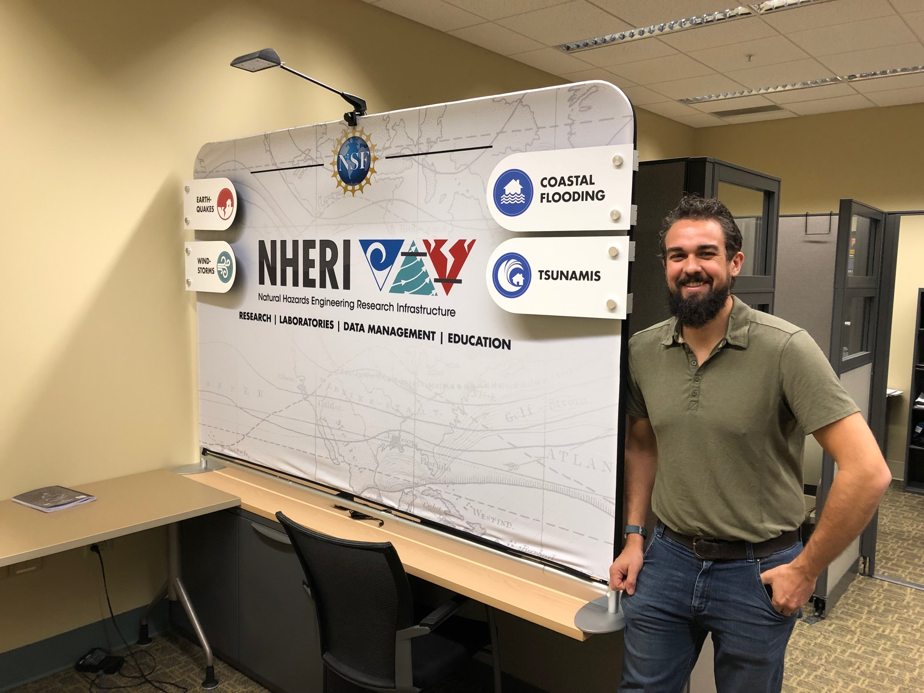
NHERI Booth: The 10-foot booth has been received and is easily transportable in its own case and assembling does not require excessive effort. It will be deployed with a laptop computer and a monitor to show demos, videos etc.

Action Item: Dan will inform the Council when the booth components are ready for deployment. Likely starting sometime in June 2019. Please let the NCO know when you need it for one of your meetings etc. We requested in the supplement some funding to support shipping and staff participation.

NHERI Video: Dan updated the Council on his recent interaction with NSF Office of Public Affairs on this topic. The office is going to assist in the production of the video, including editing and promotion. We will share with them our outline of the intent of the video and key points we want to make, and then start requesting footage from the NHERI components. The NSF staff will then request any additional footage we may need, write a script, and provide voice over as needed. They’ll edit it for us and distribute to their social media and traditional media channels.

Action Item: please share in the NHERI box videos you may wish to have considered for the 90-sec video.

  - CONVERGE (Lori Peek)
- NHERI session at this year's 44th Annual Natural Hazards Workshop (https://hazards.colorado.edu/workshop/2019/schedule). All are welcome!
- Leadership Corps meeting (NSF funded EER's and NHERI NCO, NHERI RAPID, and NHERI DesignSafe) at NSF in April.
- Introduced CONVERGE and associated NHERI facilities and NSF EER networks at the Coalition on National Science Funding meetings in Washington, DC (several science representatives, staff of elected officials, and NSF program directors from other directorates including SBE and GEO attended the event and asked about the "great work" in engineering!). This was part of an advocacy day to request $9B in funding for NSF via the CNSF advocacy network.

  - SimCenter (Matt Schoettler)

Matt informed the Council about two upcoming events in June and July and the planning of the Regional Recovery workshop to be held the first week of October 2019.

Summer workshops (DesignSafe will be advertising these soon). Registration is open for both events and travel stipends are available for need-based applicants.

      - June 13-14: SimCenter Training in Natural Hazards Engineering (a Tool Training workshop)
      - July 22-26: Programming Bootcamp

  - Oregon State University (Pedro Lomonaco)
Pedro informed the Council about the New-User Workshop July 31/Aug 1 in Corvallis, OR. The workshop will also include RAPID. They are inviting Billy Edge from the NCO to talk about the NSF NHERI Science Plan workshop from the coastal perspective.

  - FIU (Arindam Chowdhury)
Informed the Council about the upcoming Facility User workshop on June 14. Registration is open now: Facility User Workshop Registration

- NSF Items (Joy Pauschke)

  - Available to join workshops etc. remotely to provide information related to NSF.
  - Annual Reports- those due on April 30th, if you have not done so please submit and do not forget to send a separate e-mail if supplements are requested.
  - CMMI no proposal submission deadlines- for your expected possible start of award date, back up 6 months from submission date.
  - Follow up on NSF 10 big ideas, i.e. CONVERGE etc., offers possibilities for funding.

- Ongoing Action Items:
  - NHERI-Wide Metrics (All)
NHERI Video (U. of Florida EF, NCO working with NSF and all components)

- Next Meeting- June 13, 2019 2:00 PM EST.
Action Item: Julio will send zoom meeting details to Council and a calendar event.

- Adjourn
Meeting adjourned at 2:55 PM EST.

