Subject: Request for Call Out Box for NHERI Science Plan
Dear Colleagues,
We are requesting your help on a key task related to Version 2 of the NHERI Science Plan. Please read this message, and if you would like to have your facility / component highlighted, please send me a callout box – using the model described below, by September 15, 2019.

The NHERI working group assembling Version 2 of the Plan (for later review by the larger Science Plan Task Group and the Council) is eager to illustrate the impact of the ongoing work in NHERI while highlighting key themes that make NHERI stand out as unique. We are looking for short, visually appealing call out boxes that focus on, for example, the importance of NHERI in terms of:
- the power of shared–use facilities
- how your facility or component encourages multi- and interdisciplinary research collaboration
- how you are training and mentoring a diverse next generation of researchers
- how you are using or integrating disruptive technologies
- how your research facility has contributed to advances in engineering, science, policy, or practice
- how open access to data and high-performance computing resources are advancing the state of knowledge
- the grand challenges you are addressing to improve the resilience of communities against natural hazards

We have prepared three such cases that the working group envisions interspersed throughout the plan text to draw attention to the community contributions towards the goal of NHERI. Note that the general theme is emphasized at the top in bold, and the NHERI facility is named. We also recommend a picture, and a short 3-5 sentence call out box that underscores the key theme. (Joe – Please note we just made up the numbers for the RAPID box! Similarly, Arindam, the case for the WoW is meant to be an example to get readers thinking about the shared use theme and how we might tell the story! We make no claims to accuracy at this stage—just an example!)

We are excited to learn from you and to showcase the work of your facilities. We hope you may choose to write up one or more of these call out boxes. Even if we cannot use all of them in the Science Plan, these may make for great news stories or call out boxes via DesignSafe as well.

Thank you in advance for your time.
Training a Diverse Next Generation of Reconnaissance Researchers – NHERI RAPID

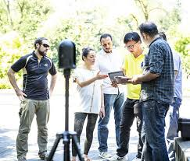
The NHERI RAPID facility is dedicated to advancing natural hazards reconnaissance through the shared use of equipment, tools, and technologies. Since its founding in 2017, RAPID has conducted 13 training sessions for over 72 researchers from diverse disciplinary, geographic, and cultural backgrounds.

Coordinating Rapid Reconnaissance Researchers – NHERI CONVERGE
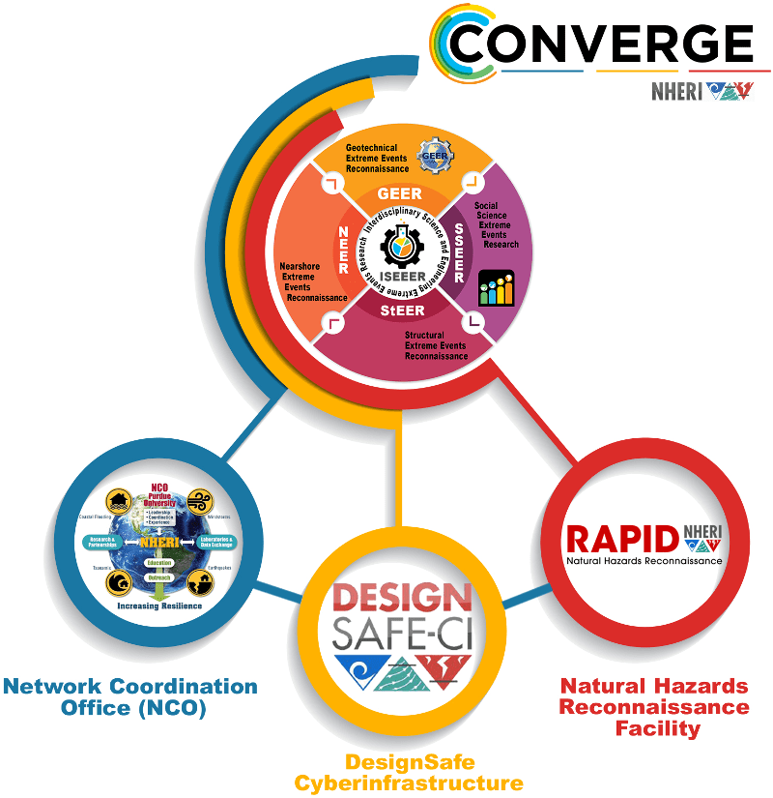

How will the research community respond effectively in the event of a major disaster? NHERI CONVERGE is home to the first-ever disaster reconnaissance Leadership Corps—which includes the leaders of the NSF-funded Extreme Events Research / Reconnaissance networks and the NHERI components that support them. The Leadership Corps is working together to ensure that geotechnical, social science, structural engineering, nearshore, operations and systems engineering, and interdisciplinary research communities are effectively coordinating, communicating, and collaborating as they do scientifically rigorous and ethically grounded work.

Shared Use for a Safer Nation – NHERI Wall of Wind
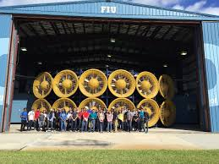
The Wall of Wind at Florida International University is the nation’s largest wind testing facility. Under the NHERI umbrella, it is now open to researchers across the nation. Why does this matter? In 2018, Elaina Sutley, an assistant professor of civil engineering at the University of Kansas was able to use the facility to test the performance of mobile home structures in major wind events. This work would not have been possible at her home University, but now she is able to collaborate through NHERI to help advance community resilience through advancing new mitigation techniques for vulnerable structures.

