NHERI Council Monthly Meeting No. 1 in Y-5
July 2, 2020, 2:00 – 3:00 PM EDT

NHERI Council Summer 2020 Meetings

Topic: NHERI Council Summer 2020
Time: Jun 4, 2020 02:00 PM Eastern Time (US and Canada)
Every month on the First Thu, 3 occurrence(s)
Jun 4, 2020 02:00 PM
Jul 2, 2020 02:00 PM
Aug 6, 2020 02:00 PM
Please download and import the following iCalendar (.ics) files to your calendar system.
Monthly: https://DesignSafe-ci.zoom.us/meeting/tZIpcOygrTosucamLKrH22zZUXNnxZrHOg/ics?icsToken=98tyKuGuqjwvEteUtl3te7YqOZXqbM_ukWRNq65xtw3NUXJJWDbOGOxaCKBXP9-B

Join Zoom Meeting
https://DesignSafe-ci.zoom.us/j/864758316?pwd=ejYwUVZxR3IrZUdnUHd6RzFiSHhaUT09

Meeting ID: 864 758 316
Password: nheri-nco
One tap mobile
+13017158592,,864758316# US (Germantown)
+13126266799,,864758316# US (Chicago)

Dial by your location
+1 301 715 8592 US (Germantown)
+1 312 626 6799 US (Chicago)
+1 646 558 8656 US (New York)
+1 253 215 8782 US (Tacoma)
+1 346 248 7799 US (Houston)
+1 669 900 6833 US (San Jose)
Meeting ID: 864 758 316
Find your local number: https://DesignSafe-ci.zoom.us/u/aee0KiJbWo

Attending:
- Oregon State University: Dan Cox (EF Dir.) and Pedro Lomonaco (Fac. Dir.) Hinsdale
- University of California, Berkeley: Sanjay Govindjee (Co-Dir.), and Matt Schoettler (Assoc. Dir. – Ops), Stanford University: Greg Deierlein (Co-Dir), SimCenter
- University of California, Davis: Ross Boulanger (EF Dir) and Dan Wilson (Assoc. Dir.) CGM
- University of California, San Diego: Joel Conte (EF Dir., Council Chair) LHPOST
- University of Colorado Boulder: Lori Peek (Dir., CONVERGE)
- University of Florida: Forrest Masters (EF Dir.) and Jennifer Bridge (EF Dep. Dir.) Powell Lab
- University of Texas at Austin: Ellen Rathje (CI Dir.) and Tim Cockerill (Dep. Proj. Dir.) DesignSafe-CI)
- University of Texas at Austin: Ken Stokoe (EF Dir.), Brady Cox and Tricia Clayton (Co. Pis), and Farn Yuh Menq (EF Manager) Texas Mobile Equipment Facility
- University of Washington: Joe Wartman (EF Dir.) and Jeff Berman (CoPI and Fac. Manager) RAPID
- National Science Foundation: Joy Pauschke (Prog. Dir, NHERI)
- Purdue University: Julio Ramirez (NCO Dir., Council Secretary), and Dan Zehner (NCO Sch./Ops. Coord.)
- Florida International University: Arindam Chowdhury (EF Dir., Council Vice-Chair), and Ioannis Sizis (CoPI) WOW
- Lehigh University: Jim Ricles (EF Dir.) and Chad Kusko (Facility Manager), ATLSS

Agenda
- Attendance

- Review and Approval of Minutes (previously distributed by e-mail) of Meeting No. 12 (6/4/2020) in Y-4 (Conte)
Approved Minutes are posted at: https://www.designsafe-ci.org/facilities/nco/governance/nheri-council/

- Continuing Business

- COVID-19 Facility Status (All)
- NHERI participation at the Structures Congress (Joe Wartman, Dan Cox)

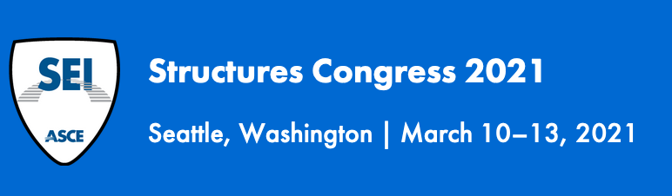

- New Business
  - NSF Items (Joy Pauschke)

- Next Meeting- Aug 6, 2020; 2:00-3:00 PM (EDT)

- Adjourn

