NHERI User Satisfaction Survey of Known NHERI Site Users Results
2020

Maggie Leon-Corwin, M.A.,
Oklahoma State University
Department of Sociology

and Liesel Ritchie, Ph.D.
Virginia Polytechnic and State University
Department of Sociology

Funded by the National Science Foundation, CMMI-1612144.
September 30th, 2020

Table of Contents
Year Four User Satisfaction Survey 3
Overall Findings Summary 3
Item-Level Data 5
Q1-Do you consider yourself an early career researcher? (N=48) 5
Q2-Which of the following best describes your position? (N=49) 6
Q3-Please select your gender. (N=49) 7
Q4-Which of the following best describes your current position in the proposal process for NHERI Facilities and Resources? (N=43)
Q5-How many facilities are you using/have you used? (N=33) 9
Q6-How many proposals have you prepared that used the NHERI Facilities and Resources? (N=33) 10
Q7-How many facilities are you writing proposals for? (N=38) 11
Q8-Which of the following best describes how you intend to utilize NHERI Facilities and Resources? (N=40) 12
Q9A-Information about NHERI Facilities and Resources is Readily Accessible (N=38) 13
Q9B- Information about NHERI Facilities and Resources is Comprehensive (N=38) 14
Q10-Do you have any additional comments regarding information about NHERI Facilities and Resources? (N=10) 14
Q11-NHERI experimental facility staff has provided useful feedback on proposed/ongoing/completed tests. (N=38) 15
Q12-Do you have any additional comments about NHERI Facilities’ and Resources’ staff? (N=4) 15
Q13-Have you participated in any of the proposal writing workshops and/or seminars, or utilized NHERI support resources? (N=37) 16
Q14-Have you requested assistance from NHERI as you write your proposal? (N=37) 16
Q15-Has the assistance you received been helpful? (N=13) 17
Q16-How many times a month, on average, do you use DesignSafe and other NHERI online resources and tools? (N=31) 17
Q17-Regarding NHERI Data: (N=38). 18
Q18-Do you have any additional comments regarding NHERI data? (N=10) 21
Q19A-The training available for online resources and tools meets my needs. (N=40) 21
Q21-What service, tool, or resource not currently in NHERI should be added? (N=2) 23
Q23-The information regarding NHERI in DesignSafe is useful. (N=37) 24
Q24b - Please indicate all of the ways in which you have used the NHERI Science Plan. (N=49) 25
Q25-Do you have any additional comments regarding NHERI services and information? (N=3) 26
Q26 - Do you have any final comments regarding NHERI Facilities and Resources? (N=2) 26
APPENDIX A-Survey Instrument 27
APPENDIX B-Comprehensive Qualitative Response Data by Question 32

NHERI User Satisfaction Research
The National Science Foundation (NSF) requires the Natural Hazards Engineering Research Infrastructure (NHERI) to conduct user satisfaction research yearly for the first five years of the NHERI program. This survey was conducted by the User Forum committee to fulfill this requirement for the fourth year of the program.

Year Four User Satisfaction Survey
The 2020 survey instrument was nearly identical to the 2019 version, with minor question modifications and added demographic questions. Modifications and added demographic questions were designed to yield descriptive data to better inform user satisfaction efforts for year five. Questions featured mixed-response options that captured both qualitative and quantitative data. Building on feedback from the 2019 survey, which was designed to collect data from individuals known to actively engage with NHERI facilities and resources, the committee opted to send the 2020 survey to a targeted population of known NHERI facility users. Known NHERI facility users were identified with assistance from NHERI facility PIs at NHERI experimental facilities. Using the online survey software, Qualtrics, the committee collected data from May 21st, 2020 to June 22nd, 2020. An initial invitation was sent by NHERI leadership to 330 known NHERI site users whose information was shared with the committee by NHERI facility PIs. The initial invitation to participate included a request that those who received the invitation share it with Co-PIs, post-doctoral researchers, graduate students, and other researchers who they knew to have utilized NHERI services, tools, and resources. Two reminder messages were sent following the initial invitation encouraging known site users to complete the survey if they had not already done so. Sixty-one users began the survey, and fifty-seven agreed to participate. Due to the request that known site users share the survey invitation with others known to have utilized NHERI services, tools, and resources, we are unable to calculate a response rate.

Overall Findings Summary
The 2020 survey was constructed to yield both quantitative and qualitative data on various dimensions of user satisfaction. Responses to demographic questions indicate most NHERI facility users are male, hold PI or Co-PI positions, and are not early career researchers.

Feedback derived from quantitative data suggests respondents had positive experiences with NHERI facilities and resources. Regarding interaction with and utilization of NHERI facilities and resources in the proposal process, all respondents were at some point in the proposal and research process. Of the 57 responses received, 25.6% reported were actively performing experiments/using the SimCenter, and 53.5% had either completed experiments or had completed experiments and were working on the next proposal. The remaining 20.9% had not yet begun utilizing facilities or were writing their first proposal. Regarding the intended utilization of NHERI data, 67.5% of respondents reported wanting to both access and use data and produce and upload original data, and only 10.0% reported intending to exclusively utilize pre-existing data.

In the areas of satisfaction with information about NHERI facilities and resources, NHERI staff, scheduling, equipment, support resources, data utilization and interface, and online resources and tools, respondent feedback was largely positive and similar to feedback from 2019. Several questions from the 2017, 2018, and 2019 user satisfaction surveys were repeated in 2020; at basic levels, respondent feedback in 2020 on those questions was as positive as it was in 2019 and more positive than it was in years prior.

Qualitative data on NHERI facilities, staff, and resources yielded some critical feedback that was detailed and constructive, but the majority of respondent feedback was overwhelmingly positive. Even so, given the limited number of respondents compared to the number of presumed active users in the NHERI community, care should be given to putting too much emphasis on both qualitative and quantitative findings presented here. Rather, these results should be used to consider ways to refine and improve NHERI’s offerings.

The findings are discussed in more depth in the following sections, which provide detailed item-level data. A copy of the survey instrument and comprehensive qualitative data are attached to this report as Appendices A and B.

[THIS SPACE INTENTIONALLY LEFT BLANK]

Item-Level Data

This section provides detailed, question-level data. The question in the survey that deals with informed consent and agreement to participate is excluded from this section.

Q1-Do you consider yourself an early career researcher? (N=48)
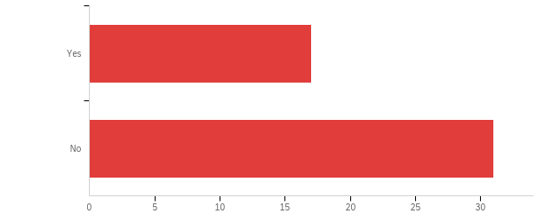
This question was included in the 2020 NHERI user satisfaction survey instrument as part of a trio of questions designed to capture demographic data on user satisfaction survey participants. 64.6% of respondents do not consider themselves an early career researcher, and the remaining 35.4% of respondents do consider themselves an early career researcher.

[THIS SPACE INTENTIONALLY LEFT BLANK]

Q2-Which of the following best describes your position? (N=49)
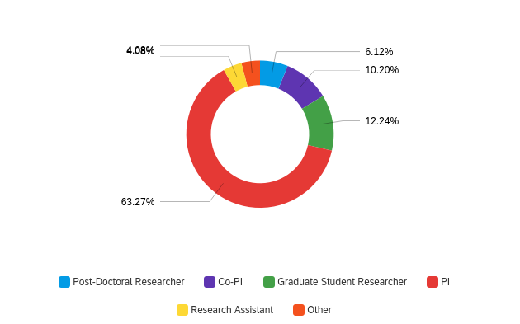
This question was included in the 2020 NHERI user satisfaction survey instrument as part of a trio of questions designed to capture demographic data on user satisfaction survey participants. A majority of participants who took the survey hold PI (63.3%) or Co-PI positions (10.2%). A smaller percentage of participants indicated they were a Graduate Student Researcher (12.2%), Post-Doctoral Researcher (6.1%), Research Assistant (4.1%), or held an ‘Other’ (4.1% position at the time they took the survey.

[THIS SPACE INTENTIONALLY LEFT BLANK]

Q3-Please select your gender. (N=49)
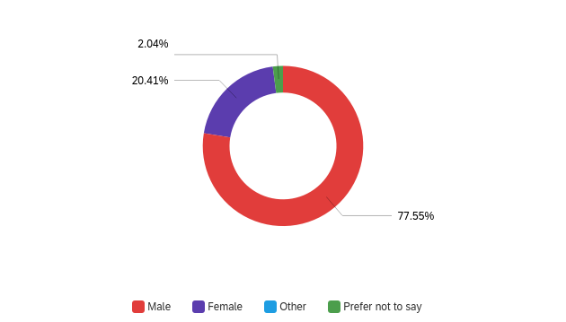

This question was included in the 2020 NHERI user satisfaction survey instrument as part of a trio of questions designed to capture demographic data on user satisfaction survey participants. A substantial majority of participants indicated they identify as Male (77.6%), with a smaller proportion of participants identifying as Female (20.4%). One respondent (2.0%) indicated that they ‘Prefer not to say’ when prompted to select their gender.

[THIS SPACE INTENTIONALLY LEFT BLANK]

Q4-Which of the following best describes your current position in the proposal process for NHERI Facilities and Resources? (N=33)

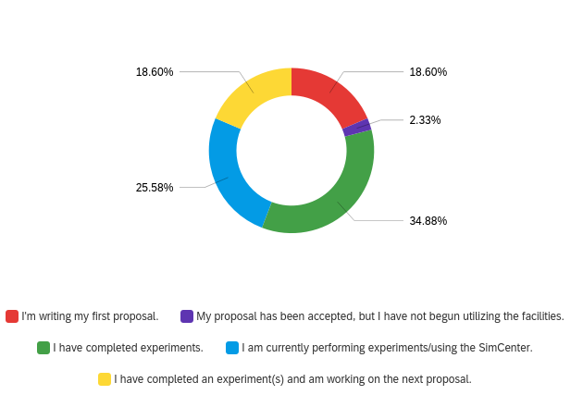
This question was added to the user satisfaction survey in 2018 to provide more details about the NHERI user group’s interaction with NHERI through the proposal process. In 2020, a majority of respondents indicated they had completed experiments (34.9%) or were currently performing experiments/using the SimCenter (25.6%). Remaining respondents indicated they were writing their first proposal (18.6%), had completed an experiment(s) and were working on the next proposal (18.6%), or that their proposal had been accepted, but they had not begun utilizing facilities (2.3%).

[THIS SPACE INTENTIONALLY LEFT BLANK]

Q5-How many facilities are you using/have you used? (N=33)
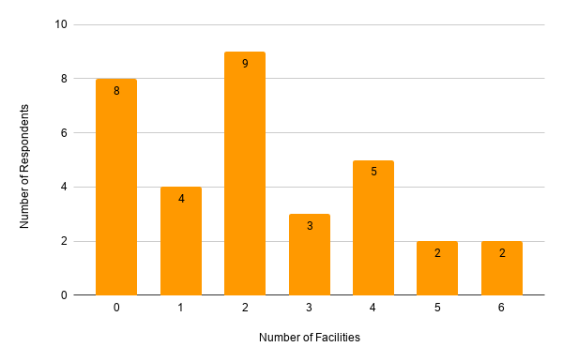
If participants indicated they were currently performing experiments, had completed experiments, or had completed experiments and are working on the next proposal they were asked to report how many facilities they had used or were currently using. Responses to this question ranged from 0 to 6, with most respondents reporting using or having used a single NHERI facility.

Q6-How many proposals have you prepared that usedthe NHERI Facilities and Resources? (N=33)
Most respondents indicated they had prepared one to four proposals that used NHERI facilities and resources, with some reporting they had prepared up to six proposals. A notable number of respondents indicated they had prepared no proposals that used NHERI facilities and resources. This may reflect the number of respondents that had previously indicated they were writing their first proposal.

Q7-How many facilities are you writing proposals for? (N=38)
Most respondents indicated they are writing proposals for at least one facility, with fewer respondents reporting they were not writing proposals for any facility. Moreover, some (but notably fewer) respondents indicated they were writing proposals for more than two facilities.

[THIS SPACE INTENTIONALLY LEFT BLANK]

Q8-Which of the following best describes how you intend to utilize NHERI Facilities and Resources? (N=40)

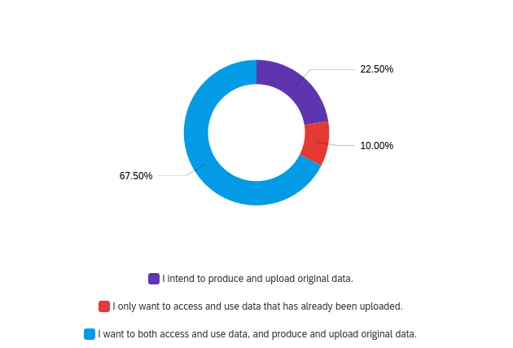

Most respondents (67.5%) reported wanting to both access and use data and produce and upload original data. A smaller proportion of respondents (25.5%) reported intending to produce and upload original data, while the smallest proportion of respondents (10.0%) reported only wanting to access and use data that has already been uploaded.

[THIS SPACE INTENTIONALLY LEFT BLANK]

Q9A-Information about NHERI Facilities and Resources is Readily Accessible (N=38)
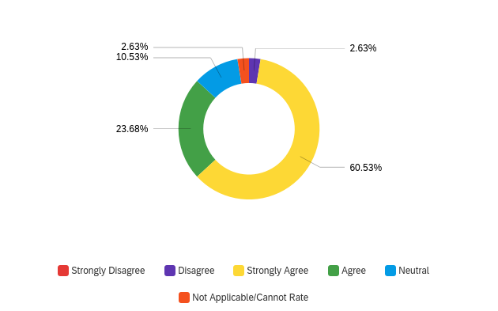A significant majority of respondents indicated they Strongly Agreed (60.5%) or Agreed (23.7%) with the statement that Information about NHERI Facilities and Resources is Readily Accessible, with a very small proportion of respondents indicating they Disagreed (2.6%) with the statement. Remaining respondents indicated that they found the statement Not Applicable/Cannot Rate (2.6%) or were Neutral (10.5%) to the statement.

[THIS SPACE INTENTIONALLY LEFT BLANK]

Q9B- Information about NHERI Facilities and Resources is Comprehensive (N=38)
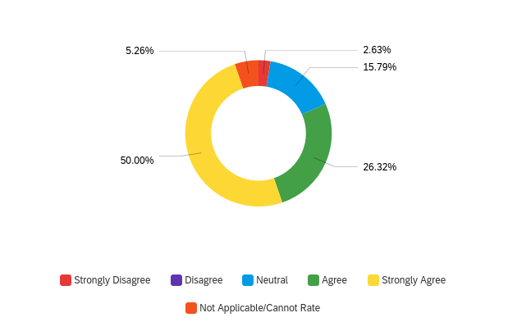
A significant majority of respondents indicated they Strongly Agreed (50.0%) or Agreed (26.3%) with the statement that Information about NHERI Facilities and Resources is Comprehensive, and a very small proportion of respondents indicating they Strongly Disagreed (2.6%) with the statement. Remaining respondents indicated that they found the question Not Applicable/Cannot Rate (2.6%) or were Neutral (15.8%) to the statement.

Q10-Do you have any additional comments regarding information about NHERI Facilities and Resources? (N=10)
Participants were given the option to provide comments regarding information about NHERI Facilities and Resources. Respondents who opted to answer this question delivered constructive commentary on how NHERI could develop more inclusive workshops by making “sketch/CAD drawing or other layouts of facilities available” and noted that an experimental facility for tornado research does not currently exist. Additional, positive comments noted that NHERI facilities are “nice,” they have “great equipment and people,” NHERI is “the best program in the nation”, and NHERI is a “critical NSF program” that should “be funded and supported at the highest possible levels.”

Q11-NHERI experimental facility staff has provided useful feedback on proposed/ongoing/completed tests. (N=38)

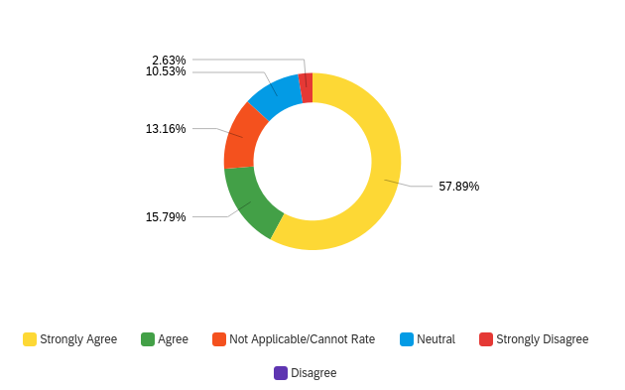

Most respondents Strongly Agreed (57.9%) or Agreed (15.8%) that NHERI experimental staff provided useful feedback, with a smaller proportion of respondents indicating that they found the question Not Applicable/Cannot Rate (13.2%) or were Neutral (10.5%) to the statement. The smallest proportion of respondents indicated they Disagreed (2.6%) with the statement, and no respondents Strongly Disagreed with this statement.

Q12-Do you have any additional comments about NHERI Facilities’ and Resources’ staff? (N=4)
Respondents were again asked to provide additional feedback – this time regarding staff –
in an open-ended manner. Those who provided substantive feedback had positive comments regarding NHERI staff, noting that the staff were “extremely helpful,” “amazing,” and that their help was “invaluable, particularly for instrumentation and planning.”

No respondents described negative experiences associated with NHERI Facilities’ and Resources’ staff, and all comments received regarding NHERI Facilities’ and Resources’ staff, were positive.

Q13-Have you participated in any of the proposal writing workshops and/or seminars, or utilized NHERI support resources? (N=37)
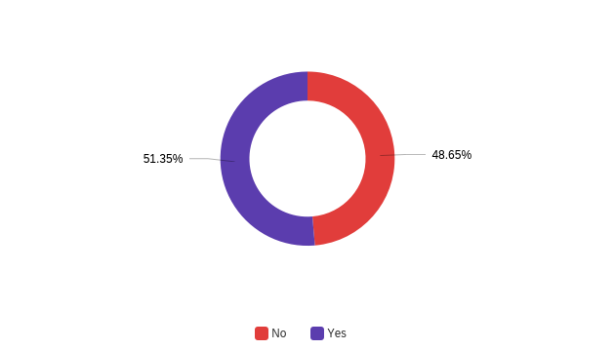
Just over half of respondents (51.4%) reported participating in proposal writing workshops, and/or seminars, or utilizing NHERI support resources. Conversely, just under half of respondents reported not participating in proposal writing workshops, and/or seminars, or utilizing NHERI support resources.

Q14-Have you requested assistance from NHERI as you write your proposal? (N=37)
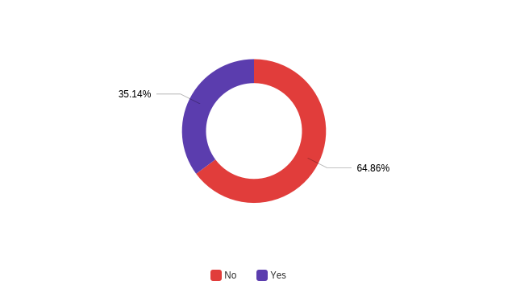
About 35.1% of respondents had requested assistance from NHERI during the proposal writing process, while a majority of respondents (64.9%) did not indicate they requested assistance from NHERI during the proposal writing process. Respondents who indicated they requested assistance were asked a follow up question, discussed below.

Q15-Has the assistance you received been helpful? (N=13)
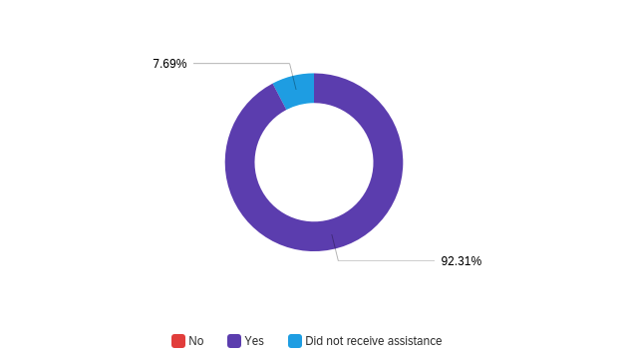
This question was available only to respondents who indicated they had requested assistance from NHERI during the proposal writing process. Of the respondents who requested assistance, an overwhelming majority (92.3%) reported they received assistance and found the assistance useful. Remaining respondents (7.7%) reported they did not receive assistance that had been requested.

Q16-How many times a month, on average, do you use DesignSafe and other NHERI online resources and tools? (N=31)
Respondents reported using DesignSafe and other NHERI online resources and tools on average two times a month, with responses ranging from 0 to 30.

[THIS SPACE INTENTIONALLY LEFT BLANK]

Q17-Regarding NHERI Data: (N=38) Respondents were asked to respond to 5 dimensions of satisfaction with NHERI data. Findings here are generally consistent with responses to corresponding questions from previous surveys.

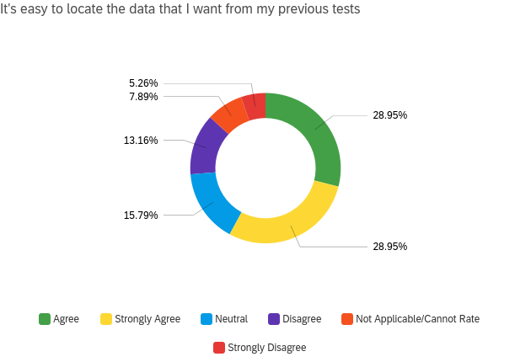

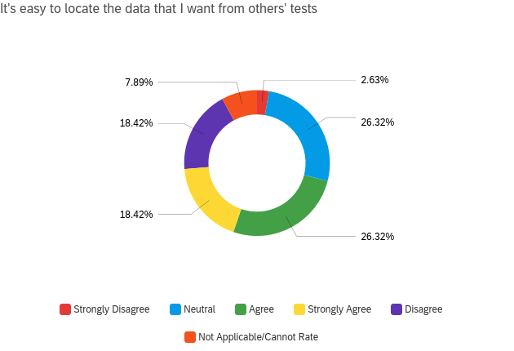
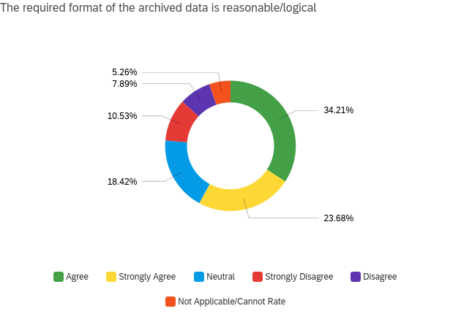
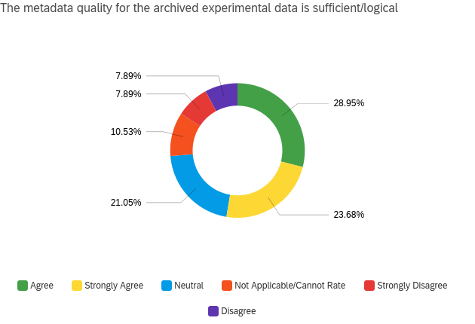
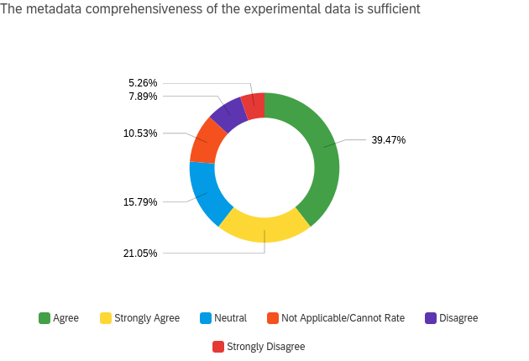
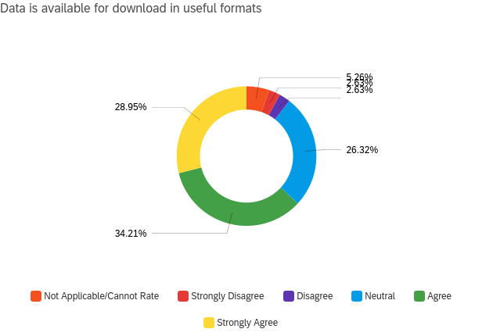

Q18-Do you have any additional comments regarding NHERI data? (N=10)
Participants were also asked to provide comments regarding data. Some respondents described the search engine in DesignSafe as “very poor,” noting that DesignSafe “needs a better search engine.” Another noted that there was “very little descriptive information” included with NHERI data, going on to stress that this made NHERI data “very difficult to understand.” Most of the respondents who answered this question had no additional comments regarding NHERI data.

Q19A-The training available for online resources and tools meets my needs. (N=40)
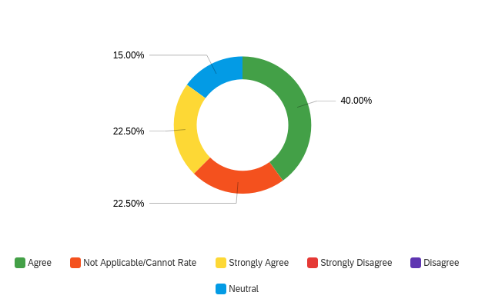
A majority of respondents either Agreed (40.0%) or Strongly Agreed (22.5%) that the training available for online resources and tools meets [their] needs. Remaining respondents were either neutral to the statement (15.0%) or found it Not Applicable/Cannot Rate (22.5%). No respondents Disagreed or Strongly Disagreed with this statement.

Q19B-The technical support for online resources and tools meets my needs. (N=40)
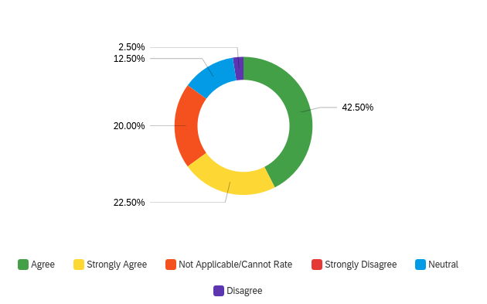
A majority of respondents either Agreed (42.5%) or Strongly Agreed (22.5%) that the technical support for online resources and tools meets [their] needs. The smallest proportion of respondents Disagreed (2.5%) with this statement, and all remaining respondents were either Neutral (12.5%) to this statement or found it Not Applicable/Cannot Rate (20.0%). No respondents Strongly Disagreed with this statement.

Q20-What is the most important change to NHERI’s services, tools, and resources that would improve your experience with them? (N=5)
This open-ended question was designed to elicit qualitative responses that allow respondents to provide feedback regarding NHERI services, tools, and resources. Respondents commented suggesting improvements to website speed and resources. Another respondent suggested improvements be made to the user experience, stressing the importance of data usability and suggesting that “consistent formatting” would help.

[THIS SPACE INTENTIONALLY LEFT BLANK]

Q21-What service, tool, or resource not currently in NHERI should be added? Please specify what need your suggestion is going to meet. (N=2)
As with Question 20 this open-ended question was designed to elicit qualitative responses that allowed respondents to comment on what service, tools, or resources NHERI should add. Suggestions were made to add “computational models to simulate hurricane damage to coastal communities.”

Q22-Information regarding NHERI is distributed at a useful rate and quantity. (N=37)
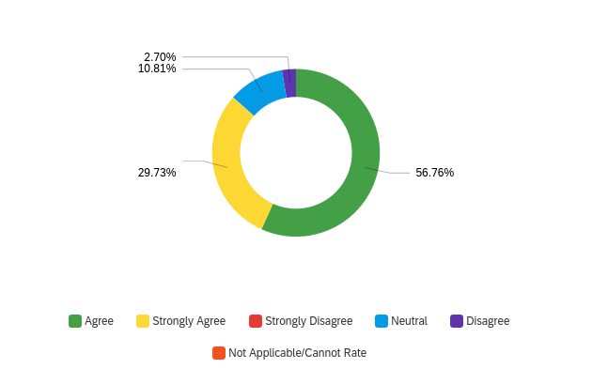
A majority of respondents Agreed (56.8%) or Strongly Agreed (29.7%) that information regarding NHERI is distributed at a useful rate and quantity. The smallest percentage of respondents Disagreed (2.7%), and remaining respondents were Neutral (10.8%) to this statement.

[THIS SPACE INTENTIONALLY LEFT BLANK]

Q23-The information regarding NHERI in DesignSafe is useful. (N=37)
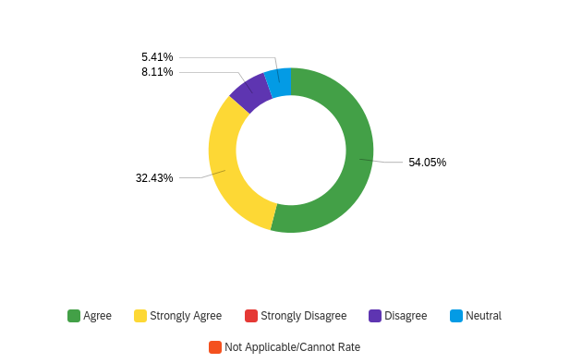
A majority of respondents Agreed (54.0%) or Strongly Agreed (32.4%) that information regarding NHERI in DesignSafe is useful. The smaller percentage of respondents Disagreed (8.1%), and remaining respondents were Neutral (5.4%) to this statement.

[THIS SPACE INTENTIONALLY LEFT BLANK]

Q24a-Have you been made aware of the NHERI Science Plan? (N=37)
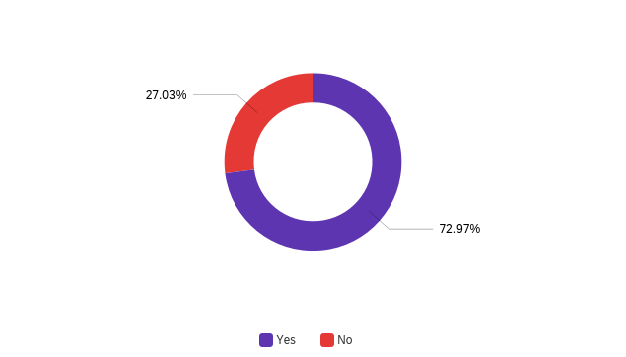
A majority of respondents indicated they were aware of the NHERI science plan (about 73%).

Q24b - Please indicate all of the ways in which you have used the NHERI Science Plan (select all that apply). (N=49)
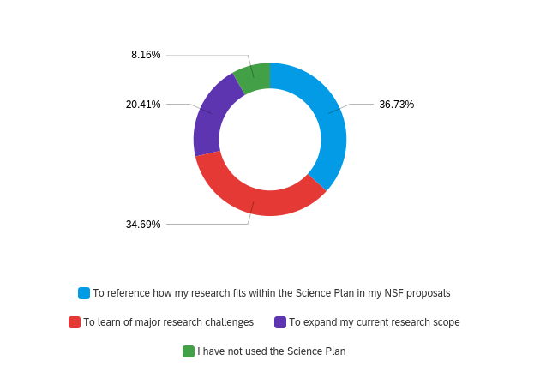
Response options for this question were expanded in 2020 to include the option ‘I have not used the Science Plan’ following results from the 2019 NHERI User Satisfaction Survey Report. Respondents indicated they use the NHERI Science Plan primarily to reference how [their] research fits within the Science Plan in [their] NSF proposals (36.7%), to learn of major research challenges (34.7%), and to expand [their] current research scope (20.4%). The smallest percentage of respondents indicated they had not used the Science Plan (8.2%).

Q25-Do you have any additional comments regarding NHERI services and information? (N=3)
Respondents who opted to answer this open-ended question had no additional comments regarding NHERI services and information.

Q26 - Do you have any final comments regarding NHERI Facilities and Resources? (N=1)
Respondents who opted to answer this open-ended question had no additional comments regarding NHERI services and information.

[THIS SPACE INTENTIONALLY LEFT BLANK]

APPENDIX A-Survey Instrument
Greetings! You have been invited to participate in a user satisfaction survey for the Natural Hazards Engineering Research Infrastructure (NHERI). We greatly appreciate any feedback or comments you may have so that services and user experiences with NHERI may be improved. If you opt to participate in this survey, you will be asked about your experiences using NHERI and related programs based on your experiences in the last year. No personal information will be associated with your responses. Your participation is voluntary, and you may withdraw consent and/or discontinue participation at any time. You may skip questions you prefer not to answer. Completion of the survey should take approximately 8-10 minutes.

Would you like to participate?
a. Yes, I would like to participate in the survey.
b. No, I would not like to participate in the survey.

-If A, then:
Thank you for your participation. Please answer the following demographic questions.

Q1. Do you consider yourself an early career researcher?
a. Yes
b. No

Q2. Which of the following best describes your position?
a. PI
b. Co-PI
c. Post-Doctoral Researcher
d. Graduate Student Researcher
e. Research assistant
f. Other:

Q3. Please select your gender:
a. Male
b. Female
c. Other
d. Prefer not to say

We would now like to ask you questions regarding
how you intend to utilize NHERI Facilities and Resources (i.e., experimental
facilities, DesignSafe, RAPID, CONVERGE, and SimCenter; referred to as "Facilities and Resources" for the remainder of the survey).

Q4. Which of the following best describes your current position in the proposal process for
NHERI Facilities and Resources?

a. I’m writing my first proposal.
b. My proposal has been accepted, but I have not begun utilizing the facilities.
c. I am currently performing experiments/using the SimCenter.
d. I have completed experiments.
e. I have completed an experiment(s) and am working on the next proposal.

-If A then skip to Q6

Q5. How many proposals have you prepared that used NHERI Facilities and Resources?
- Numeric response

Q6. (IF Q2 = b, c, d, e) How many facilities are you using/have you used?
- Numeric response

Q7. (IF Q2 = a, e) How many facilities are you writing proposals for?
- Numeric response

Q8. Which of the following best describes how you intend to utilize NHERI Experimental
Facilities and/or the SimCenter?
a. I want to access and use data that has already been uploaded.
b. I intend to produce and upload original data.
c. I want to access and use data and produce and upload original data (a and b).
-If A, then skip to Q11.

Please respond to the following statements about NHERI experimental facilities.

Q9a. Information about NHERI experimental facilities is readily accessible:
1. Strongly Disagree
2. Disagree
3. Neutral
4. Agree
5. Strongly Agree
6. Not Applicable/ Cannot Rate

Q9b. Information about NHERI experimental facilities is comprehensive:
1. Strongly Disagree
2. Disagree
3. Neutral
4. Agree
5. Strongly Agree
6. Not Applicable/ Cannot Rate

Q10. Do you have any additional comments regarding information about NHERI Facilities and
Resources?
- Open ended

We would like to ask you about NHERI Facilities' and Resources' staff.

Q11. NHERI experimental facility staff has provided useful feedback on
proposed/ongoing/completed tests:
1. Strongly Disagree
2. Disagree
3. Neutral
4. Agree
5. Strongly Agree
6. Not Applicable/ Cannot Rate

Q12. Do you have any additional comments about NHERI Facilities’ and Resources’ staff?
- Open ended

We have some questions regarding NHERI Facilities’ and Resources’ support resources.

Q13. Have you participated in any of the proposal writing workshops and/or seminars, or utilized
NHERI support resources in the past year?
1. No
2. Yes

Q14. Have you requested assistance from NHERI as you write your proposal?
1. No
2. Yes
- (IF Q14 = 2) Has the assistance you received been helpful?
1. No
2. Yes
3. Did not receive assistance

Q15. How many times a month, on average, do you use DesignSafe and other NHERI online
resources and tools?
- Numeric response

Next, we would like to ask a few questions about data and data management with NHERI
Facilities and Resources.

Please respond to the following statements related to data.
Q16a. It’s easy to locate the data that I want from my previous tests:
1. Strongly Disagree
2. Disagree
3. Neutral
4. Agree
5. Strongly Agree
6. Not Applicable/ Cannot Rate

Q16b. It’s easy to locate the data that I want from others’ tests:
1. Strongly Disagree
2. Disagree
3. Neutral
4. Agree
5. Strongly Agree
6. Not Applicable/ Cannot Rate

Q16c. The required format of the archived data is reasonable/logical:
1. Strongly Disagree
2. Disagree
3. Neutral
4. Agree
5. Strongly Agree
6. Not Applicable/ Cannot Rate

Q16d. The metadata quality for the archived experimental data is sufficient/logical:
1. Strongly Disagree
2. Disagree
3. Neutral
4. Agree
5. Strongly Agree
6. Not Applicable/ Cannot Rate

Q16e. The metadata comprehensiveness of the experimental data is sufficient:
1. Strongly agree
2. Disagree
3. Neutral
4. Agree
5. Strongly agree
6. Not Applicable/ Cannot Rate

Q16f. Data is available for download in useful formats:
1. Strongly Disagree
2. Disagree
3. Neutral
4. Agree
5. Strongly Agree
6. Not Applicable/ Cannot Rate

Q17. Do you have any additional comments regarding NHERI data?
- Open ended

Now we have a few questions regarding NHERI online resources and tools.

Q18a. The training available for NHERI’s online resources and tools meets my needs:
1. Strongly Disagree
2. Disagree
3. Neutral
4. Agree
5. Strongly Agree
6. Not Applicable/ Cannot Rate

Q18b. The technical support for NHERI’s online resources and tools meets my needs:
1. Strongly Disagree
2. Disagree
3. Neutral
4. Agree
5. Strongly Agree
6. Not Applicable/ Cannot Rate

Q19. What is the most important change to NHERI’s services, tools, and resources that would
improve your experience with them?
- Open ended

Q20. What service, tool, or resource not currently in NHERI should be added?
Please specify what need your suggestion will meet.
- Open ended

Almost done! We just have a few more questions for you about NHERI services and information.

Q21. Information regarding NHERI is distributed at a useful rate and quantity:
1. Strongly disagree
2. Disagree
3. Neutral`
4. Agree
5. Strongly agree
6. Not Applicable/ Cannot Rate

Q22. The information regarding NHERI in DesignSafe is useful:
1. Strongly Disagree
2. Disagree
3. Neutral
4. Agree
5. Strongly Agree
6. Not Applicable/Cannot Rate

Q23. Have you been made aware of the NHERI Science Plan?
1. No
2. Yes
- (If Q23 = 2) Please indicate all of the ways in which you have used the NHERI Science
Plan (select all that apply).
a. To learn of major research challenges
b. To expand my current research scope
c. To reference how my research fits within the Science Plan in my NSF proposals
d. I have not used the NHERI science plan

Q24. Do you have any final comments regarding NHERI services and information?
- Open ended

Q25. Do you have any final comments regarding NHERI Facilities and Resources?
- Open ended

APPENDIX B-Comprehensive Qualitative Response Data by Question

Q10-Do you have any additional comments regarding information about NHERI Facilities and Resources? (N=10)

They are nice.

This critical NSF program must continue to be funded and supported at the highest possible levels.

NHERI is the best program in the nation.

Would be nice to have sketch/CAD drawing or other layouts of facilities available for PIs to modify

be more inclusive with workshops

NHERI currently does not have an experimental facility for tornado research.

We had a great experience using NHERI@UTexas shakers. Great equipment and people.

no

No.

Q12-Do you have any additional comments about NHERI Facilities’ and Resources’ staff? (N=4)
- Dr. Stokoe and his staff are extremely helpful.
- The staff from the RAPID (Mike) were amazing. It is very helpful to have them join. Similarly, we had an excellent experience at OSU and Pedro was invaluable, particularly for instrumentation planning.
- We had a great collaboration with the staff and PI at NHERI@UTexas field shakers.
- No.

Q18-Do you have any additional comments regarding NHERI data? (N=10)
- Nope.
- NHERI data is extremely significant and timely.
- no
- There is very little descriptive information included with these data. So it is vey difficult to understand.
- Is there a download API? It will be great if I can download using wget or curl, etc, from command line.
- Search engine in DesignSafe is very poor.
- Na
- DesignSafe needs a better search engine.
- No.
- These answers could change drastically depending on perspective. Am I rating the data I put up there (obviously excellent) or am I rating metadata and projects for others? It is impossible to rate it in general because I have only sampled a few projects besides my own. Some are very good and others are not evaluated.

Q20-What is the most important change to NHERI’s services, tools, and resources that would improve your experience with them? (N=5)
- Resources.
- Easier user experience. Data is the main thing that is useful there, so consistent formatting would help.
- NA
- Website speed.

Q21-What service, tool, or resource not currently in NHERI should be added? Please specify what need your suggestion is going to meet. (N=1)
- computational models to simulate hurricane damage to coastal communities

Q25-Do you have any additional comments regarding NHERI services and information? (N=3)
- No
- None.
- Odd that this survey did not ask about SimCenter tool

Q26 - Do you have any final comments regarding NHERI Facilities and Resources? (N=2)
- No
- None.

