NHERI Council Monthly Meeting No. 5 in Y-5
November 5, 2020, 2:15 – 3:15 PM EDT

NHERI Council - Fall 2020 Meetings
Time: 02:15 PM Eastern Time (US and Canada), every month
Sep 3, 2020 02:15 PM
Oct 1, 2020 02:15 PM
Nov 5, 2020 02:15 PM
Dec 3, 2020 02:15 PM

Join Zoom Meeting
https://DesignSafe-ci.zoom.us/j/95715546066?pwd=NlhnZTNTc1BSV3U3ZzBiampDL0ZZdz09

Meeting ID: 957 1554 6066
Passcode: nheri-nco
One tap mobile
+13017158592,,95715546066# US (Germantown)
+13126266799,,95715546066# US (Chicago)

Dial by your location
+1 301 715 8592 US (Germantown)
+1 312 626 6799 US (Chicago)
+1 646 558 8656 US (New York)
+1 253 215 8782 US (Tacoma)
+1 346 248 7799 US (Houston)
+1 669 900 6833 US (San Jose)
Meeting ID: 957 1554 6066
Find your local number: https://DesignSafe-ci.zoom.us/u/abK1sU7ACG

Attending:
- Oregon State University: Dan Cox (EF Dir.) Hinsdale
- Stanford University: Greg Deierlein (Co-Dir), SimCenter
- University of California, San Diego: Joel Conte (EF Dir., Council Chair) LHPOST
- University of Colorado Boulder: Lori Peek (Dir., CONVERGE)
- University of Florida: Forrest Masters (EF Dir.) and Jennifer Bridge (EF Dep. Dir.) Powell Lab
- University of Texas at Austin: Ellen Rathje (CI Dir.), Tim Cockerill (Dep. Proj. Dir.), and Hedda Prochaska DesignSafe-CI)
- University of Texas at Austin: Farn Yuh Menq (EF Manager) Texas Mobile Equipment Facility
- University of Washington: Joe Wartman (EF Dir.) RAPID
- National Science Foundation: Joy Pauschke (Prog. Dir, NHERI)
- Purdue University: Julio Ramirez (NCO Dir., Council Secretary), and Dan Zehner (NCO Sch./Ops. Coord.)
- Florida International University: Steven Diaz (EF Manager)
- Lehigh University: Tommy Marullo (EF IT manager), ATLSS

Minutes
- Attendance
(See above)

- Review and Approval of Minutes (previously distributed by e-mail) Meeting No. 4 (10/01/20) in Y-5 (Conte)

Lori moved approval of the minutes as distributed, and Ellen seconded. Minutes approved without objection.

Approved Minutes are posted at: https://www.designsafe-ci.org/facilities/nco/governance/nheri-council/

- Continuing Business

- Design Safe-CI: update on the website re-design (10’) (Ellen Rathje and Hedda Prochaska)
Ellen Rathje and Hedda Prochaska described the status of the facing outward pages of DesignSafe-CI and received feedback from the Council. They will continue working on the pages and will take up the input. The presented material can be found at:
https://xd.adobe.com/view/cca67126-a94d-401d-42dd-44c7e8ff1f76-ba97/

- AGU Virtual Booth: on the 9/03 meeting NCO asked the Council to think about a possible NHERI participation at the virtual AGU meeting in December 2020. (5’) (Dan Zehner)
Dan shared the link to a video on the current status of the virtual booth and solicited material from the NHERI components to include in it, and names to staff the booth. The NCO offered to support 5 registrants to the conference that would also agree to staff the booth. Staffing details can be discussed with Dan regarding time availability and also possible office hours. There will be two windows to provide the material. One is by November 10, and the second one is from Nov. 20 to 25, before the booth goes live on December 1.

Action Item: provide material and names of volunteers to staff the booth.

- International Collaborations Status (5’) (Julio Ramirez)
Julio updated the Council on two upcoming virtual meetings related to the international collaborations of NHERI. One is on Dec. 15th from 11:00 AM – 2:00 PM Eastern with EUCentre, and the other one is with E-Defense on December 16th from 8:00 to 11:00 PM Eastern. There will be a webinar on December 9th at 3:00 PM Eastern to provide information on these collaborations primarily aimed to early career researchers. Registration information for all three events will be available via DesignSafe-CI. Please stay tuned.

- NHERI CONVERGE Updates (5’) (Lori Peek)
  - Publish Your Data! Event Materials
  - CONVERGE Extreme Events Research Check Sheets
Lori provided brief updates on both important events.

- COVID-19 Facility Status (15’) (All)
Brief updates were provided by some of the facilities. UCSD now is looking at October 2021 for the reopening of the shake table. RAPID has reverted to online only as the University of Washington has gone in that direction.
- NHERI participation at the SEI Congress (Joe Wartman) and EMI Conference 2021 (Sanjay Govindjee)
SEI: because of the switch back to online the plans to use campus to host a workshop have been suspended. This item will be removed from subsequent agendas until there is new information to update the Council.

EMI: No updates; although, it seems that EMI is going online also.
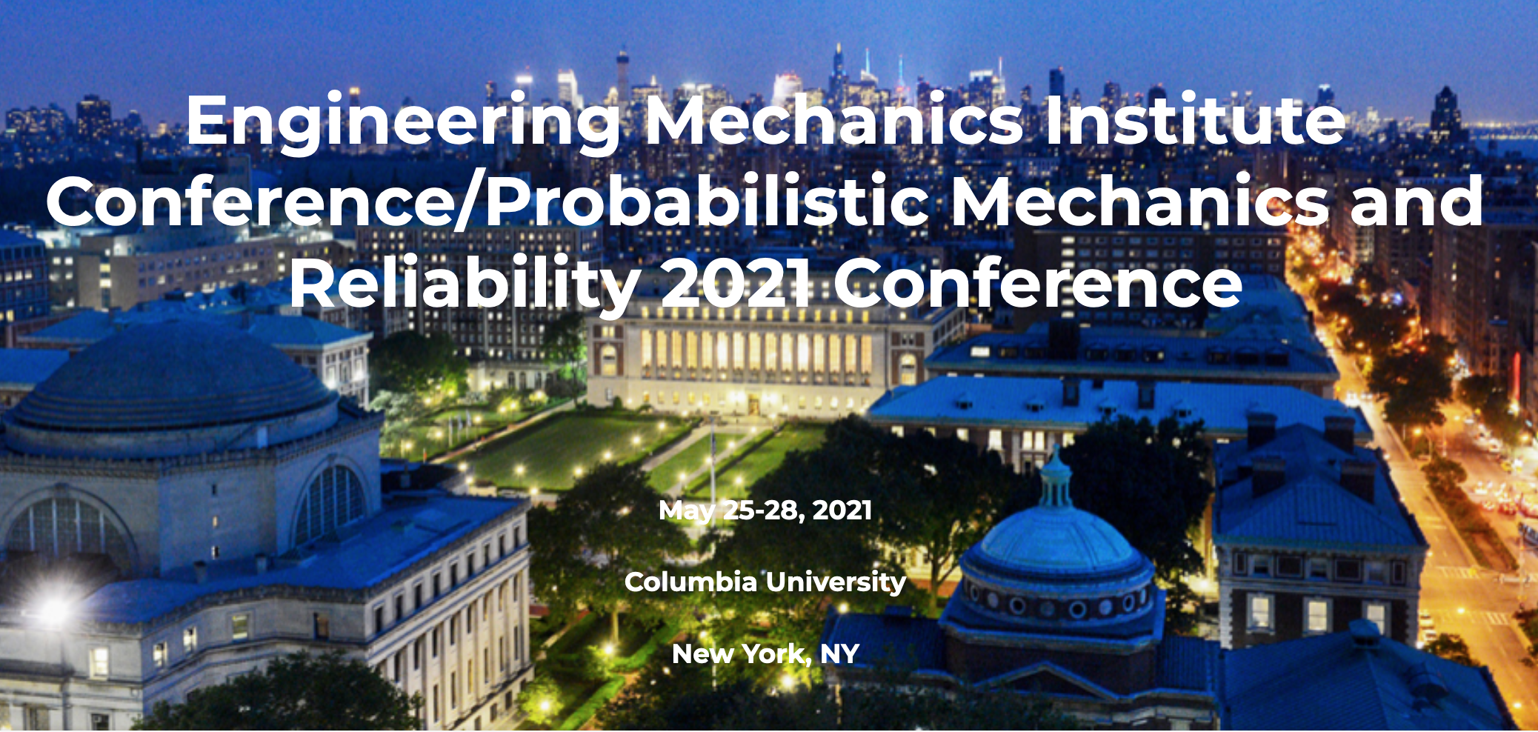
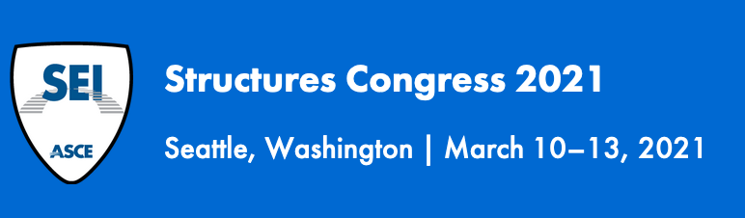

- New Business
  - NSF Items (Joy Pauschke)
Updates on the Midscale Research II competition.
b) Other items
    - Schedule of Council Meetings from January-May, 2021
Julio asked the Council to confirm that the current schedule works for next year’s meetings.

- Adjourn
Meeting adjourned at 2:59 PM Eastern.

