NHERI Council Monthly Meeting No. 10, Y-6
April 7, 2022 02:00 – 3:00 PM EDT

NHERI Council – Spring 2022 Meetings

Topic: NHERI Council - 2022
Time: Apr 7, 2022 02:00 PM (US and Canada)
Every month on the First Thu, until May 5, 2022, 5 occurrence(s)
May 5, 2022 02:00 PM

Please download and import the following iCalendar (.ics) files to your calendar system.
Monthly: https://DesignSafe-ci.zoom.us/meeting/tJUtfuCprjMtG9Hqq8sjgehkA7W5FWSo-rhN/ics?icsToken=98tyKuCprjIjG9SdtxiCRowcAor4XevziFxajfp1jQ69ECpUZwv9F7V1Z5RII9ed

Join Zoom Meeting
https://DesignSafe-ci.zoom.us/j/91099108715

Meeting ID: 910 9910 8715

Attending:
- Oregon State University: Pedro Lomonaco (Fac. Dir.) Hinsdale
- University of California, Berkeley: Matt Schoettler (Assoc. Dir. – Ops), Stanford University: Greg Deierlein (Co-Dir), SimCenter.
- University of California, Davis: Ross Boulanger (EF Dir) CGM
- University of California, San Diego: Joel Conte (EF Dir.,) LHPOST
- University of Colorado Boulder: Lori Peek (Dir., CONVERGE)
- University of Florida: Jennifer Bridge (EF Dir. and Council Vice-Chair) Powell Lab
- University of Texas at Austin: Ellen Rathje (CI Dir.) DesignSafe-CI)
- University of Texas at Austin: Ken Stokoe (EF Dir.) Texas Mobile Equipment Facility
- University of Washington: Michael Grilliot (Operations Manager) RAPID
- National Science Foundation: Joy Pauschke (Prog. Dir, NHERI)
- Purdue University: Julio Ramirez (NCO Dir., Council Secretary), and Dan Zehner (NCO Sch./Ops. Coord.)
- Florida International University: Arindam Chowdhury (EF Dir., Council Chair) WOW
- Lehigh University: Jim Ricles (EF Dir.) ATLSS

Minutes
- Attendance

- Review and Approval of Minutes (previously distributed) Meeting No. 9, 3/3/22 in Y-6 (Jennifer Bridge)

Attendance: see previous page.

Approval of Minutes: Minutes of Meeting No. 9 3/3/22 were approved as distributed, with Lori moving approval and Ellen seconding the motion.

Approved Minutes are posted at: https://www.designsafe-ci.org/facilities/nco/governance/nheri-council/

- Continuing Business

- Update NHERI Researchers Meeting. (Jennifer Bridge and Julio Ramirez, 10’)

1. Program Planning Work: Currently finalizing speakers in Day 1. Invitations have been extended to Keynote Speaker, and Fed. Panel speakers. Reggie DesRoches is confirmed as keynote speaker. Work continues on Ted-Talk style session on Day 1. Survey out to the community to help TG identify NHERI program priorities in Day 2.

2. Conference website and registration mechanism work has commenced, go-live date May 1, 2022.

3. Save the date message is being distributed through all NHERI social media channels, DesignSafe-CI, and reaching out to partners like the Hazards Research Center, EERI, NIST Resilience Center and similar others.

- NCO Items (5 minutes)
  - Sharing data on where attendees heard about registrations for facility events.

The SimCenter kindly shared with the NCO data on events such as 9 Live Expert Tips, 2 Tool trainings and its Community Meeting. This type of information is extremely valuable for the NCO communications team to know the effectiveness of our various means of communication. NCO asked other EFs to please do something similar.

- Facility status updates (All)

- RAPID: supporting data collection in burn zones.
- OSU: supporting researchers in various projects at the facility.
- CONVERGE: data collection in burn zones.
- U of Florida: supporting researchers and working on upgrades.
- UC Davis: supporting research in several bioinspired projects, hiring, contacting career grantees to disseminate facility capabilities and availability to support their research.
- UC San Diego getting ready to reopen.
- NCO: implementing REU program and Summer Institute. Planning the Research Summit in October 2022 and the Science Plan workshop in June 2022.
- Lehigh: preparing to support new projects, researchers workshop and working MECHS, FIU on wind related hybrid simulation efforts.
- RAPID: data collection in multiple fronts in the USA and Germany. Holding one-day workshops, and awarding several grants in the Graduate Scholars Program.
- DesignSafe: new data set awards, and announcing the FEMA data availability.
- SimCenter: several activities with other NHERI facilities in simulation and data.

- New Business

NSF pointed out changes to the ECI information.

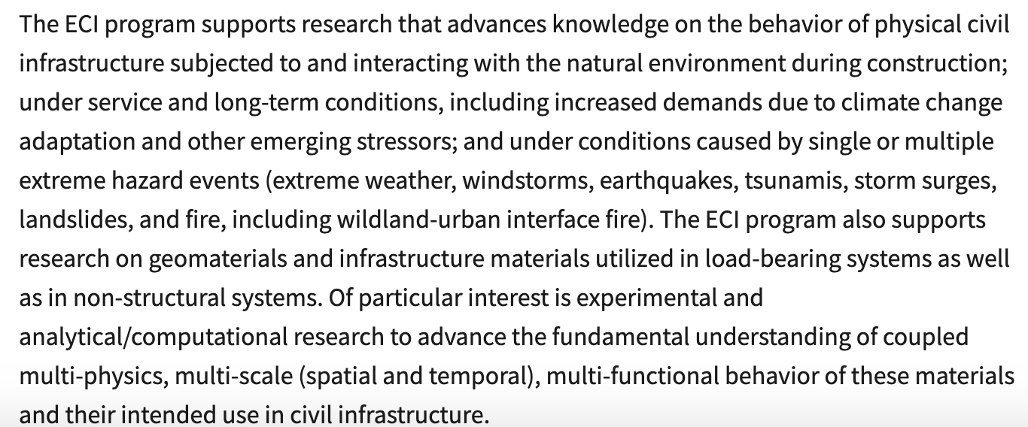

- Adjourn
Meeting adjourned at 3:12 PM Eastern.

