Natural Hazards Research Summit Feedback
October 24th 2022, 10:07 am PDT
Q6 - Role
# | Answer | % | Count
1 | Graduate Student | 21.77% | 27
2 | Postdoctoral Scholar | 5.65% | 7
3 | Early career faculty (e.g. non-tenure track instructor, untenured, etc) | 25.00% | 31
4 | Mid/late career faculty | 30.65% | 38
5 | Federal employee | 2.42% | 3
6 | Private Sector | 4.03% | 5
7 | Other (please specify) | 10.48% | 13
 | Total | 100% | 124
Q6_7_TEXT - Other (please specify)
Other (please specify) - Text
data curator
Research Engineer (might be included in Early career faculty; I was not sure)
retired
Facility Manager
Research Engineer
TTC member
Research Associate
Non-profit staff (mid-level) and grad student
Research engineer
NHERI Site Operations Manager
Faculty - professor
Recently tenured faculty
Professor of structural engineering

Q7 - Did you attend the Summit?

# | Answer | % | Count
1 | Yes, I attended both Day 1 and Day 2 | 93.55% | 116
2 | Yes, but I attended only Day 1 | 1.61% | 2
3 | Yes, but I attended only Day 2 | 3.23% | 4
4 | No, I registered but I was unable to attend either day | 1.61% | 2
 | Total | 100% | 124

Q8 - 7. Did you receive travel assistance from the NHERI NCO or receive other NSF support to attend?
# | Answer | % | Count
1 | I received a NHERI NCO travel award to attend | 37.90% | 47
2 | I used other NHERI funds to attend | 20.97% | 26
3 | I used other NSF funds to attend | 9.68% | 12
4 | I used other non-NSF funds to attend (e.g. faculty startup, company reimbursement) | 12.10% | 15
5 | I was self-funded to attend | 15.32% | 19
6 | Other | 4.03% | 5
 | Total | 100% | 124

Q8_6_TEXT - Other
Other - Text
Partial for NIAC, I think
I live in DC area
I received a professional development award from my home institution.

Q10 - What was your overall level of satisfaction with the TIMING of the Summit in October?
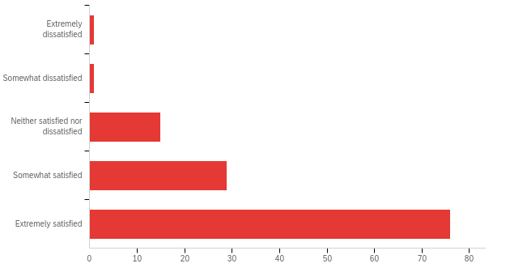
# | Answer | % | Count
1 | Extremely dissatisfied | 0.82% | 1
2 | Somewhat dissatisfied | 0.82% | 1
3 | Neither satisfied nor dissatisfied | 12.30% | 15
4 | Somewhat satisfied | 23.77% | 29
5 | Extremely satisfied | 62.30% | 76
 | Total | 100% | 122

Q11 - Comments on the timing of the Summit in October:
Two days seemed appropriate. Overall, summers work better for conferences.
The timing was great. The summit happened in the middle of the Fall semester, which was not too early or too late in the semester.
good weather - good timing in the semester
the timing was ideal for my schedule
Decent weather in a place like DC that time of year. October (Fall semester) is generally pretty busy on the downside.
The travel was a bit difficult due to the conflict with the Fall class schedule.
This was the first week of class at our institution. I’m not sure there’s a good time for everyone so I don’t have any very constructive feedback.
October is peak hurricane months. I try to avoid travelling in October in case a storm is making its way to my home. Early summer or later in the fall is better.
Any time during the academic year can be tough, but generally good.
Only issue is that it is around peak hurricane season. Not worth planning around hurricanes though.
If the meeting could move to a Weekend, it would be better.
Timing was perfect, no comment on that.
Great weather and not a very busy part of the semester
EVERYTHING is scheduled now. October is a bad time.
I think it could be scheduled for some time out of hurricane season.
It was a little hard to manage with classes but I was very happy that it ran into a holiday weekend and was held at the end of the week so it was not too disruptive.
It was a little tough given it was the day after Yom Kippur, but it was managed. I do like that it was Thu/Fri.
It was ok. Just a bit after midterms, but it was fine.
October is a good month to travel east!
The start of the new federal Fiscal Year is an excellent time for a meeting
Good timing! It was the Thursday and Friday before our Fall Break, so I only had to schedule one guest lecture in my course in order to attend.
It was challenging to manage missing classes I'm teaching. I would have preferred dates in August or September.
Good timing for me.
While I believe that the general timing of the Summit in October is fine, I do think that perhaps more consideration should be given to the specific start time of the event. An 8:00 AM start time is prohibitive for those of us with caretaking or child care responsibilities, most daycares do not open until 8. Please consider a later start time to accommodate those of us with child care responsibilities.
This is a beautiful time to have a summit, also it aligns with fall break of many institutes.
nice weather in DC
Great timing. No issues, no conflicts.
Summer would be better to avoid conflict with classes.
Could remove this one
Fall semester is ok, but spring term woudl be better
PERFECT!!!!!

Q12 - What was your overall level of satisfaction with the LOCATION of the Summit in Washington, DC?
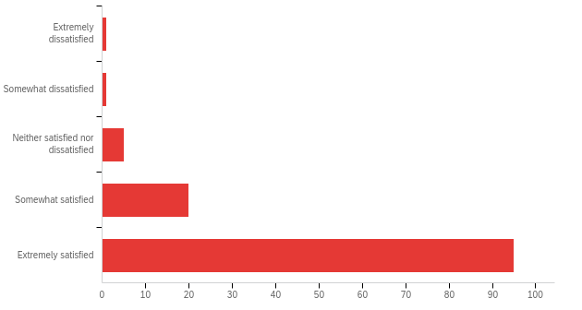
# | Answer | % | Count
1 | Extremely dissatisfied | 0.82% | 1
2 | Somewhat dissatisfied | 0.82% | 1
3 | Neither satisfied nor dissatisfied | 4.10% | 5
4 | Somewhat satisfied | 16.39% | 20
5 | Extremely satisfied | 77.87% | 95
 | Total | 100% | 122

Q13 - Comments on the location of the Summit in Washington, DC:

Comments on the location of the Summit in Washington, DC:
D.C. is accessible with direct flights to many locations.
The location was great, especially for the policy-minded social scientist that I am.
Holding both days near the conference hotel would have been preferable.
limited meal options for people with dietary restrictions both at the hotel and summit location
While it would have been nice to stay at the same location for the purposes of hotel selection, I really enjoyed NASEM and appreciate that there is not the same level of flexibility in terms of meeting space there. In all, I think the planning team did a great job!
The first day was awesome. Crystal City is not a welcoming place. I didn't even want to leave my hotel. Another place in DC would have been better.
Venue was great and location was convenient. There were a lot of flight options.
The hotel was close to DCA airport, maybe a bit overpriced, given the fact that for the first day not even breakfast was included in the price.
Day 1 at the National Academy of Sciences was really fun and immersive
One stop on the metro from DCA is great.
-
Having two venues was a bit complicated. Otherwise, I really liked that the summit was in DC. Individually both venues were good.
Would have been great if both days were in the same location, though.
Perfect location
The travel requirements for Day 1 were a bit involved and made for a very early start to the day but the National Academies Building was a special place and lent a special ambiance to the Summit.
Convenient location in Crystal City, and it was great to use the National Academy of Sciences building on Day 1 - a great venue.
Convenient to get to, and I enjoyed the first day at the National Academy of Sciences building.
Beautiful city and a great location for the summit
The day one venue was excellent and matched the ambitions for the "big tent" day of the meeting.
Very convenient to have it in DC for traveling and finding a convenient hotel to stay
Should have been in the same location for both days.
The National Academy of Science and hotel venues were both excellent.
Great location.
easily accessible location near airport
The venue at NAS was great, the room was excellent and the audiovisual worked very well. The hotel was also good, with some small issues with the audiovisuals. The breaking rooms were OK, even though the TV screens where presentations were displayed were a bit small.
Yes, DC is good. But might be good to have the next one somewhere else just to move thing around
Loved the NAS kavli auditorium and the Gateway Marriott for the 2nd day

Q14 - What was your overall level of satisfaction with the DURATION of the Summit over a 2-day period?
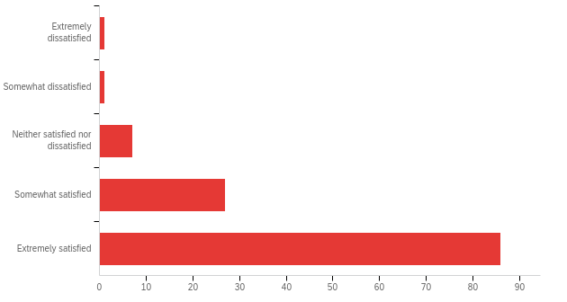
# | Answer | % | Count
1 | Extremely dissatisfied | 0.82% | 1
2 | Somewhat dissatisfied | 0.82% | 1
3 | Neither satisfied nor dissatisfied | 5.74% | 7
4 | Somewhat satisfied | 22.13% | 27
5 | Extremely satisfied | 70.49% | 86
 | Total | 100% | 122

Q15 - Comments on the duration of the Summit over a 2-day period:

Comments on the duration of the Summit over a 2-day period:
2 days was just enough time for the summit. Enough time to not be away from school or work too long, but also enough time for all the events and sessions.
The timing seemed appropriate when I made my reservations. I was not able to attend due to Covid, so my response is base entirely on my prevent perception.
The first day was probably too long. Maybe having 3 shorter days may be better
Two days seems like the perfect amount of time.
It was a perfect length. My only minor comment would be to end a tiny bit earlier so is West Coasters could’ve caught a plane home on Friday.
I thought it was a good balance of high-level discussion in Day 1 followed by more technical topics in Day 2.
While I understand the significant scheduling limitations of space and scheduling, doing slightly less intensive days over 3-4 days or having 3-4 days with more panel sessions featuring emerging research and innovation, data workshops, etc. would have been even better.
I believe the 2 full days were a good duration without over-burdening participants and their schedule.
The schedule was planned well. I was recently at a 3-day event that extended well into the evening. This one was much better
1.5 day is better.
I think the event could be slightly longer.
I found both days extremely valuable and the fact that it was only 2 days was really amazing.
Two full days might be a bit long.
It was very dense, full of very useful information! Maybe a third day would have helped to digest and connect even more, but it is also true that taking two days off in the middle of the semester is easier than taking three. So, in the end, the two days duration was great, the only suggestion- maybe we should do it more often!
A short concentrated meeting is best.
The duration allowed a good mix of TED style talks and panels on day 1, with working sessions on day 2.
It would have been nice to have 3 days and some more breaks to see sights around DC if the summit hadn't been scheduled during academic instruction. But with it being in October, 2 days was the maximum time I could have spent at the summit.
The schedule was compact for two days.
The technical quality of the day two sessions was excellent with fascinating panel discussions and high-quality research presentations.
Perfect amount of time.
The first day provided many high level ideas and we have put them into a further discussion the 2nd day. A great timeline for an informative and productive event.
nicely paced 2-day summit
It is always a challenge to have two full days because of travel. One day and a half or so usually works better, so people attending can catch flights in the afternoon.
Only a minor issue on the tail end of the excellent summit. For west coast travelers when travel funding is insufficient, perhaps the last day should be wrapped up by 2pm so we don't have to spend an extra night where hotels are not cheap.
yay

Q16 - What was your overall level of satisfaction with the theme of Decadal Visioning for NHERI
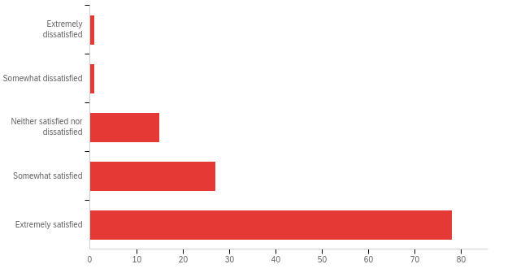
# | Answer | % | Count
1 | Extremely dissatisfied | 0.82% | 1
2 | Somewhat dissatisfied | 0.82% | 1
3 | Neither satisfied nor dissatisfied | 12.30% | 15
4 | Somewhat satisfied | 22.13% | 27
5 | Extremely satisfied | 63.93% | 78
 | Total | 100% | 122

Q17 - Comments on the theme of Decadal Visioning for NHERI:
Comments on the theme of Decadal Visioning for NHERI:
Normally, I am not involved with NSF as it is focused on fundamental research that may eventually be transitional in nature, whereas I am focussed on moving methods from research to practice. I saw in the agenda for this meeting that implementation was a topic so I attended the meeting. From the discussion/presentations, NSF has jumped from fundamental research all the way to getting local agencies to adopt and implement current building codes to reduce losses in future natural disasters. I think that this approach skipped several intermediate steps that are needed and which interface better with the researchers. The presentations on successful implementation dealt with cases after a disaster. It is relatively easy to get a code change after a failure, but it is much harder to get a change before a disaster based only on research results of what might happen.
I liked the crowd-sourcing of ideas
I liked the theme and breakout visioning sessions on Day 2. I'd encourage more of that type of activity/engagement.
Theme is really complex and it is multi-faceted. It is hard to get a single direction when different engineering disciplines are involved and different problems need to be tackled.
Only concern is I don't have a better understanding of what the community's plans are after 2025, although the vision was pretty well laid out.
OK
I would rather more engineering discussions.
I wish there was more of a focus on emerging issues like extreme heat and wildfire.
Tracy Kijewski-Correa & Jennifer Bridge did an excellent job of facilitating the vision sessions. It is vital that we work together to create our vision that is linked to our research agendas and ideas for reducing the impact of natural hazards in the real world. Well done!
Important work
Great theme to get everyone on the same page and move forward!
It was a timely topic for NHERI
An interesting and valuable chance to hear others thoughts on future directions, and to contribute to those conversations.
As an early career faculty, I found it extremely valuable and inspiring to learn about and discuss decadal visioning
Too much emphasis on social science was overwhelming
I liked the fact that every intervention and talk was oriented towards urgent topics our communities must face. The theme couldn't have been better chosen
Theme was appropriate and needed, many early career attendees did not understand what this was or the opportunity presented to them. They did not come with visions of infrastructure needs to solve grand challenges.
The idea of having a visioning session isn't bad, but the execution could have been better. Giving everyone's comment a sticky note got really out of hand.
I think the vision should have been articulated better or the goal of the summit should have been pushed forward more decisively. We talk about things we would like to do, research needed, but there was no discussion on a plan/vision.
It was ok, but could have been better. not bad though

Q19 - What was your overall level of satisfaction with the VENUE for Day 1 at the National Academies of Sciences Building?
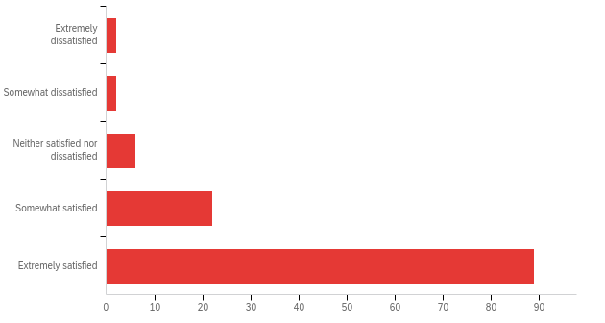

# | Answer | % | Count
1 | Extremely dissatisfied | 1.65% | 2
2 | Somewhat dissatisfied | 1.65% | 2
3 | Neither satisfied nor dissatisfied | 4.96% | 6
4 | Somewhat satisfied | 18.18% | 22
5 | Extremely satisfied | 73.55% | 89
 | Total | 100% | 121

Q20 - Comments on the Venue for Day 1 at the National Academies of Sciences Building:

Comments on the Venue for Day 1 at the National Academies of Sciences Building:
The seats in the lecture hall of the National Academy of Sciences were rather uncomfortable for the length of time we were expected to sit. I heard other people also complain about how they weren't very supportive
This was a very cool location to host this event! I just wish the hotel was also right there.
Really nice venue, maybe getting there was a bit tricky. But overall really great!
Very cool. Great location for my first time in DC
Beautiful building but the networking event / design could have been better.
It was fine, though I would have preferred not having to finish my coffee before entering the auditorium. The echo in the auditorium was absolutely horrendous.
The building is beautiful, and the stage room was perfect to accommodate all the participants. I changed seats many times during the day, and I felt engaged with the speaker from every location I sat in (probably this is also to the speakers' merit). It also had that "TED talk-style" aura that made the whole day very enjoyable to me.
Great spot, and reasonably convenient to get to from Foggy Bottom metro station.
The echo when speaking in the audience was very difficult for me
This was perhaps one of the best meeting venues I have visited.
I think the indoor space was slightly limited for the breaks.
The spaces some times felt a bit small for the amount of people we were, especially during the coffee breaks. I would just suggest locating the coffee table in a better position or keep the crowd flowing when exiting the auditorium.
Very cool venue, seemed to be a bit small to accommodate everyone during breaks/meals. Fortunately the weather was nice, so it was easy to go outside.
Great place to host such a TED talk event!
This was a great day. very interesting talks. Very well organized
Curious why NASEM is instituting a vaccination requirement to enter the building when the science on COVID-19 transmission and vaccination do not support such a requirement?
did not attend
great building. good food too

Q21 - What was your overall satisfaction with the ORGANIZATION of the Day 1 activities?
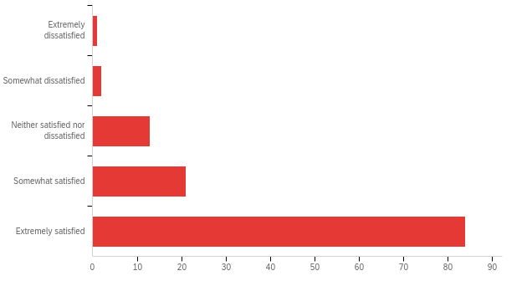

# | Answer | % | Count
1 | Extremely dissatisfied | 0.83% | 1
2 | Somewhat dissatisfied | 1.65% | 2
3 | Neither satisfied nor dissatisfied | 10.74% | 13
4 | Somewhat satisfied | 17.36% | 21
5 | Extremely satisfied | 69.42% | 84
 | Total | 100% | 121

Q22 - Comments on the organization of the Day 1 activities:
Comments on the organization of the Day 1 activities:
The activities were well organizaed
Ted-style talks are fine but the interaction (in my humble opinion) is most important between all the attending researchers. Sometimes runs of talks tamper inspiration after awhile.
Really enjoyed being in the same room all day and engaging in the presentations
Loved the ted talk style. Everyone was fantastic.
It was the most well-organized event I ever attended. Kudos to the organizers.
Great high-level topics, presentations (and presenters), and examples.
Organization was ok. Everything went according to schedule and on time.
As an attendee, the first day felt like advertising and wasn't conversational enough.
The TED-talk style was super engaging and I really liked everyone being in the same room
Great job!
Some sort of food/drink before the meeting started would have been extremely beneficial. Since travel to the location required an early start many were without food or drink until the first break
As noted previously the day 1 venue was well suited to the TED style talks and panels.
Overall, I felt that it was well organized.
Excellent program, well planned day and a very nice reception afterwards.
I am not sure if the brainstorm we did in the morning was that useful to contribute to the vision of NHERI and/or future of NHERI. Age sessions in the afternoon were informative, but I am not sure to what extend they contributed to the development of a vision/plan for NHERI.
did not attend
went smoothly. Could have used longer breaks though

Q23 - What was your overall satisfaction with the CONTENT of the Day 1 activities?
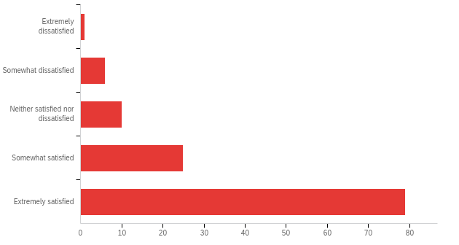
# | Answer | % | Count
1 | Extremely dissatisfied | 0.83% | 1
2 | Somewhat dissatisfied | 4.96% | 6
3 | Neither satisfied nor dissatisfied | 8.26% | 10
4 | Somewhat satisfied | 20.66% | 25
5 | Extremely satisfied | 65.29% | 79
 | Total | 100% | 121

Q24 - Comments on the content of the Day 1 activities:

Comments on the content of the Day 1 activities:
Panel discussions and presentations did not give much new information.
Given that the sessions were organized to use smart phones for the audience to participate, it would be have been good to include this requirement in the meeting announcement.
While the big-idea talks were useful, I would have liked to see some actual interesting research work presented by NHERI researchers.
Really enjoyed the TED talk style of the presentations
It was nice to have one session targeted at all participants in day one (no parallel sessions where you start to lose participants).
Talks were nice, even the panel discussion was ok, but the latter part with the interactive post-its was a bit exhausting and without overall meaning...
There were WAY too many keynotes. Max of two.
The talks were polished but some of them felt more like marketing. I liked the panel the best. I did not like the personal story talk.
All the presenters were great
Excellent sessions. I particularly enjoyed Lori Peek's talk on ensuring that the human element is not lost in engineering science and solutions.
The content was great, and this is all that matters!! Every speaker was very inspirational, with a lot of good ideas and future challenges to be solved together. I personally loved Tracy Kijewski-Correa's and Lori Peek's talks. I am looking forward to making my own research a collaborative and convergent one. These talks helped me understand better which are the steps and the things I have to consider to make this happen. I believe that if we continue to talk about this, one day it will soon become natural to link engineering and social sciences in every project. I could also relate a lot with Barbara Simpson's story- my research experience as an international visiting student determined the rest of my academic career similarly to what happened to her. I loved the activity in the afternoon, as we really worked together, brainstorming, and trying to bring solutions to common problems. I find these activities unique and potentially transforming, and I feel empowered to make a change. I felt this way also at the summer institute this summer, we need more moments like this throughout the year!
THe Keynote Speaker was disappointing...not so visionary. The TED talks were generally excellent and even the discussion portion of the day worked well with mic distribution and the option to text in via QR code various ideas. Would have been nice to have a second session where these ideas were grouped and further discussed in detail.
Good selection of topics and speakers, of wide interest and hitting key topics in the NHERI areas of interest.
I felt that there was good variety in the presentations, and I was exposed to many new ideas.
Too much social science
The presentations were a bit repetitive. It would be nice to have more diversity in terms of the topics.
The contents were great!
The town hall towards the end is the only part I would have not included.
I liked the keynote and panel discussion in the beginning and the visioning session at the end of the day. Other Ted-style talks were very nicely done; however, I did not learn anything new from them. These talks would have been more impactful to a non-NHERI audience.
A number of very useful discussions were generated as part of Day 1. It seems that a lot of the challenges are in the area of technology transfer and communication of the engineering findings to the public and the communities. That seemed to target the Broader Impacts aspect of NSF very well. Perhaps, some more weight could have been given to the Intellectual Merits part.
most of the content was focused to structural engineering and earthquake. It would be great to see some content on geotechnical engineering i.e. dam failure/levee failure/roadway collapse due to disasters and preventive measures.
Ditto.
did not attend
maybe have Elvis impersonator to break things up a little

Q26 - What was your overall level of satisfaction with the VENUE for Day 2 at the Crystal City Marriot Hotel ?
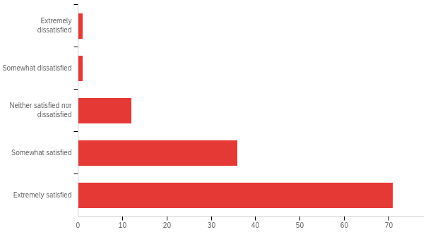

# | Answer | % | Count
1 | Extremely dissatisfied | 0.83% | 1
2 | Somewhat dissatisfied | 0.83% | 1
3 | Neither satisfied nor dissatisfied | 9.92% | 12
4 | Somewhat satisfied | 29.75% | 36
5 | Extremely satisfied | 58.68% | 71
 | Total | 100% | 121

Q27 - Comments on the venue for Day 2 at the Crystal City Marriot Hotel :

Comments on the venue for Day 2 at the Crystal City Marriot Hotel :
It was good that hotel and venue were the same for the last day so that we could easily check out
limited meal options and expensive parking for participants who drove to the summit
Nice to be close to the airport.
Many tables were set really far apart from the screens and main podium. This made people at the end hard to hear sometimes and see all the details presented on the slides.
Very convenient and plenty of space
I liked that they had good coffee and snacks throughout the day.
It would be helpful to have the same venue for both days, perhaps?
Good venue
Very convenient location! Conference rooms and poster sessions were okay
People were more spread out so we lost the "group" togetherness feel that we had on day 1. Many more places where people could be/work and not attend the sessions.
Convenient locations, mix of big and small rooms was perfect for whole-summit gatherings and smaller breakouts.
I couldn't get the wifi to work, which was an issue for the early morning brainstorming discussion session
Of course this meeting venue did not meet the sophistication and beauty of the National Academy of Sciences but it was adequate.
Did not attend Day 2
I suggest having both days in one place. NAS building is nicer of course :)
Parking validation or reimbursement for parking at the venue site would be greatly appreciated for future Summits.
As I mentioned, the TVs were a bit too small for the breakout rooms. They were also a but too low.
Great location.
The venue was fine except they took the coffee away!
hotel was nice

Q28 - What was your overall satisfaction with the ORGANIZATION of the Day 2 activities?
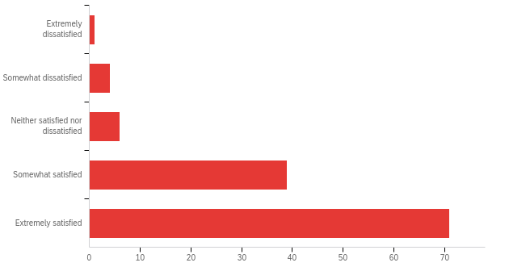

# | Answer | % | Count
1 | Extremely dissatisfied | 0.83% | 1
2 | Somewhat dissatisfied | 3.31% | 4
3 | Neither satisfied nor dissatisfied | 4.96% | 6
4 | Somewhat satisfied | 32.23% | 39
5 | Extremely satisfied | 58.68% | 71
 | Total | 100% | 121

Q29 - Comments on the organization of the Day 2 activities:
Comments on the organization of the Day 2 activities:
The activities were organized well.
I was amongst the many people who could not find the correct breakout room locations and who lost track of time and missed some of the sessions
Possibly needed more break time in between the sessions.
\
I'd encourage more breakout sessions/discussions.
I could have used another round of breakout sessions to discuss more hazard-specific/technical topics in small groups.
Parallel sessions were running for quite long (almost 1 and half hour) and it was hard to jump between them.
Aside from the group discussion period, it wasn't that helpful.
Day 2 allowed for conversations and allowed for attendees to have input. It was significantly better than Day 1.
Breakout sessions are tough but the ones I went to ended up being pretty cool.
I would note that if the summit is not ending by noon that it is probably essential to include Friday night in any travel award. Many attendees had to leave early to ensure they could fly out. This means that some of the afternoon sessions were poorly attended, or were disturbed by multiple people leaving to catch flights out.
Very good
In the first afternoon session there were several competing sessions that could have benefited from attendance by a larger group or at least be not put up head to head (i.e. tech transfer, simulation and social science)
We had a good working session in my area (Real-Time Hybrid Simulation) and I found the other discussions informative as well.
I felt like the facilitator of the participatory sections needed more training or guidance. The questions were not posed very well, which led to sparse and vague discussion.
Did not attend Day 2
Would love to have more time for the poster session.
The mini workshop was great!
The group discussion can be more coordinated. Pairing the attendees in terms of their research topics, career paths, etc. can be more effective. The poster session can be more organized with some incentives for poster presenters to stay and "present" the work. Having the poster session together with lunch makes it an activity that is less valuable than what it should have been.
It was unfortunate that so many people left early. A stronger incentive to participate the full day would have been good.
I wished there was more time to navigate over the poster area.
Because the panels I was interested in the most were occurring simultaneously, I could one attend one of them. It is reasonable to have more than one activity occurring at the same time - but perhaps recordings of the panels and discussions could be provided to participants afterwards so those of us that missed panels that we were interested in have an opportunity to attend, albeit asynchronously.
It was a good day. Lots of activities and new information. I look forward to the report from the summit.
Very well organized. I especially enjoyed the roundtable interactive discussions.
My prior comment on last day duration should have gone here 🙂
I think it would be better to have a specific starting time for the poster session (e.g. 30 minutes after lunch starts), so that the presenter can manage their lunch time with certainty.
I wish the schedule would have been better followed (many delays). I get that technical issues happen, but it seemed to be a constant theme.
i couldn't figure out what room i was supposed to be in. other than that, good job

Q30 - What was your overall satisfaction with the CONTENT of the Day 2 activities?
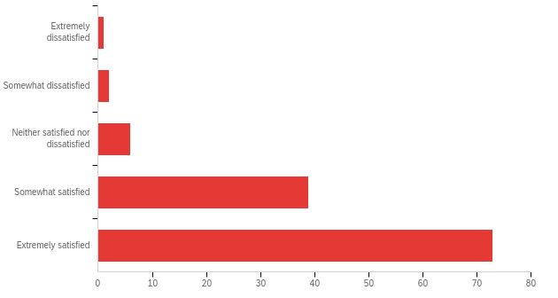
# | Answer | % | Count
1 | Extremely dissatisfied | 0.83% | 1
2 | Somewhat dissatisfied | 1.65% | 2
3 | Neither satisfied nor dissatisfied | 4.96% | 6
4 | Somewhat satisfied | 32.23% | 39
5 | Extremely satisfied | 60.33% | 73
 | Total | 100% | 121

Q31 - Comments on the content of the Day 2 activities:

Comments on the content of the Day 2 activities:
Group activities and understanding DesignSafe computational capacities better made this day better than day 1. Although the group activities were a little too much, maybe half a day would have been enough.
Same comment as before; more presentation of research studies would be great.
I didn't feel like our table got as much out of the morning discussion / roundtable as i thought we would; unure why.
Could include hazard-specific sessions. I.e., what does the next generation XX hazard facility look like? What are new faculty looking for in these facilities?
I believe there was some progress in the discussions made in Day 2, but still there was too much to resolve and set priorities to.
Not that helpful.
The content was good. I enjoyed the poster session as it allowed for a broader participation. I know this was a NHERI summit - but it would have been nice if it was really a natural hazards summit so that we could really talk broadly about natural hazard research and we weren't required to fit into the NHERI box. One topic that came up several times was regional testbeds. It would have been nice if we had an opportunity to meet within regions to get a sense of folks working in similar regions but on different hazards. It would have been interesting to see if there were any parallels there.
Content was good. The group discussion in the morning was very useful, interesting and stimulating... I wish there was a second round with a different group, to get to know others' perspectives. I also enjoyed the presentations in the afternoon, and the size of the room and number of participants made it very easy to interact and ask questions. I had to leave earlier to catch my flight, so I could not attend the international presentations, unfortunately, but one of the main takeaways of the afternoon was again about the focus on the broader impacts of our research.
The topics were good but it would have been nice to have all of NHERI participate in these topics as a group, perhaps making them more of an extension of Day 1 discussions.
Good mix of broader visioning and in-depth digging into more specific topics, especially in the breakouts.
It was good overall, but the participatory sections could have used more structure. It felt last-minute and we didn't get as much information out of these sessions as we could have. It felt like it was organized by a group of engineers (opposed to social science -type folks)
Day 2 discussions were more interesting and forward thinking in my opinion.
Did not attend Day 2
Again, the optional session that discussed short term and long term goals of the tools and methods in DesignSafe is the only session I regretted attending. I thought that session would be more of an overview of the tools available rather than a visioning session of the tools available. Of the 15 people in our group, I think only 5 use DesignSafe semi-regularly. The complaints/ideas/thoughts were all over the place, and it was difficult to gather the ideas. The graduate student and early career panel was amazing!
Day 2 was very useful for cross pollination of ideas for the future of NHERI in the next 10 years.
It was a comprehensive content. I wished I could be in more than one sessions at the same time. Having some sessions recorded and shared with the participants could be something to think about.
Ditto.
When I originally heard panel I did not think there would be presentations.
good. But what happened to the office hours with NSF program managers. felt like false advertising

Q33 - Are you interested in being involved in the following aspects of SUMMIT reporting? Click all that apply.
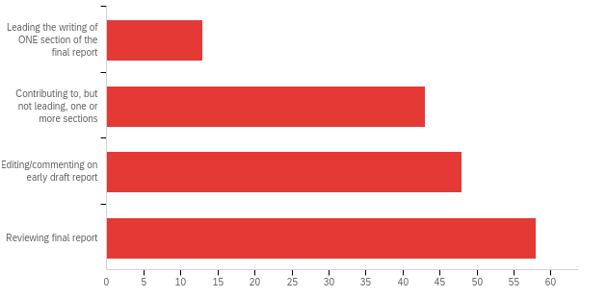

# | Answer | % | Count
1 | Leading the writing of ONE section of the final report | 8.02% | 13
2 | Contributing to, but not leading, one or more sections | 26.54% | 43
3 | Editing/commenting on early draft report | 29.63% | 48
4 | Reviewing final report | 35.80% | 58
 | Total | 100% | 162

Q34 - Is it worthwhile to discuss a future in-person National NHERI-supported meeting (e.g, > 250 people, 2-day)? The purpose of a NATIONAL meeting is to provide a venue to strengthen the collaborative network of people, ideas and tools.
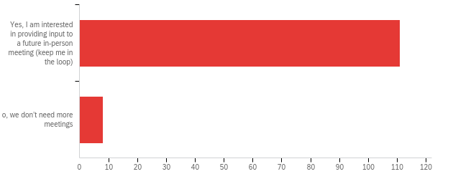

# | Answer | % | Count
1 | Yes, I am interested in providing input to a future in-person meeting (keep me in the loop) | 93.28% | 111
2 | No, we don’t need more meetings | 6.72% | 8
 | Total | 100% | 119

Q37 - Comments on the idea of a National NHERI-supported meeting:
Comments on the idea of a National NHERI-supported meeting:
It is great to catchup with colleagues in natural hazards research.
I clicked yes because others would like these additional meetings. I don't plan to attend as I learned that my work on the application part of the problem does not fit with NERHI's goals.
I found it very beneficial to interact with other researchers in the community, especially since in-person has been limited since COVID began (roughly the same time I started as early career.
I'm an engineer but hope to see more social scientists attending the future meeting. Many who attend the Natural Hazards Workshop in Boulder, CO are social scientists. Convergence between them and this summit's participants will be impactful.
This would be a good idea as we approach 2025 and need to stay organized beyond NHERI
NOT 2 full days. Max 1.5 days.
I think these national meetings are really valuable to share information across hazards as well as to open up the NHERI research. NHERI is meant to open up research in natural hazards but instead it has made it seem even more closed. Association with a NHERI site leads to greater likelihood of being asked to participate on big collaborations. How can we really attract a broader audience into this research space. How can we build new collaborations, rather than strengthen long-standing existing collaborations.
A NHERI GSC meeting, maybe a hackathon? A field data collection and instrument lesson.
It is worthy to arrange similar National NHERI-supported summits in the future
I think as wonderful as ZOOM is, in-person events are essential. There is no way to capture organic conversations and idea flow in quite the same way over ZOOM or other remote platforms. Perhaps consider rotating locations around the US - maybe every second/third year in DC, and then rotate to NHERI locations for the other years so that travel costs burdens can be rotated.
I strongly believe that these meetings are fundamental to build a strong network of diverse researchers. I really appreciate the demographic of the participants, I feel like it is a well balanced mix of young researchers, very well established and senior researchers, professionals, internationals, government representatives, ecc., able to reflect the inclusive and convergent research we are aiming at. I am currently working at San Diego State University, which is a non-R1 school, and being able to interact with top researchers in the field, and participate in the discussions is really important for me. It helps me better identifying the next research steps, key people and key tools to contribute to the society with my research. I learnt I can use the NHERI facilities (this is awesome) and collaborate with peers to get better results. And these meetings really facilitate the connections needed to actually use NHERI facilities.
I think its important to bring together all components of the network to recognize that we are all one entity, NHERI.
There are a number of topics, including design for resilience, real-time hybrid simulation, use of AI/ML in NHERI engineering, etc. that I think would warrant a further discussion in the 2-day formal.
It could be helpful if the networking aspect was carefully designed and planned.
I think this event demonstrated just how much we as a community enjoy in need in person meetings (following far too many zoom meetings).
I really like the brainstorming sessions in this event. I'd like to have more of these sessions (and have even deeper conversations) and engage more people from different disciplines (social science, economy, government officers).
After covid era it was refreshing to meet people working on related topics in-person
These discussions are fruitful. Once the decadal vision has been fixed after this first meeting, more focused meetings can be held. Deterioration and socio-technical collaboration were mentioned a lot. They might deserve independent meetings.
Several people expressed disappointment that NHERI didn't offer annual networking opportunities that in-person meetings such as this event make possible.
One national meeting per year seems sufficient to me for building collaborative networks.
Would be invaluable to me as an early-career researcher to have more opportunities like this.
Perhaps in two-three years we may want to have another meeting.

Q35 - Is it worthwhile to discuss future in-person REGIONAL NHERI-supported meetings (e.g., < 75 people, half-day).? The purpose of REGIONAL meetings is to broaden the participation of people into the network particularly early career researchers, students, people at non-R1 institutions, and community ‘superstakeholders’, with an emphasis on regional disasters and opportunities within the NHERI network.
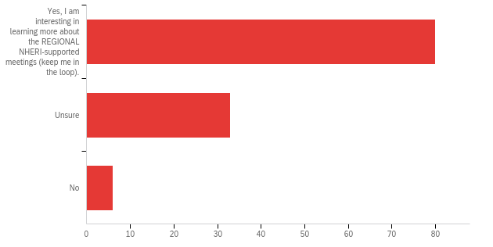
# | Answer | % | Count
1 | Yes, I am interesting in learning more about the REGIONAL NHERI-supported meetings (keep me in the loop). | 67.23% | 80
2 | Unsure | 27.73% | 33
3 | No | 5.04% | 6
 | Total | 100% | 119

Q38 - Comments on the idea of Regional NHERI-supported meetings:
Comments on the idea of Regional NHERI-supported meetings:
It would be great to focus on specific hazards that impact a region, but perhaps better not to limit that to early career researchers and R1 universities.
I think the workshops organized by NHERI facilities are already playing this role to some extent. I would suggest improving those rather than introducing yet another kind of event.
Would provide an opportunity to bring staff from multiple facilities together to discuss opportunities and resources for addressing specific natural hazards. Ie wind Engineering in south east, earthquake and wildfire in the west.
I work in seismic research, but regionally we are not near an active seismic region
Some sort of proposal buy-in and organization. Contact me for additional details if needed.
I love this idea but foresee challenges in community stakeholder engagement, which requires established relationships with the regional communities. A careful planning effort will be essential.
I don't like the idea of separation but could see maybe something early career; although I thought that was what the summer institute is for...
It seems people in different fields are not as regionally isolated as I would have thought
Too many meeting already.
I am very excited about this as I think this will lead to new collaborations. Many NSF research opportunities require large collaborative groups. It is hard to build these and many researchers feel isolated if you aren't at a big university with existing collaborations. Regional collaborations are key and as a bonus regional teams make sense for natural hazards work as natural hazard are always tied to a place. I would strongly encourage regional NHERI supported meetings as a way of broadening participation and getting new teams actively engaged in NEHRI research.
Could be cool because you can really zero in on specific hazards or critical areas.
It is also worthy to arrange similar regional NHERI-supported summits in the future
Absolutely! Perhaps regional meetings are based on NHERI assets, or particular disasters. E.g. it wouldn't make sense to have an earthquake session in Texas - CA would be a better choice. However, we'd love coastal inundation sessions. Also, choosing NHERI locations with testing facilities would allow attendees to tour the various sites and see what NHERI infrastructure exists to accelerate and support research.
Well, I was about to mention this in the previous box, before reading this question, yes please! Let's do regional NHERI-supported meetings! These regional meetings will definitely enhance the networking and hence benefit the bigger general meetings (which should not be replaced completely by the regional NHERI meetings, I think). I see regional meetings as a key support element in enhancing the outcome of the discussion and the collaboration with "closer" peers. The regional meetings can be focused on a few topics only, to make it more relevant for the region and stimulate a deeper discussion. And in terms of logistics, having regional meetings would also make it easier for participants to join. But one of the beauties of national meetings is the diversity of the participants, so I would not get rid of these national events. I think we should promote both, to build closer ties with peers in the same field, while also keeping our eyes and minds open to the multi-hazard scenarios we discussed.
Regional meetings could be very valuable for tech transfer and allowing more participation at a granular level from early faculty but it wold not be a replacement for a national meeting.
I would have to see what the topics would be to determine whether I'd be interested in attending.
Many researchers work across regions and have research teams across many universities, so I'm sure how we would organize ourselves into certain regions
It would be nice to pre-select a few draft ideas or topics and gather researchers and local government agencies and stakeholder together to have a deep conversation as how to solve these regional climate induced problems
That would perhaps be more efficient to have a smaller but focused group. However, people from the same region would likely have a similar mindset/view about disasters--a downside.
They are a good opportunity to let graduate students and early career faculty to lead discussions so they can improve their leading, communication and research skills. I am VERY interested in these ones.
I believe regional meetings with stakeholders will be extremely beneficial to identify local problems and developing solutions to address them.
Good idea, but my region doesn't lend itself well to regional meetings (researchers scattered too far, would be difficult to travel for only a half day event)
The idea of regional NHERI-supported meetings is intriguing. I believe such events would potentially broaden the participation especially of undergraduate students.
There may be other venues to do this, for example the Summer Institute. The EFs may also have (or could be engaged) in this sort of activity.

