2023 NHERI Facilities Diversity Survey
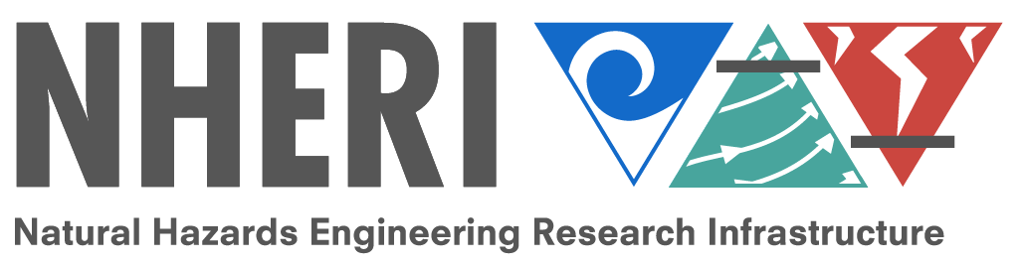
2023 NHERI Facilities Diversity Survey (5-minutes)
Thank you for supporting diversity efforts within the NHERI Network. The short survey should take less than five minutes to complete.
The purpose of the NHERI Facilities Diversity Survey is to encourage, monitor, and report diversity information within NHERI's Network and create an aggregated network profile to share within NHERI, NSF, and the wider natural hazards research community. The data will also inform education and community outreach initiatives shared at various levels within the NHERI network.
Your responses are anonymous and will only be shared in aggregate form as the NHERI Facilities Diversity Survey Infographic on the NHERI DesignSafe website.

Where do you allocate most of your time within the NHERI Network?
- Network Coordination Office (NCO) which includes (NIAC, NHERI Council, Science Plan, TTC, User Forum, ECO, ECO Committee, Communications, etc.)
- The Wall of Wind at Florida International University
- Real-time Multi-Directional Natural Hazards Simulation Facility (RTMD) at Lehigh University
- The O.H. Hinsdale Wave Research Laboratory at Oregon State University
- The NHERI SimCenter at University of California, Berkeley
- The Center for Geotechnical Modeling (CGM) at University of California, Davis
- The Large High Performance Outdoor Shake Table (LHPOST) at University of California, San Diego
- The Boundary Layer Wind Tunnel Experimental Facility at the University of Florida
- The Large-Scale Mobile Shakers at University of Texas at Austin
- The NHERI Cyberinfrastructure and Data Management team at University of Texas at Austin in collaboration with TACC
- The Rapid Response Research Facility (RAPID) at University of Washington
- CONVERGE at the University of Colorado Boulder
- Other (Please specify in the box below.) __________________________________________________

Please select the position(s) you hold within NHERI. Please select all that apply.
- Network Independent Advisory Committee (NIAC)
- User Forum
- Principal Investigator
- NHERI Council
- Science Plan Committee
- Technology Transfer Committee (TTC)
- Education and Community Outreach (ECO)
- Education and Community Outreach Committee
- NCO Communications
- Full-time support of NHERI facility
- Other (Please specify in the box below.) __________________________________________________

Job title
________________________________________________________________

Institution Zip code
________________________________________________________________

Highest degree earned
- Doctoral
- Master’s
- Bachelor’s
- Associate
- Other (Please specify below.) __________________________________________________

Year highest degree earned
________________________________________________________________

In what field did you earn your highest degree?
________________________________________________________________

Page Break

Years of employment/experience in any/all-natural hazards fields (For example, if you focused on flood hazards for 7 years before joining the UF wind facility for 5 years, please list 12 years).
________________________________________________________________

Please select your current hazards research focus. Please select all that apply.
- Wind engineering (1)
- Earthquake engineering (2)
- Coastal engineering (3)
- Tsunami research (4)
- Simulation/Computational modeling (5)
- Data management (6)
- Reconnaissance (12)
- Natural hazards research (7)
- Social Science (9)
- Education (10)
- Other (Please specify in the text box below.) (8) __________________________________________________

Please select your interests in natural hazards research that may be beyond your current focus. Please select all that apply.
- Wind engineering (1)
- Earthquake engineering (2)
- Coastal engineering (3)
- Tsunami research (4)
- Simulation/Computational modeling (5)
- Data management (6)
- Reconnaissance (11)
- Natural hazards research (7)
- Social Science (8)
- Education (9)
- Other (Please specify in the text box below.) (10) __________________________________________________

Are you the first-generation in your family to attend college?
- Yes (7)
- No (8)
- I do not know. (9)
- I do not wish to answer. (10)

Race/Ethnicity (Please select all that apply.)
- American Indian or Alaska Native (1)
- Asian or Asian American (2)
- Black or African American (3)
- Hispanic or Latinx (4)
- Native Hawaiian or Other Pacific Islander (5)
- White or Caucasian (6)
- Do not wish to answer (7)
- Other (Please specify in the box below.) (8) __________________________________________________

Gender
________________________________________________________________

What is your native language? Please select all that apply.
- Arabic (4)
- English (5)
- French (6)
- German (7)
- Italian (8)
- Mandarin (9)
- Portuguese (10)
- Russian (11)
- Spanish (12)
- Other (Please specify in the box below). (13) __________________________________________________

If you are ready to submit your survey, please click "yes" and submit by clicking the arrow in the right-hand corner.
- Yes (1)

End of Block: Default Question Block

