2023 NHERI NCO Diversity Survey

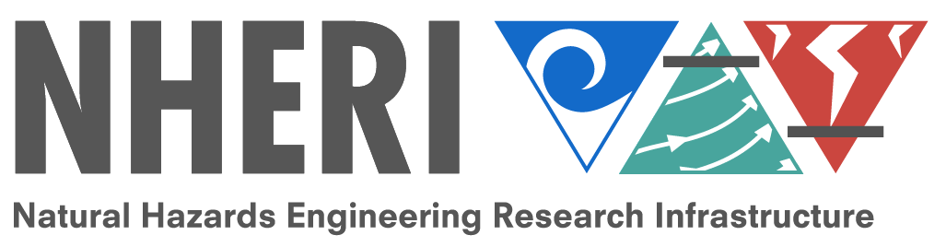

2023 NHERI NCO Diversity Survey
Thank you for supporting diversity efforts within the NCO. We ask that all those associated with the NCO (NCO, NIAC, NHERI Council, User Forum, TTC, Science Plan Task Group, ECO, ECO Committee, and NCO Communications) take the survey.
The purpose of the survey is to encourage, monitor, and report diversity information within NHERI's NCO and create an NCO profile to share within our community and the wider natural hazards research community. The short survey should take less than five minutes to complete.
Where do you allocate most of your time within the NHERI Network?
- Network Coordination Office (NCO)
- The Wall of Wind at Florida International University
- Real-time Multi-Directional Natural Hazards Simulation Facility (RTMD) at Lehigh University
- The O.H. Hinsdale Wave Research Laboratory at Oregon State University
- The NHERI SimCenter at University of California, Berkeley
- The Center for Geotechnical Modeling (CGM) at University of California, Davis
- The Large High Performance Outdoor Shake Table (LHPOST) at University of California, San Diego
- The Boundary Layer Wind Tunnel Experimental Facility at the University of Florida
- The Large-Scale Mobile Shakers at University of Texas at Austin
- The NHERI Cyberinfrastructure and Data Management team at University of Texas at Austin in collaboration with TACC
- The Rapid Response Research Facility (RAPID) at University of Washington
- CONVERGE at the University of Colorado Boulder
- Other (Please specify in the box below.) __________________________________________________

Please select the position(s) you hold within the NHERI NCO. Please select all that apply.
- Network Independent Advisory Committee (NIAC)
- User Forum
- Principal Investigator
- NHERI Council
- Science Plan Committee
- Technology Transfer Committee (TTC)
- Education and Community Outreach (ECO)
- Education and Community Outreach Committee
- NCO Communications
- Other (Please specify in the box below.) __________________________________________________

Job title
________________________________________________________________

Institution zip code
________________________________________________________________

Highest degree earned
- Doctoral
- Masters
- Bachelors
- Associates
- Other (Please specify below.) __________________________________________________

Year highest degree earned
________________________________________________________________

In what field did you earn your highest degree?
________________________________________________________________

Page Break

Years of employment/experience in any/all-natural hazards fields (For example, if you focused on flood hazards for 7 years before joining the UF wind facility for 5 years, please list 12 years).
________________________________________________________________

Please select your current hazards research focus. Please select all that apply.
- Wind engineering
- Earthquake engineering
- Coastal engineering
- Tsunami research
- Simulation/Computational modeling
- Data management
- Reconnaissance
- Natural hazards research
- Social Science
- Education
- Other (Please specify in the text box below.) __________________________________________________

Please select your interests in natural hazards research that may be beyond your current focus. Please select all that apply.
- Wind engineering
- Earthquake engineering
- Coastal engineering
- Tsunami research
- Simulation/Computational modeling
- Data management
- Reconnaissance
- Natural hazards research
- Social Science
- Education
- Other (Please specify in the text box below.) __________________________________________________

Are you the first-generation in your family to attend college?
- Yes
- No
- I do not know.
- I do not wish to answer.

Please select all that apply.
- American Indian or Alaska Native
- Asian or Asian American
- Black or African American
- Hispanic or Latinx
- Native Hawaiian or Other Pacific Islander
- White or Caucasian
- Do not wish to answer
- Other (Please specify in the box below.) __________________________________________________

Gender
________________________________________________________________

What is your native language?
- Arabic
- English
- French
- German
- Italian
- Mandarin
- Portuguese
- Russian
- Spanish
- Other (Please specify in the box below). __________________________________________________

What is your native language?
- Arabic
- English
- French
- German
- Italian
- Mandarin
- Portuguese
- Russian
- Spanish
- Other (Please specify in the box below). __________________________________________________

If you are ready to submit your survey, please click "yes" and submit by clicking the arrow in the right-hand corner.
- Yes

End of Block: Default Question Block

