NHERI Council Monthly Meeting No. 12, Y-7
June 8, 2023 11:30 – 12:30 PM Eastern (8:30 to 9:30 AM Pacific)

NHERI Council Meetings

Title: | NHERI Council - Summer 2023
Location: | https://DesignSafe-ci.zoom.us/j/93004305459
When: | June 8th, 11:30 AM to 12:30 PM Eastern

Attending:
- Oregon State University:
- University of California, Berkeley: Matt DeJong (Co-Dir.), and Matt Schoettler (Assoc. Dir. – Ops), Stanford University: Greg Deierlein (Co-Dir), SimCenter
- University of California, Davis: Jason DeJong (EF Dir) and Dan Wilson (Assoc. Dir.) CGM
- University of California, San Diego:
- University of Colorado Boulder: Lori Peek (Dir., CONVERGE)
- University of Florida: Jennifer Bridge (EF Dir. and Council Chair) Powell Lab
- University of Texas at Austin: Ellen Rathje (CI Dir.)
- University of Texas at Austin: Ken Stokoe (EF Dir.) Texas Mobile Equipment Facility
- University of Washington: Joe Wartman (EF Dir. and Council Vice-Chair) RAPID
- National Science Foundation:
- Purdue University: Julio Ramirez (NCO Dir., Council Secretary
- Florida International University: Arindam Chowdhury (EF Dir
- Lehigh University: Richard Sause (CoPI), and Joe Saunders, Ph.D. Associate Director of Operations (jms815@lehigh.edu) ATLSS
- Guests: Alia Amer (Lehigh)

Minutes
- Attendance (Julio)
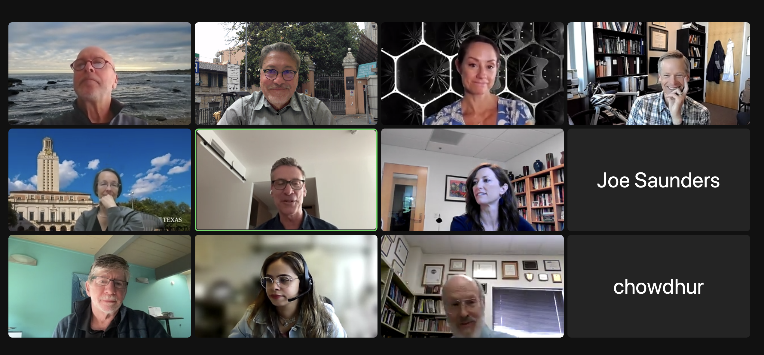

- (5 min) Review and Approval of Minutes (previously distributed) Meeting No. 11, 5/04/23 in Y-7 (Jennifer)

Approved Minutes posted at: https://www.designsafe-ci.org/facilities/nco/governance/nheri-council/

Minutes approved as distributed. Lori moved and Joe Wartman seconded the motion.

- (10 min) Council Officers for 2023 – 2024 (Julio)
The Council thanked Jennifer for her service as Chair for the term of July 2022 to June 2023. Joe Wartman began his term as chair at the conclusion of this meeting. The Council nominated Dan Cox as the vice-chair. Julio was reaffirmed as the secretary.
Action Item: Julio to confirm Dan's acceptance to serve as the next vice-chair.

- (20 min) Old Business –

  - Post Summit Activities

    - Next NHERI-wide meeting, 2024 (Jennifer, Julio, 5 min)
Brief report on a potential partnership with the CE section of the NAE. More details on the save the date and venue at the next meeting.

  - Facility reports (All, 15 min)
UT Mobile: Ken reported on the activities in Hawaii and the collaboration with the University of Hawaii in studying potential beach liquefaction. Marti LaChance will reach out to Ken to prepare a news item.
DesignSafe-CI: Ellen shared that 40 students are ready to go in the Academy. Also, announced a new data event organized with several facilities.
SimCenter: Greg shared information on the partnership with DesignSafe in the Computational Academy and the ongoing bootcamp.

- (15 min) New Business - Next steps for strengthening NHERI community

  - Lowering Barriers to Entry for NHERI Research
    - NHERI FAQs (Jennifer, 5min)
    - Discussion (all)
Themes are requested for future meetings.

  - Scheduling discussion topics for future Council Meetings (Jennifer, 5 min).
    - Team Science Study (Dan)
    - Revisit NHERI Impact Metrics
    - Others
Item will be continued on the agenda

  - Other New Business
    - Renewal of LOA with NIED/E-Defense (Julio, 5 min)
Julio shared the draft of the LOA. The item will be continued on next meeting's agenda.

- Adjourn
A motion to adjourn by Julio and seconded by Lori at 12:35 PM EDT concluded the meeting.

