NHERI Council Monthly Meeting No. 5, Y-8
Nov 2, 2023 2:00 – 3:00 PM, Eastern (11:00 to Noon, Pacific)

NHERI Council Meetings

Title: | NHERI Council - Fall 2023
Location: | https://DesignSafe-ci.zoom.us/j/92003080202
When: | November 2, 2:00 to 3:00 PM Eastern

Attending:
- Oregon State University: Dan Cox (EF Dir.) and Pedro Lomonaco (Fac. Dir.) Hinsdale
- University of California, Berkeley: Matt DeJong (Co-Dir.), and Matt Schoettler (Assoc. Dir. – Ops), Stanford University: Greg Deierlein (Co-Dir), SimCenter
- University of California, Davis: Jason DeJong (EF Dir) and Dan Wilson (Assoc. Dir.) CGM
- University of California, San Diego: Joel Conte (EF Dir.,) LHPOST
- University of Colorado Boulder: Lori Peek (Dir., CONVERGE)
- University of Florida: Jennifer Bridge (EF Dir. and Council Chair) Powell Lab
- University of Texas at Austin: Ellen Rathje (CI Dir.) and Tim Cockerill (Dep. Proj. Dir.) DesignSafe-CI)
- University of Texas at Austin: Ken Stokoe (EF Dir.), Tricia Clayton (CoPi), and Sungmoon Hwang (syongmoon@utexas.edu) (Operations Manager) Texas Mobile Equipment Facility
- University of Washington: Joe Wartman (EF Dir. and Council Vice-Chair) and Jeff Berman (CoPI and Fac. Manager) RAPID
- National Science Foundation: Joy Pauschke (Prog. Dir, NHERI)
- Purdue University: Julio Ramirez (NCO Dir., Council Secretary), JoAnn Browning (NCO ECO Leader), and Dan Zehner (NCO Sch./Ops. Coord.)
- Florida International University: Arindam Chowdhury (EF Dir.), Ioannis Sizis (CoPI) and Steve Diaz (Site Operations Manager) WOW
- Lehigh University: Jim Ricles (EF Dir.), Liang Cao (lic418@lehigh.edu), Joe Saunders, (Facility Manager)
- Guests: Cheryl Ann Blain, NCO Communications Lead.

Minutes
- Attendance and introductions (All, 5 min)
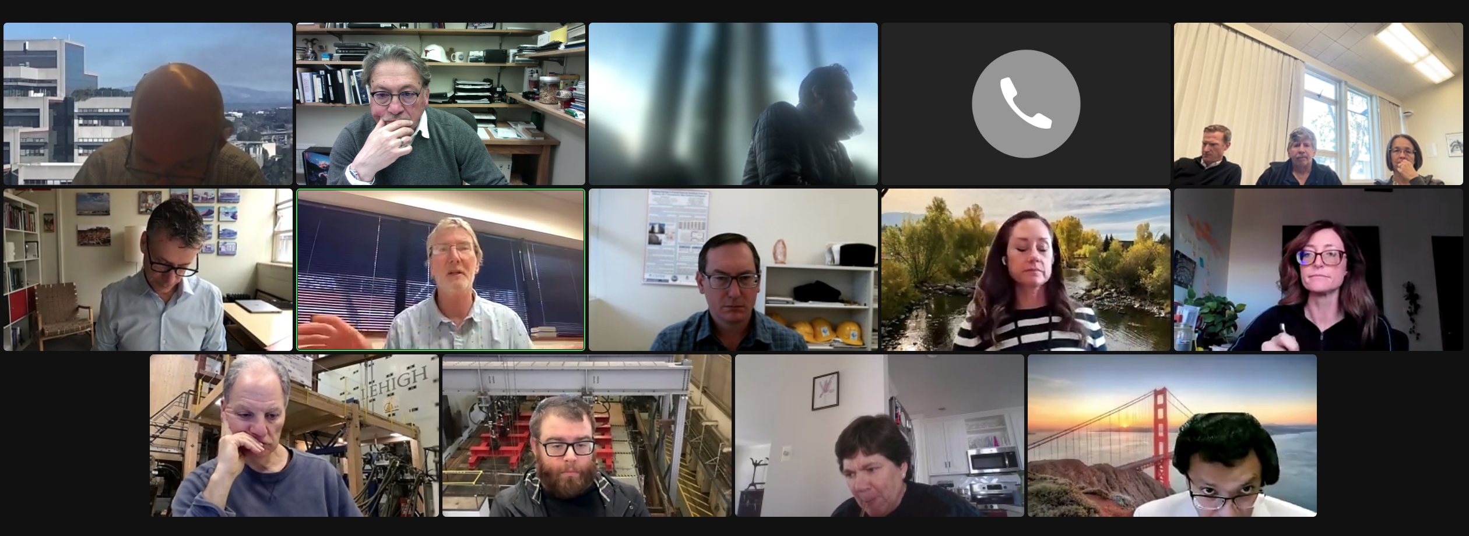
Via Phone: Jason DeJong, PI UC Davis.
Minutes were approved as distributed, Julio moved approval.

- (5 min) Review and Approval of Minutes of 10/05/23 Meeting No. 4 in Y-8 (Joe Wartman.)

Approved Minutes posted at: https://www.designsafe-ci.org/facilities/nco/governance/nheri-council/

- (35 min) Old Business –

  - Post Summit Activities

    - Next Summit May 14-15, 2024 College Park, MD (Dan Cox, Jennifer Bridge, Julio, 10 min)
          - Organizing Committee
          - Report
          - Facilities that wish to have activities around Summit 2024
Registration fee regular attendance: $250/2-day. Flyer and postcard with QR code. Invite Jared and Nora from Nexhigh.
Action Item: Joe to contact Joy Pauschke to discuss possible interactions with NSF.
  - NHERI presence at conferences and professional meetings from Oct 1., 2023 to Sept. 30th, 2024. (Joe Wartman, Julio, Dan Zehner, 10 min)
Dan Zehner and Joe Wartman asked for volunteers to staff the booth during AGU. Dan will follow up. Selection of the second meeting to deploy the booth will be on the agenda for the next Council Meeting.

  - Update on NHERI Impact Collection in Frontiers (Cheryl Ann Blain, NCO Communications Lead, 5 min)
Cheryl Ann invited the Council to submit proposals for papers. Template distributed for the brief description of the proposal included two questions:
- 2-3 sentence statement that specifically addresses how the NHERI EF at University of Florida has 1) significantly changed the way professionals practice natural hazards engineering or, 2) significantly changed the way researchers conduct investigations in natural hazards engineering.
- High-level, plain-language abstract and title with your paper idea to special collection editors (cc’d) by Friday, Dec. 1.

  - Possible International Partnerships with New Zealand and Canada (Joe Warman, Julio Ramirez, All, 10 min)
Council perspective is that is important to continue international collaboration to enable:
    - Data sharing
    - Maintain contact to stay informed about developments
    - Research planning
    - Disseminate impact
    - Formal path for research collaboration
Additionally, engage the NSF International Collaboration Office. Explore invitation to attend a meeting of the Council
- ( min) New Business

- Adjourn
Matt, Ellen and Greg moved and seconded to adjourn at 3:00 PM ET.

