NHERI Council Monthly Meeting No. 7, Y-8
Jan 11, 2024 2:00 – 3:00 PM, Eastern (11:00 to Noon, Pacific)

NHERI Council Meetings

Title: | NHERI Council - Spring 2024
Location: | https://DesignSafe-ci.zoom.us/j/98793304101
When: | January 11, 2:00 to 3:00 PM Eastern

Attending:
- Oregon State University: Dan Cox (EF Dir.) and Pedro Lomonaco (Fac. Dir.) Hinsdale
- University of California, Berkeley: Matt DeJong (Co-Dir.), and Matt Schoettler (Assoc. Dir. – Ops), Stanford University: Greg Deierlein (Co-Dir), SimCenter
- University of California, Davis: Jason DeJong (EF Dir) and Dan Wilson (Assoc. Dir.) CGM
- University of California, San Diego: Joel Conte (EF Dir.,) LHPOST
- University of Colorado Boulder: Lori Peek (Dir., CONVERGE)
- University of Florida: Jennifer Bridge (EF Dir. and Council Chair) Powell Lab
- University of Texas at Austin: Ellen Rathje (CI Dir.) and Tim Cockerill (Dep. Proj. Dir.) DesignSafe-CI)
- University of Texas at Austin: Ken Stokoe (EF Dir.), Tricia Clayton (CoPi), and Sungmoon Hwang (syongmoon@utexas.edu) (Operations Manager) Texas Mobile Equipment Facility
- University of Washington: Joe Wartman (EF Dir. and Council Vice-Chair) and Jeff Berman (CoPI and Fac. Manager) RAPID
- National Science Foundation: Joy Pauschke (Prog. Dir, NHERI)
- Purdue University: Julio Ramirez (NCO Dir., Council Secretary), JoAnn Browning (NCO ECO Leader), and Dan Zehner (NCO Sch./Ops. Coord.)
- Florida International University: Arindam Chowdhury (EF Dir.), Ioannis Sizis (CoPI) and Steve Diaz (Site Operations Manager) WOW
- Lehigh University: Jim Ricles (EF Dir.), Liang Cao (lic418@lehigh.edu), Joe Saunders, (Facility Manager)
- Guests: Cheryl Ann Blain, NCO Communications Lead, Marti LaChance, NCO Media Communications Manager, and Andrew Kennedy University of Notre Dame.

Minutes
- Attendance and introductions (All, 5 min)
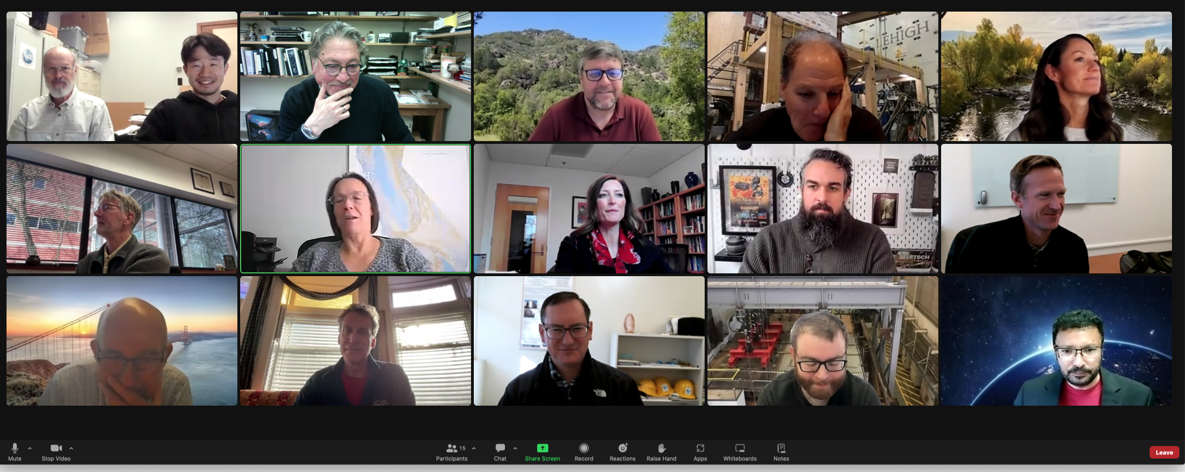

- (3 min) Review and Approval of Minutes of 12/07/23 Meeting No. 6 in Y-8 (Joe Wartman.)
Lori moved and Arindam seconded the motion to approve the meeting Minutes as distributed. Approved with no objections.

Approved Minutes posted at: https://www.designsafe-ci.org/facilities/nco/governance/nheri-council/

- (40 min) Old Business –

  - Summit 2024

    - Update Summit 2024 May 14-15, 2024 College Park, MD (Dan Cox, Jennifer Bridge, and Julio Ramirez, 5 min)
Dan indicated that the Summit planning was coming together well. Described the program as to date and noted that remained to determine the keynote speaker for Day 1 and the lightning talks require more work. The program in Day 2 is almost complete.
    - Suggestions for possible Lightning Talks and suggestions for Day 1 booths, etc. (Dan Cox, 5 min)
We are still collecting proposals for these talks and suggestions for Day 1 booth displays.
Action Item: to the Council, please nominate speakers and propose booth displays.

  - NHERI presence at conferences and professional meetings from Oct 1., 2023 to Sept. 30th, 2024. (Joe Wartman, Dan Zehner, 8 min)
    - AGU after deployment report.
The booth received over 200 visitors, with 45 e-mail contact requests. Cross referencing with other NSF entities led some good contacts. More information on the booth deployment will be available in the next few weeks, including lessons learned and opportunities.
    - Participation at more at more disciplinary meetings, EERI annual meeting, Summit 2024 and Large Facilities workshop
The discussion included possible participation at the Natural Hazards Research Workshop, EERI annual meeting, SEI Meeting and AGU Ocean Sciences.
Upon further deliberations, Joe moved and Ellen seconded the motion to participate at the EERI annual meeting and the Summit 2024. The motion passed. Dan Zehner will be reaching out to coordinate with other facilities NHERI presence at the Large Facilities workshop.
Action Item: The booth will deploy to the EERI annual meeting and the Summit 2024.

  - NHERI Special Collection in ASCE Journals (All, 7 min): Andrew Kennedy provided another presentation on a NHERI collection in ASCE journals. Council feedback on this proposal. (Minutes from the 12-07-23 Council meeting)
Action Item: Joe Wartman will reach out to Andrew and indicate that the Council would prefer to defer participation in the partnership at this time.
  - Topics for discussion in 2024 (Joe Wartman, 10 minutes). Jared Kosters from Nexhight will debrief the Council at the February 8th Meeting. Beyond this presentation, ask the Council about other possible topics of networkwide interest.
Nexhight report is now due out in February.
Action Item: Joe will reach out to Joy and Jared to determine the best time for Jared to debrief the Council at one of its meetings.
  - Next phase of the NIED-EDefense/NHERI research collaboration- update (Julio, 5 minutes)
Julio reported on the status of the new phase of the collaboration and the framework planning meeting in San Diego. He will report to the Council at a future meeting.
- (5 min) New Business
  - Schedule of Council Meetings in January same times - June 2024: January 11, February 8, March 7, April 4, May 2, and June 6. (2 min)
Accepted.
  - User Satisfaction Survey Results (2023): invite Maggie Corwin to the next Council meeting (3 min.)
To be determined.

- Adjourn
Julio moved to adjourn and Lori seconded the motion. Meeting adjourned at 3:00 PM Eastern.

