NHERI Council Monthly Meeting No. 5 (November 7 meeting was postponed), Y-9
December 5, 2024, 2:00 – 3:00 PM, Eastern (11:00 to Noon, Pacific)

NHERI Council Meetings

Title: | NHERI Council - Fall 2024
Location: | https://DesignSafe-ci.zoom.us/j/91812950270
When: | December 5, 2:00 to 3:00 PM Eastern (last scheduled meeting)

Attending:
- Oregon State University: Dan Cox (EF Dir. and Council Chair) and Pedro Lomonaco (Fac. Dir.) Hinsdale
- University of California, Berkeley: Matt DeJong (Co-Dir.), and Matt Schoettler (Assoc. Dir. – Ops), Stanford University: Greg Deierlein (Co-Dir), SimCenter
- University of California, Davis: Jason DeJong (EF Dir) and Dan Wilson (Assoc. Dir.) CGM
- University of California, San Diego: Joel Conte (EF Dir.,) LHPOST
- University of Colorado Boulder: Lori Peek (Dir., CONVERGE)
- University of Florida: Jennifer Bridge (EF Dir.) Powell Lab
- University of Texas at Austin: Ellen Rathje (CI Dir. and Council Vice-Chair) and Tim Cockerill (Dep. Proj. Dir.) DesignSafe-CI)
- University of Texas at Austin: Ken Stokoe (EF Dir.), Tricia Clayton (CoPi), and Sungmoon Hwang (syongmoon@utexas.edu) (Operations Manager) Texas Mobile Equipment Facility
- University of Washington: Joe Wartman (EF Dir.) and Jeff Berman (CoPI and Fac. Manager) RAPID
- National Science Foundation: Joy Pauschke (Prog. Dir, NHERI)
- Purdue University: Julio Ramirez (NCO Dir., Council Secretary), JoAnn Browning (NCO ECO Leader), Cheryl Ann Blain (NCO-Comms Leader) and Dan Zehner (NCO Sch./Ops. Coord.)
- Florida International University: Arindam Chowdhury (EF Dir.), Ioannis Sizis (CoPI) and Steve Diaz (Site Operations Manager) WOW
- Lehigh University: Jim Ricles (EF Dir.), Liang Cao (lic418@lehigh.edu), Joe Saunders, (Facility Manager), and Claudia Reis (Co-PI Lehigh NHERI Facility)
- Guests:

Minutes
- (5 min) Attendance and introductions (All)
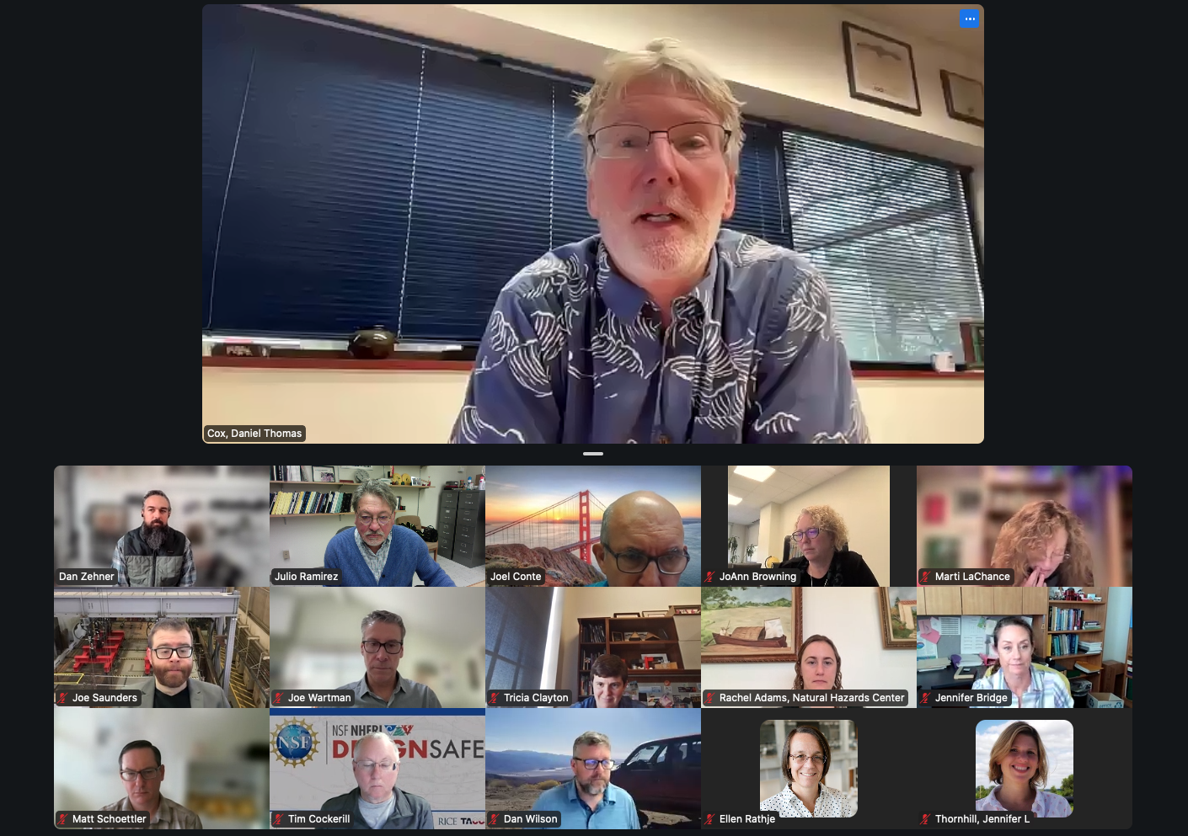

- (4 min) Review and Approval of Minutes of 10/03/24 Meeting No. 4 in Y-9. Meeting of November 7 was postponed to December 5. (Dan Cox)
Minutes approved as distributed.

Approved Minutes posted at: https://www.designsafe-ci.org/facilities/nco/governance/nheri-council/

- (45 min) Ongoing Business –

  - (10 min) Update on booth deployments (Julio Ramirez, Dan Zehner): Status of AGU deployment and Geo-Congress and EMI planning
Dan Z. and Marti reported on the preparations. Everything is going as scheduled and will report to the Council on the Metrics collected at a future meeting. Geo Congress will be in Louisville KY and the booth will deploy there. Dan will be reaching to NHERI awardees to help staffing the booth.

  - (5 min) Update on NHERI-NIED/EDefense Research Collaboration Meeting (Julio Ramirez)
Julio reported that the participants have been confirmed on both the US and Japan side. Currently the theme leaders on the US side have begun to coordinate their presentations. The agenda is being refined and will be share with the Council as soon as it is ready.

  - (5 min) Update on timing of the next NHERI Solicitation
Nothing to update currently.

  - (20 min) Status on the NHERI pieces for the NSF 75th Anniversary (JoAnn and Dan)
Several activities were reported by the NHERI components in this regard.
- Joel Conte reported on the testing of the cold formed steel building on the UCSD shake table.
- Discussion on a possible 2’ video of highlights.
- Possible industry round table.
- Contacts with NSF marketing
Action Item: Dan Cox invited Council members to contact him and volunteer as members of an Ad-Hoc committee to help coordinate the NHERI participation as much as it is feasible to make sure that the broader impact of NHERI is properly conveyed during this year of special NSF activities in celebration of its 75th Anniversary.

- (5 min) New Business
  - Schedule of meetings January-June 2025: proposal is to keep meeting time 2:00 to 3:00 PM EST and convene on January 9, February 13, March 6, April 3, May 1, and June 5.
There were conflicts with the time of the meeting and Julio will issue a poll to find an alternate time for the meeting on the same dates and report at the next Council meeting on January 9th.
  - SimCenter/DesignSafe Symposium (Matt)
Matt reported over 200 registrants already for the Symposium to be held during the 1st week in February in Los Angeles.

- Adjourn
Meeting adjourned at 2:55 PM ET.

