NHERI Council Monthly Meeting No. 6 (November 7th meeting was postponed), Y-9
January 9, 2025, 11:00 – 12:00 PM, Eastern (8:00 to Noon, Pacific)

NHERI Council Meetings

Title: | NHERI Council - Fall 2024
Location: | https://DesignSafe-ci.zoom.us/j/95386905023
When: | January 9, 11:00 AM to 12:00 PM Eastern (1st scheduled meeting of the Spring 2025) confirm time on Thursdays for the period from February to June 2025

Attending:
- Oregon State University: Dan Cox (EF Dir. and Council Chair) and Pedro Lomonaco (Fac. Dir.) Hinsdale
- University of California, Berkeley: Matt DeJong (Co-Dir.), and Matt Schoettler (Assoc. Dir. – Ops), Stanford University: Greg Deierlein (Co-Dir), SimCenter
- University of California, Davis: Jason DeJong (EF Dir) and Dan Wilson (Assoc. Dir.) CGM
- University of California, San Diego: Joel Conte (EF Dir.,) LHPOST
- University of Colorado Boulder: Lori Peek (Dir., CONVERGE)
- University of Florida: Jennifer Bridge (EF Dir.) Powell Lab
- University of Texas at Austin: Ellen Rathje (CI Dir. and Council Vice-Chair) and Tim Cockerill (Dep. Proj. Dir.) DesignSafe-CI)
- University of Texas at Austin: Ken Stokoe (EF Dir.), Tricia Clayton (CoPi), and Sungmoon Hwang (syongmoon@utexas.edu) (Operations Manager) Texas Mobile Equipment Facility
- University of Washington: Joe Wartman (EF Dir.) and Jeff Berman (CoPI and Fac. Manager) RAPID
- National Science Foundation: Joy Pauschke (Prog. Dir, NHERI)
- Purdue University: Julio Ramirez (NCO Dir., Council Secretary), JoAnn Browning (NCO ECO Leader), Cheryl Ann Blain (NCO-Comms Leader) and Dan Zehner (NCO Sch./Ops. Coord.)
- Florida International University: Arindam Chowdhury (EF Dir.), Ioannis Sizis (CoPI) and Steve Diaz (Site Operations Manager) WOW
- Lehigh University: Jim Ricles (EF Dir.), Liang Cao (lic418@lehigh.edu), Joe Saunders, (Facility Manager), and Claudia Reis (Co-PI Lehigh NHERI Facility)
- Guests: Robin Nelson (NCO, ECO), Jennifer Thornhill (OSU)

Minutes
- (5 min) Attendance and introductions (All)
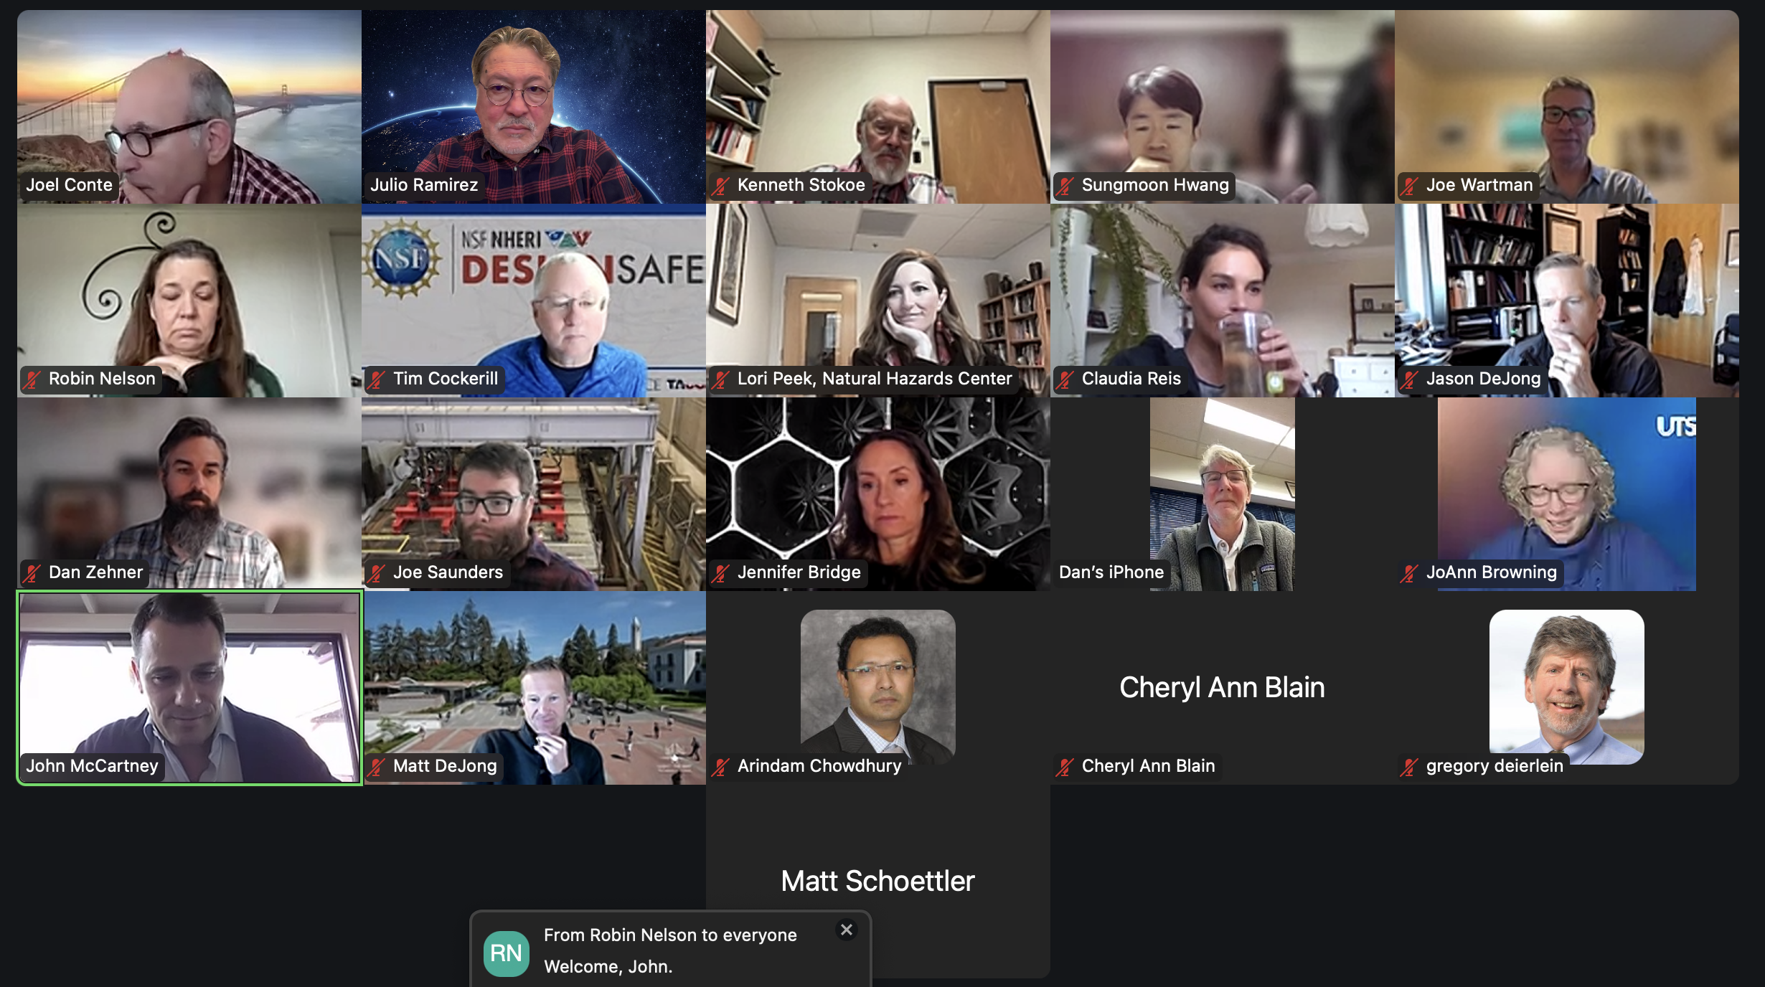
Joel Conte introduced Prof. John McCartney as the new PI for UCSD. He will be added to the Council e-mail list.

- (5 min) Review and Approval of Minutes of 12/05/24 Meeting No. 5 in Y-9. (Meeting No. 4 of November 7 was postponed to December 5) (Dan Cox)
Lori moved approval of the Minutes as distributed, and Joel seconded the motion.

Approved Minutes posted at: https://www.designsafe-ci.org/facilities/nco/governance/nheri-council/

- (40 min) Ongoing Business –

- (5 min) Scheduling NHERI Council meetings January-June 2025: proposal is to meet 11:00 AM to 12:00 PM EST and February 13, March 6, April 3, May 1, and June 5. (Julio)
Council agreed on the dates and times for its meetings until and including June when Summer Council meetings will begin. Calendar invites will be distributed in the next few weeks.
- (5 min) Report out AGU meeting, NHERI booth (Marti LaChance and Dan Zehner)
Marti submitted a report on the impact of the NHERI booth presence during AGU (attached). A separate meeting will be held to debrief the booth NHERI participants. Marti will report at the next Council Meeting. Find more information at this link:
https://www.designsafe-ci.org/community/news/2024/november/nheri-network-at-the-agu-fall-meeting-in-washington-dc/
- (5 min) Reminder/update of NHERI Computational Symposium dates and deadlines (Matt)
Matt reported that at the time of this meeting 245 participants had registered. Program is set and everyone is looking forward to the meeting in LA.
https://simcenter.designsafe-ci.org/nheri-computational-symposium/2025/
- (5 min) Reminder of NHERI Summer Institute dates and deadlines for travel award Feb 23, 2025, and registration May 1, 2025 (ECO, JoAnn Browning)
Robin Nelson provided an update on the activities. The update slides are attached to the Minutes.
- (5 min) Reminder of REU application deadline Feb 16, 2025 (ECO, JoAnn, Robin Nelson)
Update in Robin’s slides.
- (5 min) Update on ECO’s plans for REU symposium (ECO, JoAnn, Robin Nelson)
Ah-hoc Task Group led by Dan Cox and JoAnn Browning is working on coordinating activities and organizing the REU symposium at OSU in August. Other activities held jointly with the symposium include a demonstration of the OSU NHERI facility and a computational modeling symposium led by OSU. Dan and JoAnn invited Council members to join in upcoming meetings of the Task Group and asked for nominations of REU grads from the facilities to receive invitations to attend and participate in the Symposium. Also, nominations are welcomed of outstanding graduate student that have been REU mentors. Another suggestion was to coordinate scheduling times so that facilities can broadcast activities during the 3-day Symposium.
Action Item: Dan will share with the Council the dates of future meetings of this Task Group and all interested Council members are invited to join.
- (5 min) Update on HWRL plans for NSF 75th (Dan C.)
See report in Item f)
- (5 min) Data Depot metrics (Tim C.)
Tim extended the offer to work with facilities to provide data for their proposals. Some examples of the metrics that can be collected by DesignSafe are shown in the attachment to the Minutes.
Action Item: Council members please look carefully through the data provided by Tim and check accuracy and set up meetings with him as needed.

- (5 min) New Business
  - None

- Adjourn: Meeting adjourned at Noon. Lori moved and Joel seconded the motion to adjourn.

