2019 NHERI REU Weekly Evaluation

Name: Site:

Mentor(s):

Please answer the following questions as candidly as possible. Your responses will help us improve the summer experience.
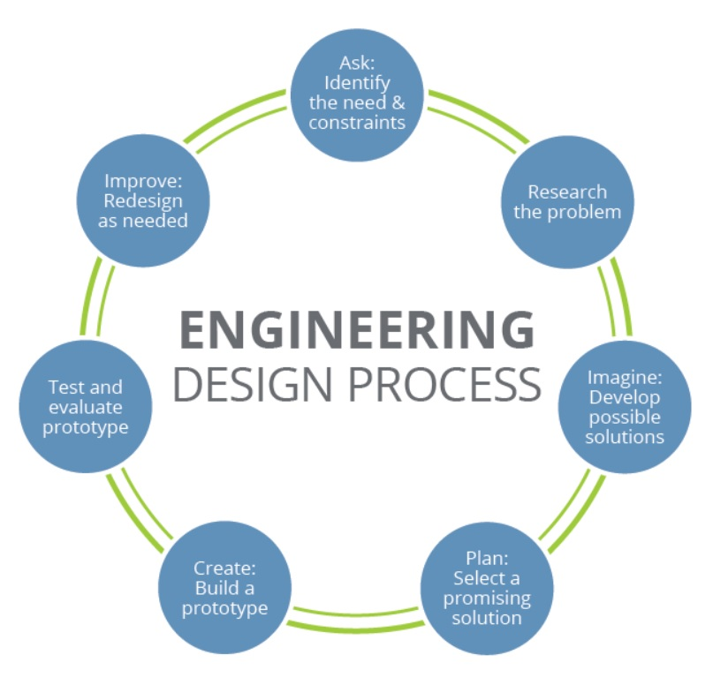
- Above is an image of the Engineering Design Process. What part(s) of the engineering design process have you been a part of during the REU Summer Program? Explain with details of your tasks for each one, if applicable.

- At which step of the engineering design process have you felt the most challenged? Explain how.

- Thinking of your future career goals, what new opportunities would you like to explore and learn more about now that you are a part of a research project? How have these potential opportunities opened up to you?

- What has been the most enjoyable and memorable experience during your REU experience so far?

