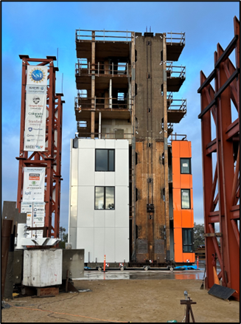 | 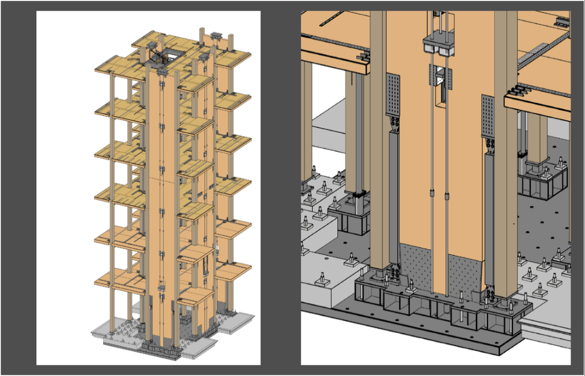 | Photos by Simpson Strong-Tie  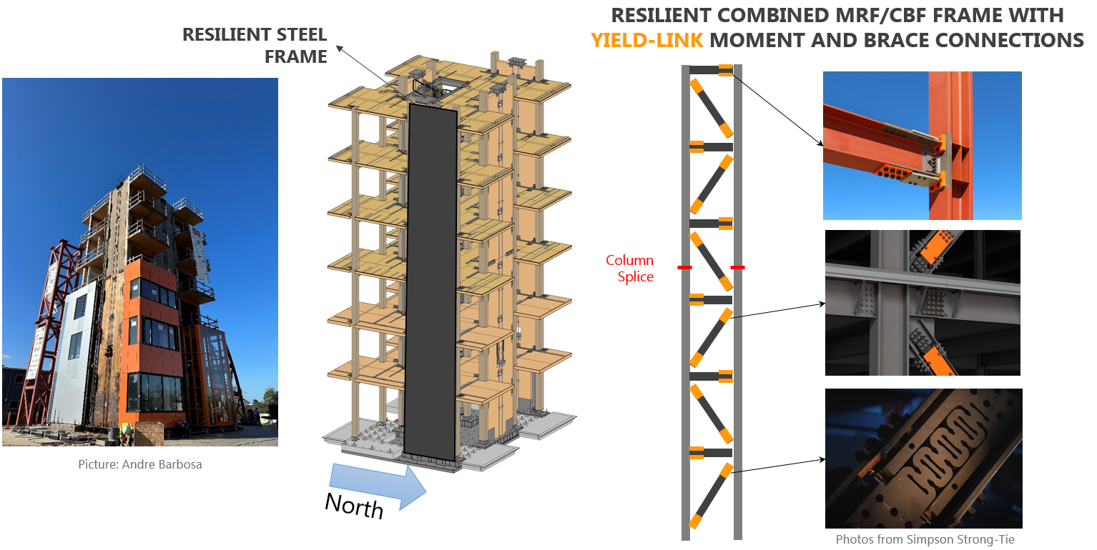
Phase 1  (complete) | Phase 2  (testing Dec. 2023 - Jan. 2024) | Phase 3  (upcoming 2024)

Detailed blurb:
Funded by the National Science Foundation (NSF), the Converging Design project includes full-scale testing of a six-story mass timber building at the Natural Hazards Engineering Research Institute (NHERI) Large-High Performance Outdoor Shake Table. The project re-uses the bottom six stories of a 10-story mass timber building previously tested as part of the NSF Tallwood project. Shake table testing includes three phases featuring different seismic-force resisting systems aimed at achieving near damage-free post-earthquake performance, as shown in Fig. 1. Construction and testing can be monitored via the live webcam at https://nheri.ucsd.edu/live-cams.
The Converging Design team completed Phase 1 of testing in November 2023, which included post-tensioned mass timber rocking walls with steel U-shaped energy dissipators. The building exhibited no apparent residual drifts and minimal post-earthquake damage after 43 shakes, half of which consisting of severe ground shaking. Construction for Phase 2 re-using the six-story gravity system is currently underway, featuring post-tensioned mass timber rocking walls with Buckling-Restrained Braces provided by CoreBrace. Shake table testing for Phase 2 is expected to begin in December 2023. In the subsequent phase, Phase 3 will feature a combined mass timber gravity frame with a resilient lateral-force resisting frame provided by Simpson Strong-Tie using Simpson’s Yield-Link® moment connection and the Yield-Link® brace connection.
This work is part of the Converging Design project with collaborators from Oregon State University, Stanford University, Colorado State University, and Penn State University with support from the National Science Foundation (#2120683, #2120692, and #2120684), USDA Agricultural Research Service, and TallWood Design Institute, along with several other industry partners listed on the project website https://tallwoodinstitute.org/converging-design-partners.

Short blurb:
Shake table testing of a six-story mass timber building will begin in December 2023 at the Natural Hazards Engineering Research Institute (NHERI) Large-High Performance Outdoor Shake Table. This is the second of a three-phase experimental program aimed at achieving near damage-free post-earthquake performance, as shown in Fig. 1. The building features post-tensioned self-centering mass timber rocking walls, with Buckling-Restrained Braces and all other materials provided by industry partners and sponsors listed on the project website, https://tallwoodinstitute.org/converging-design-partners. Construction and testing can be monitored via the live webcam at https://nheri.ucsd.edu/live-cams. This work is part of the Converging Design project with collaborators from Oregon State University, Stanford University, Colorado State University, and Penn State University with support from the National Science Foundation (#2120683, #2120692, and #2120684), USDA Agricultural Research Service, and TallWood Design Institute, along with several other industry partners.

