Use Case Documentation Template (11/18/2021)
Template is based on NGL documentation from Scott Brandenberg (see below and also https://ngl-tools.readthedocs.io/en/latest/index.html). I will follow up with how to develop markdown files to render the text as a navigable webpage, but for now you can use this Word document to develop your headings, text, etc.
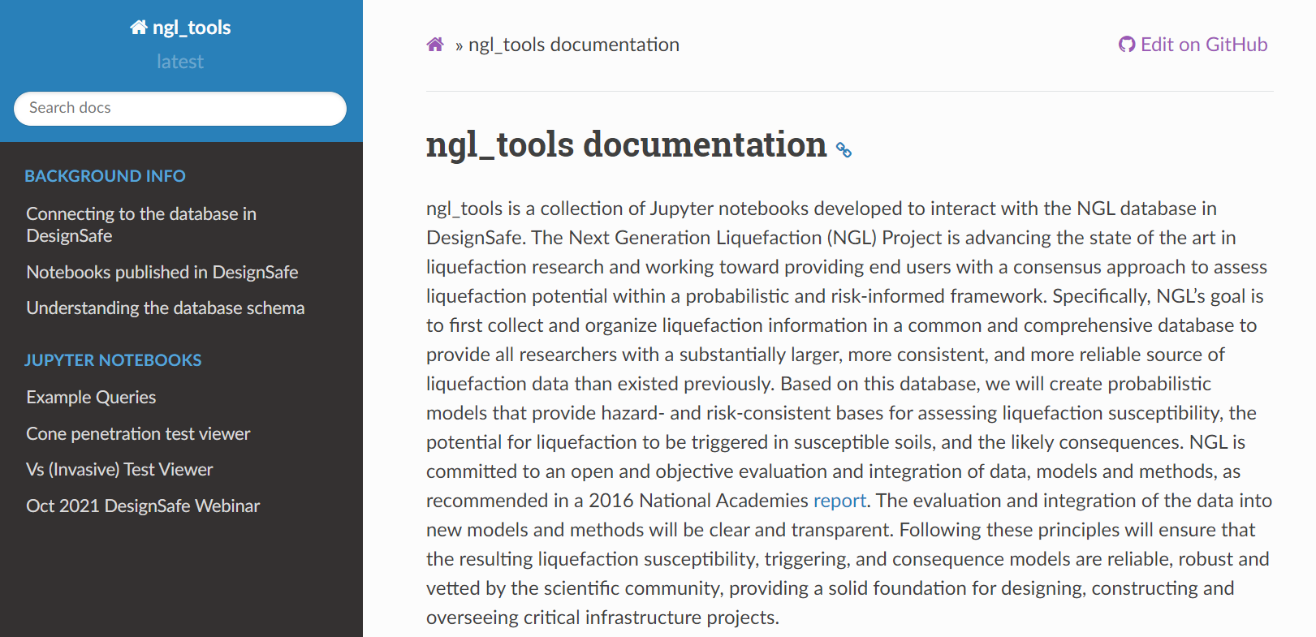
Sub HEadings
HEading 2
Sub HEadings
HEading 1
Introduction page
Title
TITLE (descriptive of PRODUCT, not project)
- Introduction page gives a high-level overview of what product does
HEADING 1 (Recommended heading: “Background Info”)
- Sub-heading 1.1 (defined to be relevant to your use case, rename with a meaningful title)
  - Write text/figures that will go under this sub-heading
- Sub-heading 1.2
  - Write text/figures that will go under this sub-heading
Note: Define enough sub-headings to help users navigate to important information without needing to read through a long web page.
HEADING 2 (Defined differently for each use case)
- Sub-heading 2.1 (rename to be relevant to your use case product)
  - Write text/figures that will go under this sub-heading
- Etc.
HEADING 3 (maximum number of headings should be 3)
- Sub-heading 3.1 (rename to be relevant to your use case product)
  - Write text/figures that will go under this sub-heading
- Etc.

